Decision Support System (DSS)

DSS FY17 User Guide

Software Version 3.0

Patch ECX*3.0*161



October 2016

Document Version 1.1

Revision History

| Date | Version | Description | Author |
| --- | --- | --- | --- |
| 10/07/2016 | 1.1 | Applied Product Support changes from Stacy Hardy | Team SMS/LMCO |
| 08/10/2016 | 1.0 | Initial Document Release | Team SMS/LMCO |

Table of Contents

1. Introduction 1

1.1. Purpose 1

1.2. Document Orientation 1

1.2.1. Organization of the Manual 1

1.2.2. Assumptions 2

1.2.3. Coordination 2

1.2.4. Disclaimers 2

1.2.4.1. Software Disclaimer 2

1.2.4.2. Documentation Disclaimer 2

1.2.5. Documentation Conventions 2

1.2.6. References and Resources 3

1.3. National Service Desk and Organizational Contacts 3

2. System Summary 4

2.1. System Configuration 4

2.2. Data Flows 4

2.3. User Access Levels 4

3. Getting Started 6

3.1. Setup Required DSS Information 6

3.2. Logging On - System Menu 6

3.3. Accessing DSS 6

3.4. Caveats and Exceptions 7

4. Using the Software 8

4.1. Maintenance Menu 8

4.1.1. CBOC Activity Report 8

4.1.2. Current Procedural Terminology (CPT) Inquiry 10

4.1.3. DSS Department Management 11

4.1.3.1. Enter/Edit DSS Ward 11

4.1.4. Event Capture 11

4.1.4.1. Unusual Volume Report for Event Capture 11

4.1.5. Laboratory 14

4.1.5.1. Add/Edit Lab Results Translation Table 14

4.1.5.2. Lab Results Extract Untranslatable Results Report 16

4.1.5.3. Lab Results DSS LOINC® Code Report 17

4.1.6. Pharmacy 18

4.1.6.1. Pharmacy Volume Edit and Volume Edit Log 18

4.1.6.1.1. Pharmacy Volume Edit 18

4.1.6.1.2. Pharmacy Volume Edit Log 22

4.1.6.2. Pharmacy Extracts Incomplete Feeder Key Reports 25

4.1.6.2.1. PRE Extracts Incomplete Feeder Key Report 29

4.1.6.2.2. IVP Extracts Incomplete Feeder Key Report 32

4.1.6.2.3. UDP Extracts Incomplete Feeder Key Report 35

4.1.6.3. Pharmacy Extracts Unusual Cost Report 37

4.1.6.3.1. PRE Unusual Cost Report 38

4.1.6.3.2. IVP Unusual Cost Report 39

4.1.6.3.3. UDP Unusual Cost Report 40

4.1.6.4. Pharmacy Extracts Unusual Volume Report 42

4.1.6.4.1. PRE Unusual Volume Report 43

4.1.6.4.3. IVP Unusual Volume Report 44

4.1.6.4.4. UDP Unusual Volume Report 45

4.1.6.4.5. BCM Unusual Volume Report 47

4.1.6.5. UDP/IVP Source Audit Report 50

4.1.7. Print Feeder Keys 52

4.1.8. Print Feeder Locations 53

4.1.9. Prosthetics 54

4.1.9.1. Cost by PSAS HCPC Report 54

4.1.9.2. Prosthetic Extracts Unusual Cost Report 55

4.1.9.3. Prosthetics (PRO) YTD HCPCS Report 57

4.1.9.4. Prosthetics (PRO) YTD Laboratory Report 59

4.1.9.5. Prosthetics Edit and Edit Log 61

4.1.9.5.1. Prosthetics Edit 61

4.1.9.5.2. Prosthetics Edit Log 62

4.1.10. Setup for DSS Clinic Information 62

4.1.10.1. CHAR4 Codes List 63

4.1.10.2. Create DSS Clinic Stop Code File 64

4.1.10.2.1. New Clinic Entries 65

4.1.10.2.2. Existing Clinic Entries 65

4.1.10.3. Clinics and DSS Stop Codes Print 65

4.1.10.4. Enter/Edit Clinic Parameters 70

4.1.10.5. Approve Reviewed DSS Clinic Worksheet 72

4.1.10.6. Clinic and Stop Codes Validity Report 72

4.1.10.7. Clinic Edit Log Report 73

4.1.11. Setup for Inpatient Census Information 74

4.1.11.1. Trial for Setup Extract 74

4.1.11.2. Generate the Inpatient Setup Extract 75

4.1.11.3. Active MAS Wards for Fiscal Year Print 76

4.1.11.4. Primary Care Team Print 77

4.1.12. Setup for Inpatient Medications Information 78

4.1.12.1. Print IV Room Worksheet 78

4.1.12.2. Enter/Edit IV Room Division 79

4.1.12.3. Pharmacy NDC Lookup 79

4.1.13. Surgery 80

4.1.13.1. SUR Volume Report 81

4.1.13.2. Surgery Extract Unusual Volume Report 82

4.2. Package Extracts 83

4.2.1. Admissions Extract (ADM) 84

4.2.2. BCMA Extract (BCM) 85

4.2.3. Blood Bank Extract (LBB) 85

4.2.4. Clinic Visit Extract (CLI) 85

4.2.5. Event Capture Local Extract (ECS) 85

4.2.6. IV Extract (IVP) 85

4.2.7. Lab Extract (LAB) 85

4.2.8. Lab Results Extract (LAR) 86

4.2.9. Prescription Extract (PRE) 86

4.2.10. Prosthetics Extract (PRO) 86

4.2.11. QUASAR Extract (ECQ) 87

4.2.12. Radiology Extract (RAD) 87

4.2.13. Surgery Extract (SUR) 87

4.2.14. Transfer and Discharge Extract (MOV) 87

4.2.15. Treating Specialty Change Extract (TRT) 87

4.2.16. Unit Dose Extract (UDP) 87

4.2.17. Fiscal Year Logic – DSS Testing Only 88

4.3. SAS Extract Audit Reports 88

4.3.1. SAS Prescription Audit Report 89

4.3.2. SAS Radiology Audit Report 90

4.3.3. SAS Surgery Audit Report 92

4.4. Extract Audit Reports 93

4.4.1. Admission (ADM) Extract Audit 95

4.4.2. QUASAR (ECQ) Audit 96

4.4.3. Event Capture Local (ECS) Extract Audit 97

4.4.4. Laboratory (LAB) Extract Audit 98

4.4.5. Laboratory Results (LAR) Extract Audit 99

4.4.6. Laboratory Blood Bank (LBB) Audit Reports 99

4.4.6.1. Laboratory Blood Bank (LBB) Comparative Report 100

4.4.6.2. Laboratory Blood Bank (LBB) Pre-Extract Audit 101

4.4.7. Physical Movement (MOV) Extract Audit 101

4.4.8. Prosthetics (PRO) Extract Audit 103

4.4.9. Radiology (RAD) Extract Audit 105

4.4.10. Surgery (SUR) Extract Audit 106

4.4.11. Treating Specialty Change (TRT) Extract Audit 107

4.5. Transmission Management 108

4.5.1. Review a Particular Extract for Transmission 108

4.5.2. Transmit Data from Extract Files 109

4.5.3. Summary Report of Extract Logs 110

4.5.4. Delete Extract Files 112

4.5.5. Purge Extract Holding Files 113

4.5.6. Recreate Extract Holding Files 114

5. Troubleshooting 116

5.1. Special Instructions for Error Correction 116

Appendix A. Abbreviations and Acronyms A-1

Appendix B. Glossary B-1

Appendix C. Reference Materials C-1

Appendix D. Feeder Key Transmission D-1

Appendix E. Create a LAR Translation Table E-1

Appendix F. Exporting a Report to a Spreadsheet F-1

List of Tables

Table 1: Reference Documentation on the VDL 3

Table 2: Tier Support Contact Information 3

Table 3: ECXMGR Menu Table 5

Table 4: ECXPVE Menu Table 5

Table 5: ECXDSS Test Menu Table 5

Table 6: Incomplete Feeder Key Report Description 26

Table 7: New Clinic Entry Field Defaults 65

Table 8: PRO Extract Audit Versions 103

Table 9: Acronyms A-1

Table 10: Glossary B-1

Table 11: Feeder Key Transmission Table D-1

Table 12: LAR Translation Table E-1

List of Figures

Figure 1: DSS Application Data Flow Diagram 4

Figure 2: Example: System Menu for System Administrator 6

Figure 3: Example: Extract Manager’s Menu 8

Figure 4: Example: Maintenance Menu Options 8

Figure 5: Example: CBOC Activity Report Screen Print 9

Figure 6: Example: Exported CBOC Activity Report 10

Figure 7: Example: CPT Inquiry 10

Figure 8: Example: DSS Department Management Menu 11

Figure 9: Example: DSS Department Management – Ward Selection 11

Figure 10: Example: ECS Extract Unusual Volume Report – All DSS Units Screen Print 12

Figure 11: Example: Exported ECS Extract Unusual Volume Report – All DSS Units 13

Figure 12: Example: ECS Extract Unusual Volume Report Screen Print – Single DSS Unit 14

Figure 13: Example: Exported ECS Extract Unusual Volume Report - Single DSS Unit 14

Figure 14: Example: Laboratory Menu Options 14

Figure 15: Example: Add/Edit Lab Results Translation Table 15

Figure 16: Example: LAR Extract Untranslatable Results Report Screen Print 16

Figure 17: Example: Exported LAR Extract Untranslatable Results Report 17

Figure 18: Example: Lab Results DSS LOINC CODE Report Screen Print 17

Figure 19: Example: Exported Lab Results DSS LOINC CODE Report 18

Figure 20: Example: Pharmacy Options Menu 18

Figure 21: Example: Pharmacy Volume Edit Log for PRE Screen Print 23

Figure 22: Example: Pharmacy Volume Edit Log for IVP Screen Print 24

Figure 23: Example: Pharmacy Volume Edit Log for UDP Screen Print 24

Figure 24: Example: Pharmacy Volume Edit Log for BCM Screen Print 25

Figure 25: Example: PRE Extracts Incomplete Feeder Key Report Screen Print 31

Figure 26: Example: PRE Header 31

Figure 27: Example: PRE Detail-1 31

Figure 28: Example: PRE Detail-2 31

Figure 29: Example: PRE Detail-3 32

Figure 30: Example: Exported PRE Extracts Incomplete Feeder Key Report 32

Figure 31: Incomplete Feeder Key Report (IVP) Header 32

Figure 32: Incomplete Feeder Key Report (IVP) – Detail-1 33

Figure 33: Incomplete Feeder Key Report (IVP) – Detail-2 33

Figure 34: Incomplete Feeder Key Report (IVP) – Detail-3 33

Figure 35: Example: IVP Extracts Incomplete Feeder Key Report Screen Print 34

Figure 36: Example: IVP Header 34

Figure 37: Example: IVP Detail-1 34

Figure 38: Example: IVP Detail-2 35

Figure 39: Example: IVP Detail-3 35

Figure 40: Example: Exported IVP Extracts Incomplete Feeder Key Report 35

Figure 41: Example: UDP Extracts Incomplete Feeder Key Report Screen Print 36

Figure 42: Example: UDP Header 37

Figure 43: Example: UDP-Detail-1 37

Figure 44: Example: UDP-Detail-2 37

Figure 45: Example: UDP-Detail-3 37

Figure 46: Example: Exported UDP Extracts Incomplete Feeder Key Report 37

Figure 47: Example: PRE Unusual Cost Report Screen Print 38

Figure 48: Example: Exported PRE Unusual Cost Report 39

Figure 49: Example: IVP Unusual Cost Report Screen Print 39

Figure 50: Example: Exported IVP Unusual Cost Report 40

Figure 51: Example: UDP Unusual Cost Report with SIG/Order Directions Added Screen Print 40

Figure 52: Example: Exported UDP Unusual Cost Report with SIG/Order Directions Added 41

Figure 53: Example: UDP Unusual Cost Report without SIG/Order Directions Added Screen Print 41

Figure 54: Example: Exported UDP Unusual Cost Report without SIG/Order Directions Added 42

Figure 55: Example: PRE Extract Unusual Volume Report Screen Print 43

Figure 56: Example: Export PRE Extract Unusual Volume Report 43

Figure 57: Example: IV Detail Extract Unusual Volume Report Screen Print 44

Figure 58: Example: Exported IV Detail Extract Unusual Volume Report 44

Figure 59: Example: UDP Detail Extract Unusual Volume Report with SIG/Order Directions Added Screen Print 45

Figure 60: Example: Exported UDP Detail Extract Unusual Volume Report with SIG/Order Directions Added 46

Figure 61: Example: UDP Detail Extract Unusual Volume Report without SIG/Order Directions Added Screen Print 46

Figure 62: Example: Exported UDP Detail Extract Unusual Volume Report without SIG/Order Directions Added 47

Figure 63: Example: BCM Detail Extract Unusual Volume Report without SIG/Order Directions Added Screen Print (IV) 48

Figure 64: Example: Exported BCM Detail Extract Unusual Volume Report without SIG/Order Directions Added (IV) 48

Figure 65: Example: BCM Detail Extract Unusual Volume Report with SIG/Order Directions Added Screen Print (Non-IV) 49

Figure 66: Example: Exported BCM Detail Extract Unusual Volume Report with SIG/Order Directions Added (Non-IV) 49

Figure 67: Example: UDP Source Audit Report Screen Print 50

Figure 68: Example: Exported UDP Source Audit Report 51

Figure 69: Example: IVP Source Audit Report Screen Print 51

Figure 70: Example: Exported IVP Source Audit Report 52

Figure 71: Example: Print Feeder Keys Screen Print 53

Figure 72: Example: Exported Print Feeder Keys - PRO 53

Figure 73: Example: Print List of Feeder Locations Screen Print 54

Figure 74: Example: Exported Print List of Feeder Locations 54

Figure 75: Example: Prosthetics Menu Options 54

Figure 76: Example: Cost by PSAS HCPC Report Screen Print 55

Figure 77: Example: Exported Cost by PSAS HCPC Report 55

Figure 78: Example: PRO Extracts Unusual Cost Report Screen Print 56

Figure 79: Example: Export PRO Extracts Unusual Cost Report 57

Figure 80: Example: PRO Extract YTD HCPCS Report Screen Print 58

Figure 81: Example: Exported PRO Extract YTD HCPCS Report 59

Figure 82: Example: PRO Extract YTD Laboratory Report Screen Print 60

Figure 83: Example: Exported PRO Extract YTD Laboratory Report 61

Figure 84: Example: Prosthetics Edit and Edit Log Menu Options 61

Figure 85: Example: Prosthetics Extracts Edit Log Screen Print 62

Figure 86: Example: DSS Clinic Information Menu Options 62

Figure 87: Example: CHAR4 Codes List Screen Print 63

Figure 88: Example: Exported CHAR4 Codes List 63

Figure 89: Example: All Clinics Option Screen Print 67

Figure 90: Example: Active Clinics Option Screen Print 68

Figure 91: Example: Duplicate Clinics Option Screen Print 68

Figure 92: Example: Inactive Clinics Option Screen Print 68

Figure 93: Example: Unreviewed Clinics Option Screen Print 69

Figure 94: Example: Exported All Clinics Spreadsheet 70

Figure 95: Example: Exported Active Clinics Spreadsheet 70

Figure 96: Example: Exported Duplicate Clinics Spreadsheet 70

Figure 97: Example: Exported Inactive Clinics Spreadsheet 70

Figure 98: Example: Exported Unreviewed Clinics Spreadsheet 70

Figure 99: Example: Clinic and Stop Codes Validity Report Screen Print 73

Figure 100: Example: Exported Clinic and Stop Codes Validity Report 73

Figure 101: Example: Clinic Edit Log Report Screen Print 74

Figure 102: Example: Exported Clinic Edit Log Report 74

Figure 103: Example: Patient Census Information Menu Options 74

Figure 104: Example: Inpatient Population Report on a Selected Date Screen Print 75

Figure 105: Example: Active MAS Wards for Fiscal Year Print – Screen Print 76

Figure 106: Example: Exported Active MAS Wards for Fiscal Year Print 77

Figure 107: Example: Primary Care Team Print- Screen Print 77

Figure 108: Example: Exported Primary Care Team Print 78

Figure 109: Example: Inpatient Medications Information Option Menu 78

Figure 110: Example: IV Room Worksheet Screen Print 78

Figure 111: Example: Exported IV Room Worksheet 79

Figure 112: Example: Selecting a NDC 80

Figure 113: Example: Surgery Menu Options 81

Figure 114: Example: SUR Volume Report Screen Print 81

Figure 115: Example: Exported SUR Volume Report 81

Figure 116: Example: Surgery Extract Unusual Volume Report Screen Print 83

Figure 117: Example: Exported Surgery Extract Unusual Volume Report 83

Figure 118: Example: Package Extracts Options 84

Figure 119: Example: SAS Extracts Audit Reports Menu Options 89

Figure 120: Example: SAS Audit Report for Prescription (PRE) Extract Screen Print 90

Figure 121: Example: Exported SAS Audit Report for Prescription (PRE) Extract 90

Figure 122: Example: SAS Audit Report for Radiology (RAD) Extract Screen Print 91

Figure 123: Example: Exported SAS Audit Report for Radiology (RAD) Extract 92

Figure 124: Example: SAS Audit Report for Surgery (SUR) Extract Screen Print 93

Figure 125: Example: Exported SAS Audit Report for Surgery (SUR) Extract 93

Figure 126: Example: Extract Audit Reports Menu on Extract Managers Menu 94

Figure 127: Example: Admission (ADM) Extract Audit Report Screen Print 95

Figure 128: Example: Exported Admission Extract Audit Report 96

Figure 129: Example: QUASAR Extract Audit Report Screen Print 96

Figure 130: Example: Exported QUASAR Extract Audit Report 97

Figure 131: Example: ECS Extract Audit Report Screen Print 97

Figure 132: Example: Exported ECS Extract Audit Report 98

Figure 133: Example: Laboratory Extract Audit Report Screen Print 98

Figure 134: Example: Exported Laboratory Extract Audit Report 98

Figure 135: Example: Laboratory Results Extract Audit Report Screen Print 99

Figure 136: Example: Exported Laboratory Results Extract Audit Report 99

Figure 137: Example: LBB Audit Report Options Menu 100

Figure 138: Example: LBB Extract Comparative Audit Report Screen Print 100

Figure 139: Example: LBB Exported Extract Comparative Audit Report 100

Figure 140: Example: LBB Pre-Extract Audit Report Screen Print 101

Figure 141: Example: Exported LBB Pre-Extract Audit Report 101

Figure 142: Example: Physical Movement Extract Audit Report Screen Print 102

Figure 143: Example: Exported Physical Movement Extract Audit Report 102

Figure 144: Example: PRO Extract Audit Menu 103

Figure 145: Example: Summary Report for PRO Extract Audit Screen Print 103

Figure 146: Example: Exported Summary Report for PRO Extract Audit 104

Figure 147: Example: Pro Extract Audit Detail Report for PRO Extract Audit Screen Print 104

Figure 148: Example: Pro Exported Audit Detail Report for PRO Extract Audit 104

Figure 149: Example: Radiology Extract Audit Report Screen Print 105

Figure 150: Example: Exported Radiology Extract Audit Report 105

Figure 151: Example: Surgery Extract Audit Report Screen Print 106

Figure 152: Example: Exported Surgery Extract Audit Report 107

Figure 153: Example: Treating Specialty Change Extract Audit Report Screen Print 107

Figure 154: Example: Exported Treating Specialty Change Extract Audit Report 108

Figure 155: Example: Transmission Management Options Menu 108

Figure 156: Example: Review a Particular Extract for Transmission Screen Print 109

Figure 157: Example: Sample Mail Message - Completed Extracted Data 110

Figure 158: Example: Summary Report Extract Logs Screen Print 111

Figure 159: Example: Exported Summary Report Extract Logs 112

Figure 160: Example: Confirmation Message 114

Figure 161: Example: Confirmation Message for Recreate 115

Figure 162: Display selection from Setup Menu Option F-2

Figure 163: Display Setup screen F-2

Figure 164: Logging selection from File Menu F-3

Figure 165: Logging Screen F-3

Figure 166: Log Output To Disk File screen F-4

Figure 167: DSS Export Report screen F-4

Figure 168: Logging screen F-5

Figure 169: From Text option from Data Menu F-5

Figure 170: Import Text File screen F-5

Figure 171: Text Import Wizard – Step 1 of 3 F-6

Figure 172: Text Import Wizard – Step 2 of 3 F-6

Figure 173: Text Import Wizard – Step 3 of 3 F-7

Figure 174: Import Data screen F-7

Figure 175: Excel Report F-7

# Introduction

The Decision Support System (DSS) is the designated Managerial Cost Accounting (MCA) System, of the Department of Veterans Affairs (VA), as mandated in *VHA Directive 1750 Veterans Health Administration (VHA) Managerial Cost Accounting System (Decision Support System (DSS)), March 24, 2015*.

DSS is a derived database built from standard VHA data sources. The Managerial Cost Accounting Office (MCAO) uses clinical and financial data to provide state-of-the-art activity-based costing and clinical productivity analyses.

This is a design-to-schedule project with a compulsory patch release date of no later than November 1, of the new Fiscal Year (FY). This project enables the MCAO to accurately accommodate changes, to the primary Clinical Transaction Systems, made during the preceding year, ensuring the Workload data has been accurately captured and costed to the Product Level.

MCA Cost Data is used at all levels of the VA for important functions, such as budgeting and resource allocation. Additionally, the system contains a rich repository of clinical information used to promote a more proactive approach to the care of high-risk (i.e. diabetes and acute coronary patients) and high-cost patients.

## Purpose

The DSS FY17 User Guide is intended for use as an instructional guide, for the DSS application software. Users may use this manual as a supplemental guide, to the DSS application Online Help options.

## Document Orientation

The following sub-paragraphs are intended to provide general information helpful with understanding how to use this document.

### Organization of the Manual

This document is organized into the following major sections:

Introduction - This section provides a brief description of the purpose of the guide and an orientation into the document’s structure and use.

System Summary - This section provides a general description, of the system written in non-technical terminology and the purpose for which the system is intended, the system configuration, data flows, user access and continuity of operations.

Getting Started - This section provides a general walkthrough of the system from initiation through exit. The logical arrangement of the information enables functional personnel to understand the sequence and flow of the system.

Using the Software – This section is designed to serve as reference to the user, covering vital aspects of this tool. It is categorized into five components.

* Maintenance
* Package Extracts
* Statistical Analysis System (SAS) Extract Audit Reports
* Extract Audit Reports
* Transmission Management

Troubleshooting – This section provides general troubleshooting advice on commonly encountered issues.

Appendix – Appendices for Acronyms, Abbreviations, Glossary, Feeder Key Transmission Formatting, Creating a Lab Results extract (LAR) Translation Table and Exporting data into Excel Spreadsheets.

Index – Index major topics of interest.

### Assumptions

This guide was written with the following experience/skillset of the audience:

* Users have a basic knowledge of the Veterans Health Information Systems and Technology Architecture (VistA) Kernel operating system (such as details of logging on and off the VistA system, using commands, menu options and navigation tools).
* Users have been assigned the appropriate active roles, menus and security keys required for DSS.
* Users are using DSS to perform their job role and/or responsibilities.
* Users have validated access to DSS.
* Users have completed any prerequisite training.

### Coordination

The DSS application enables MCA personnel to ensure the Healthcare Workload is accurately captured and costed to the Product Level, by providing the capability to periodically run extracts and perform analyses, without intervention or assistance from other Healthcare staff.

### Disclaimers

The following disclaimers apply to all VA user documentation.

#### Software Disclaimer

This software was developed at the VA by employees of the Federal Government in the course of their official duties. Pursuant to Title 17 Section 105 of the United States Code (U.S.C.), this software is not subject to copyright protection and is in the public domain. VA assumes no responsibility whatsoever for its use by other parties, and makes no guarantees, expressed or implied, about its quality, reliability, or any other characteristic. We would appreciate acknowledgement if the software is used. This software can be redistributed and/or modified freely provided that any derivative works bear some notice that they are derived from it, and any modified versions bear some notice that they have been modified.

#### Documentation Disclaimer

The appearance of external hyperlink references in this manual does not constitute endorsement by the VA, of this web site or the information, products or services contained therein. The VA does not exercise any editorial control over the information you may find at these locations. Such links are provided and are consistent with the stated purpose of the VA.

### Documentation Conventions

To avoid displaying sensitive information regarding our patients and staff, the examples in this manual contain pseudonyms, scrambled data and/or data replaced with “X”s. Our patients and staff examples will use names such as “DSS1”, “PAT1”, “ECPATIENT, ONE”, “ECPROVIDER, ONE”, “USER, ONE” etc. Scrambled data is a series of random letters that replace a real name like “AAADY, JWHTRE”. Likewise, real social security numbers (SSNs), real addresses, and other personal identifiers are not used*.*

Also, throughout the document many of the examples of print and export versions of reports will only include portions of the actual output produced for the purposes of saving space and maintaining clarity.

### References and Resources

Listed below are documents that are available for reference on the [DSS VA Software Document Library (VDL)](http://www.va.gov/vdl/application.asp?appid=35) intranet site.

1. Reference Documentation on the VDL

|  |  |  |
| --- | --- | --- |
| File Name | Manual Name | Description |
| DSS_3_FY2017_DD | DSS Extracts Data Definitions Guide | Provides detailed information on formatting and defines the data terminology. |
| DSS_3_FY2017_TM | DSS Extract FY2017 Technical Manual | Describes the DSS Extract technical (high- level) terminology. |
| DSS_3_FY2017_UM | DSS FY2017 Extracts User Manual | Provides an overview of the functionality and enhancements. |
| DSS_3_FY2017_RN | DSS Extract FY2017 Release Notes | Provides detailed information on the DSS extracts and DSS reports modified for this Patch Release. |

## National Service Desk and Organizational Contacts

The three tiers of support documented herein are intended to restore normal service operation, as quickly as possible and minimize the adverse impact on business operations, while ensuring the best possible levels of service quality and availability are maintained.

Table 2 lists organizational contacts needed by Site Users, for troubleshooting purposes. Support contacts are listed by name of service, associated tier level, organization and contact information (email and phone number).

1. Tier Support Contact Information

| Name | Role | Org | Contact Information |
| --- | --- | --- | --- |
| Local DSS Site Manager | Tier 0 Support | VHA | DSS Site Manager/Site Dependent |
| Local MCA VISN Coordinator | Tier 0 Support | VHA | Site Dependent |
| OI&T National Service Desk | Tier 1 Support | OI&T | [Nationalservicedeskanr@va.gov](mailto:Nationalservicedeskanr@va.gov)  1-855-673-4357 |
| Health Product Support | Tier 2 Support | VHA | [Nationalservicedeskanr@va.gov](mailto:Nationalservicedeskanr@va.gov)  1-855-673-4357 |
| VistA Maintenance Management Systems | Tier 3 Application Support | OI&T | [OITPDVistAMaintenanceManagementSystems@va.gov](mailto:OITPDVistAMaintenanceManagementSystems@va.gov) |

# System Summary

DSS Extracts Version 3.0 provides a means of exporting data, from selected VistA database modules, to a MCA database, located in the VA Austin Information Technology Center (AITC).

This transfer is accomplished through a set of extract routines, intermediate files, audit reports, a transmission routine and a purge routine. Data from VistA packages is stored, by the extract routines, in the intermediate files, where it is temporarily available for local use and auditing. The data (extract and derivative files) are then transmitted, to the AITC where it is formatted and uploaded into commercial software. After the data has been successfully uploaded into the commercial software, it is purged, from the intermediate files.

The DSS Extracts software includes the following functionalities:

* DSS Extract field additions and modifications.
* DSS Menu additions, modifications and deletions.
* New DSS reports and report modifications.
* Implementation of the new and/or deleted extracts.

## System Configuration

Information pertaining to system configuration, prior to application execution may be found in the DSS Technical Manual, as identified in the Reference and Resources section above. Additional DSS application setup options are also described, under the appropriate menu options, covered in this document.

## Data Flows

The following diagram depicts the major paths of data flow, through the DSS application supporting activities conducted, by MCA personnel:

1. DSS Application Data Flow Diagram

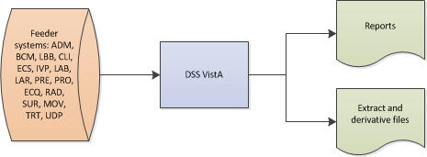

## User Access Levels

User access to DSS application features is controlled, through the implementation of Security Keys assigned to users. This KEY functionality is implemented in Vista's Kernel Key Management functions. Simple adjustments make it possible to assign the [ECXMGR] Extract Manager's Options to a user, enabling the viewing of all DSS reporting functionality, with the assignment of a single option. The Security Key controls only options that actually create/change data; and should not be available to all DSS users.

The ECXMGR key has been assigned to the following menus:

1. ECXMGR Menu Table

| Menu Name | Description |
| --- | --- |
| [ECXSCLOAD] | Create DSS Clinic Stop Code File |
| [ECXSCEDIT] | Enter/Edit Clinic Parameters |
| [ECXSCAPPROV] | Approve Reviewed DSS Clinic Worksheet |
| [ECX IV DIV EDIT] | Enter/Edit IV Room Division |
| [ECX LAB RESULTS TRANS EDIT] | Add/Edit Lab Results Translation Table |
| [ECXMENU] | Package Extracts |
| [ECXTRANS] | Transmit Data from Extract Files |
| [ECX WARD DSSDEPT] | Enter/Edit DSS Ward |

The ECXPVE key has been assigned to the following menu:

1. ECXPVE Menu Table

| Menu Name | Description |
| --- | --- |
| [ECX PHA VOL EDIT] | Pharmacy Volume Edit |

The ECX DSS TEST Security Key has been assigned for the following option:

1. ECXDSS Test Menu Table

| Menu Name | Description |
| --- | --- |
| [ECX FISCAL YEAR EXTRACT] | Fiscal Year Logic – DSS Testing Only |

# Getting Started

## Setup Required DSS Information

Refer to the DSS Extracts Version 3.0 Installation Guide, for information about installing and implementing the software.

* Setup for DSS Clinic Information
* Setup for Inpatient Census Information
* Setup for Inpatient Medications Information

In addition, the Maintenance submenu, of the Extract Manager'sMenu located, in the section titled "Using the Software" contains additional information regarding setup of the required DSS information.

## Logging On - System Menu

Users logging on to the VistA system are presented a System Menu, with options made available through permissions assignment, performed by a Systems Administrator, when setting up the User’s account. An example of the Systems Manager Menu, for a user assigned Systems Administrator privileges appear below:

1. Example: System Menu for System Administrator

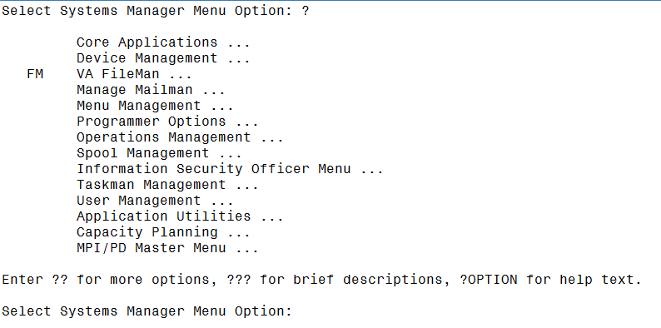

## Accessing DSS

Once logged on to VistA, and depending on setup and permissions, Users may have a short cut to the DSS application options, on the Extract Managers Menu. If so, the VistA Kernel command “^extract” can be used to access to the Extract Managers Menu directly.

The following options also provide access to the Extract Managers Menu, from the Systems Manager Menu:

1. On the Systems Manager Menu, select option: Core Applications.
2. On the Core Applications Menu, select option: Administrative Services Menus.
3. On the Administrative Services Menus, select option: Extract Manager's Menu.

Then, view the choices on the Extract Manager’s Menu and select an option.

## Caveats and Exceptions

There are no special actions a User must take to ensure that data is properly saved or some other function executes properly, prior to running or exiting the system.

# Using the Software

The Extract Manager’s Menu [ECXMGR] is the main menu, for the DSS application. The options listed may vary based on the User’s Security Keys settings, as described in the previous section.

Each option expands to a sub-menu with detailed options for each area.

The remainder of this manual is organized according to the options shown, on the menu and its sub-menus.

1. Example: Extract Manager’s Menu

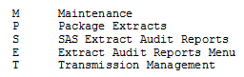

## Maintenance Menu

Choosing the Maintenance option, from the Extract Manager's Menu displays the following menu and options. Many of these options will also display on subsequent sub-menus and additional options.

1. Example: Maintenance Menu Options

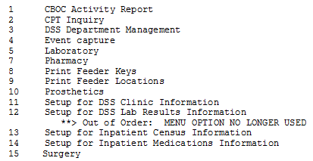

### CBOC Activity Report

This report provides information, from every Clinical (CLI) record (by extract #), with a Community-Based Outpatient Clinic (CBOC) status of “YES”. The report is grouped by Feeder Key, division and clinic. It lists the Patient Name, SSN and Date/Time of Visit. Totals for unique SSNs and Visits are printed, for each clinic, division and Feeder Key, as well as, an overall total for the station.

When purging a CLI extract, a validation check is performed to determine if the CBOC Activity Report generated. If the report did not generated, the User will receive an error message indicating such and asked if the data should be purged. If the report is generated, no additional prompts will display.

The steps to produce the CBOC Activity Report are as follows:

Select Maintenance Option: 1 CBOC Activity Report

Selectable Clinic Extracts for CBOC Activity Report Page: 1

Extract # Run Date Rec Count Date Range of Extract Division

-------------------------------------------------------------------------------

4340 01/07/2016 72337 12/01/2015 - 12/31/2015 552

4356 02/07/2016 69683 01/01/2016 - 01/31/2016 552

4372 03/07/2016 71307 02/01/2016 - 02/29/2016 552

4389 04/07/2016 80288 03/01/2016 - 03/31/2016 552

Create the CBOC Activity Report for extract number: 4340

Do you want the output in exportable format? NO//

This report requires 80-column format.

DEVICE: HOME// 0;132 HOME (CRT)

1. Example: CBOC Activity Report Screen Print

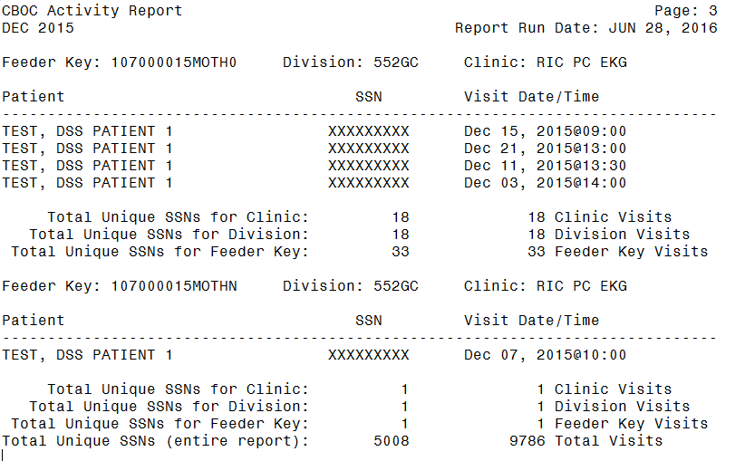

Guidance for capturing exported data into spreadsheets and the additional DSS application steps required to produce exportable versions of reports is located in Appendix F: Exporting a Report to a Spreadsheet.

The following example shows the report, after it has been produced in an exportable format and imported into a spreadsheet:

1. Example: Exported CBOC Activity Report

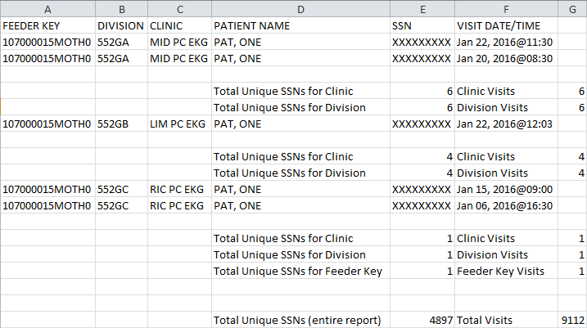

### Current Procedural Terminology (CPT) Inquiry

The CPT inquiry functions allows the User to select a Current Procedural Terminology (CPT) code and displays the Short Name, Category and Description, for the selected code.

1. Example: CPT Inquiry

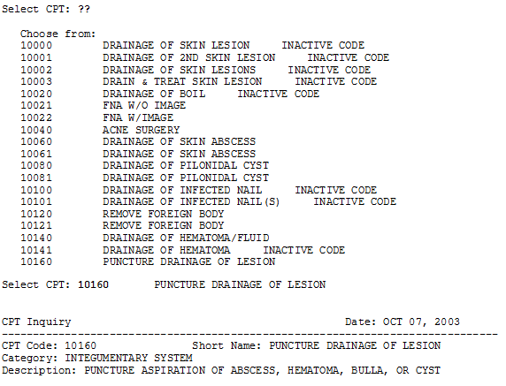

### DSS Department Management

When the DSS Department Management option is selected, from the Maintenance Menu the following sub-menu and options are displayed.

1. Example: DSS Department Management Menu

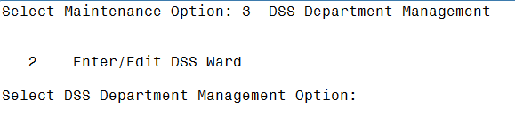

#### Enter/Edit DSS Ward

This option should only be used by the **MCA** **Site** **Manager**.

Use this option to enter or edit the DSS Department for Ward and suffix, associated with each medical center ward, within your division, if needed.

* If the ward selected exists, in the DSS WARD file (#727.4), the DSS Department Code displays and inquire if it requires editing.
* If the selected ward does not exist, in the DSS WARD file (#727.4), the User is prompted to enter a DSS Department for Ward and suffix to complete the DSS Department Code.

The suffix must have at least one character, but no more than three characters and must not contain an embedded caret. The hyphen character < **-** > should not be used, unless the DSS Department code was previously established in DSS/Austin.

After the User enters or edits the information, the new DSS Department code is displayed and the user is prompted to verify its accuracy.

1. Example: DSS Department Management – Ward Selection

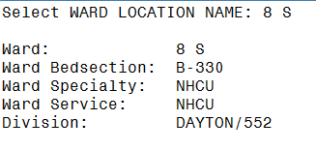

### Event Capture

#### Unusual Volume Report for Event Capture

The Unusual Volume Report, for Event Capture is a tool used, by Managers to validate the ECS volume data similar to the usage, of the Surgery or Pharmacy Unusual Volume Report. It can be used to identify volumes above a user-defined threshold, which should be reviewed for accuracy. The report should be generated, prior to information being sent to the DSS database.

The steps to produce the report for all DSS Units are as follows:

Select Maintenance Option: 4 Event Capture

1 Unusual Volume Report for Event Capture

Select Event Capture Option: 1 Unusual Volume Report for Event Capture

ECS Extract Unusual Volume Report

This report prints a listing of unusual volumes that would be

generated by the Event Capture extract (ECS) as determined by

a user-defined threshold value. It should be run prior to

the generation of an actual extract to identify and fix, as

necessary, any volumes determined to be erroneous.

Unusual volumes are those in excess of the threshold value

defined by the user. The threshold value is 20 by default.

Note: You may set a different threshold if you opt to continue.

Run times will vary depending upon the size of the EVENT CAPTURE

PATIENT file (#721) and the date range selected, but may be at

least several minutes. Queuing to a printer is recommended.

The running of this report has no effect on the actual extracts

and can be run as needed.

You may select one or all DSS Units. If you select one unit,

the report is sorted by descending volume. If you select all DSS Units,

the report is sorted by DSS Unit, then by descending volume.

Enter RETURN to continue or '^' to exit:

The default threshold volume for unusual volumes in Event Capture is 20.

Would you like to change the threshold? NO//

Do you want All DSS Units? YES//

Enter the date range for which you would like to scan the

Event Capture records.

Starting with Date: 6/1/10 (JUN 01, 2010)

Ending with Date: 6/30/10 (JUN 30, 2010)

Do you want the output in exportable format? NO//

This report is formatted for 132-column line width.

Enter 'Q' to queue report to TaskManager, then select printer.

DEVICE: HOME// 0;132

1. Example: ECS Extract Unusual Volume Report – All DSS Units Screen Print

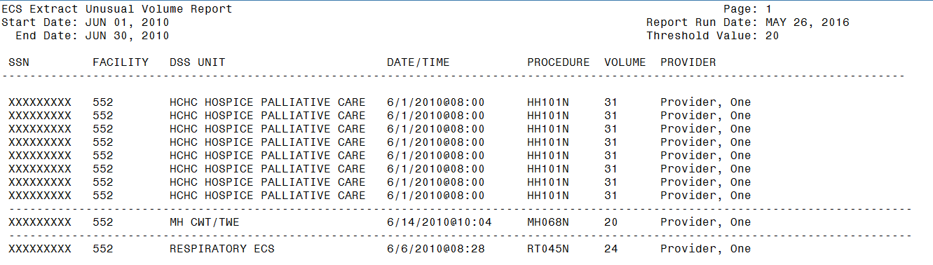

Guidance for capturing exported data, into spreadsheets and the additional DSS application steps required to produce exportable versions of reports is located in Appendix F: Exporting a Report to a Spreadsheet.

The following example displays the report, after it has been produced in an exportable format and imported into a spreadsheet:

1. Example: Exported ECS Extract Unusual Volume Report – All DSS Units

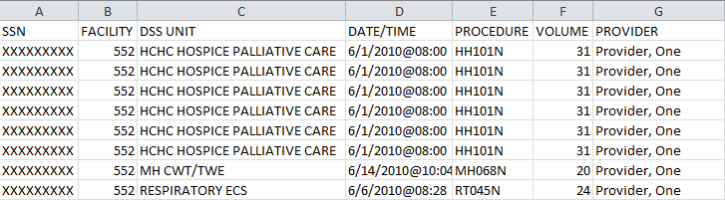

The steps to produce the report for a single DSS Unit are as follows:

The default threshold volume for unusual volumes in Event Capture is 20.

Would you like to change the threshold? NO//

Do you want All DSS Units? YES// n NO

Select DSS UNIT NAME: hchc

1 HCHC ADULT DAY CARE CENTER ATY1

2 HCHC CNH AUA1

3 HCHC HOMEMAKER/HEALTH CARE ATR1

4 HCHC HOSPICE PALLIATIVE CARE ATU1

5 HCHC INFUSION CARE ATV1

Press <RETURN> to see more, '^' to exit this list, OR

CHOOSE 1-5: 4 HCHC HOSPICE PALLIATIVE CARE ATU1

Enter the date range for which you would like to scan the

Event Capture records.

Starting with Date: 6/1/10 (JUN 01, 2010)

Ending with Date: 6/30/10 (JUN 30, 2010)

Do you want the output in exportable format? NO//

This report is formatted for 132-column line width.

Enter 'Q' to queue report to TaskManager, then select printer.

DEVICE: HOME// 0;132 HOME (CRT)

1. Example: ECS Extract Unusual Volume Report Screen Print – Single DSS Unit

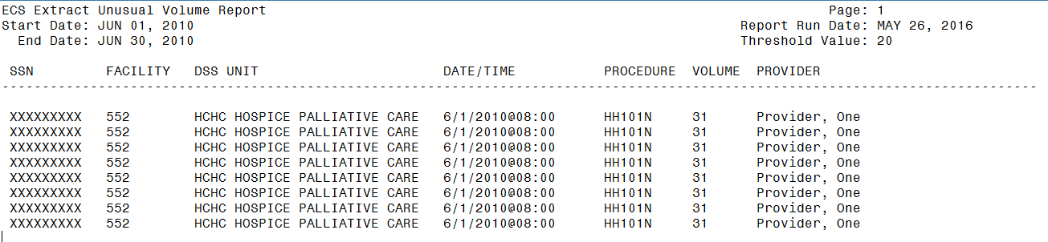

Guidance for capturing exported data, into spreadsheets and the additional DSS application steps required to produce exportable versions of reports is located in Appendix F: Exporting a Report to a Spreadsheet.

The following example displays the report, after it has been produced in an exportable format and imported into a spreadsheet:

1. Example: Exported ECS Extract Unusual Volume Report - Single DSS Unit

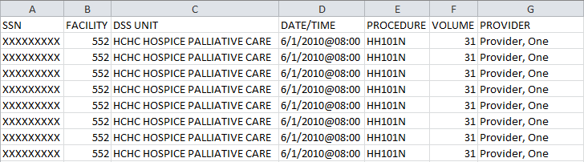

### Laboratory

When the Laboratory option is selected, from the Maintenance Menu the following sub-menu and options are displayed.

1. Example: Laboratory Menu Options

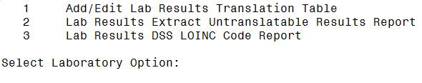

#### Add/Edit Lab Results Translation Table

This option allows the editing of existing entries or the addition of new entries, in the LAB RESULTS TRANSLATION file (#727.7). Free text results (non-numeric) are stored in this file, with their corresponding translation codes.

See Appendix E: Create a LAR Translation Table for additional information on creating a LAR Translation Table, if necessary.

1. Example: Add/Edit Lab Results Translation Table

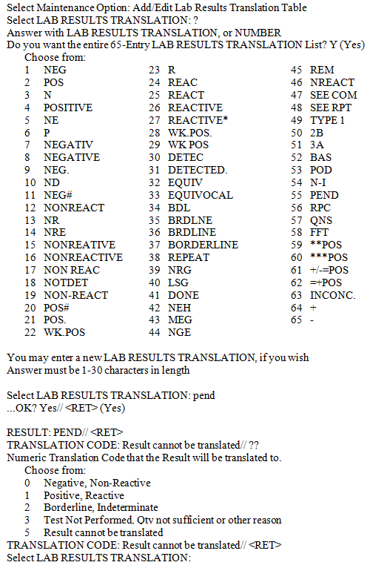

#### Lab Results Extract Untranslatable Results Report

This report prints a listing of results that are not translatable (have no entry in the LAB RESULTS TRANSLATION file (#727.7)). It is a pre-extract type Audit Report and should be run, prior to the generation of the actual extract. Generating this report has no effect on the actual extract.

NOTE: In the printed version of the report to the screen, if the Result field is longer than what can be displayed, a “+” will be appended to the field to indicate there is more text available.

The User will be prompted to enter the date range to scan the LAR Extract records. Beginning and ending dates must be in the same month and year. See Appendix E: Create a LAR Translation Table for additional information, on creating a LAR Translation Table, if necessary.

The steps to produce this report are as follows:

**Select Maintenance Option: Lab Results Extract Untranslatable Results Report**

This report prints a listing of results that are not translatable i.e. have

no entry in the Lab Results Translation File (#727.7).

This report is a pre-extract type audit report and should be run prior to the

generation of the actual extract. Running this report has no effect on the

actual extract.

**WARNING: This report can take a long time to process. You are encouraged

to queue this report for processing during the evening if possible.**

Enter the date range for which you would like to scan the LAR Extract records.

Starting with Date: 3/1/15 (MAR 01, 2015)

Ending with Date: 3/10/15 (MAR 10, 2015)

Do you want the output in exportable format? NO//

DEVICE: HOME// 0;132 HOME (CRT)

1. Example: LAR Extract Untranslatable Results Report Screen Print

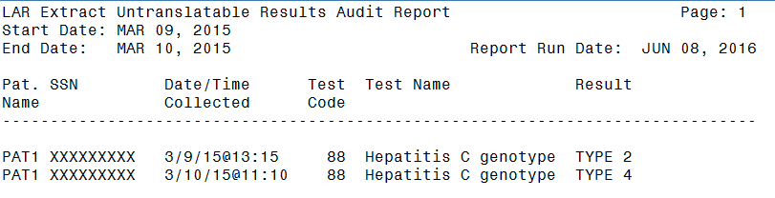

Guidance for capturing exported data into spreadsheets and the additional DSS application steps required to produce exportable versions of reports are located in Appendix F: Exporting a Report to a Spreadsheet.

The following example displays the report, after it has been produced in an exportable format and imported into a spreadsheet:

1. Example: Exported LAR Extract Untranslatable Results Report

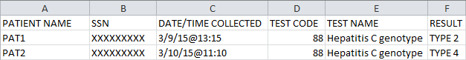

#### Lab Results DSS LOINC® Code Report

This report prints a listing of the DSS Logical Observation Identifiers, Names, Codes (LOINC®) Codes file (#727.29), its definitions of the LAR Test Numbers and the local tests assigned to them. It also compares the LOINC Code, assigned by MCAO for a LAR Test, to the LOINC Codes found on the local database. The latter is based on the linking of Workload Codes to LOINC Codes, at the particular location. Differences are marked with an asterisk, following the Local LOINC Code column, and must be resolved. This allows the MCAO to guide the location.

The report displays all Workload Codes, associated with the MCA desired LOINC code. The report prints the values, in the appropriate columns, even if a matching Workload Code is not found, in the LABORATORY TEST file (#60). The intent of the modification is to identify inexact matches and to display all Workload Codes, associated with a MCA desired LOINC code.

During processing, the system attempts to find a matching LOINC code, between the DSS LOINC FILE (#727.29) and the WKLD CODE file (#64). If a match is not found, an ‘*’ (asterisk) displays, in the FLG column which indicates no local workload setup, for the desired MCAO LOINC code. None of the ‘local’ fields (fields coming from file #60 or #64) are populated.

The steps to produce the report are as follows:

Select Laboratory Option: 3 Lab Results DSS LOINC Code Report

Do you want the output in exportable format? NO//

This report requires 132-column format.

DEVICE: HOME// 0;132 HOME (CRT)

1. Example: Lab Results DSS LOINC CODE Report Screen Print

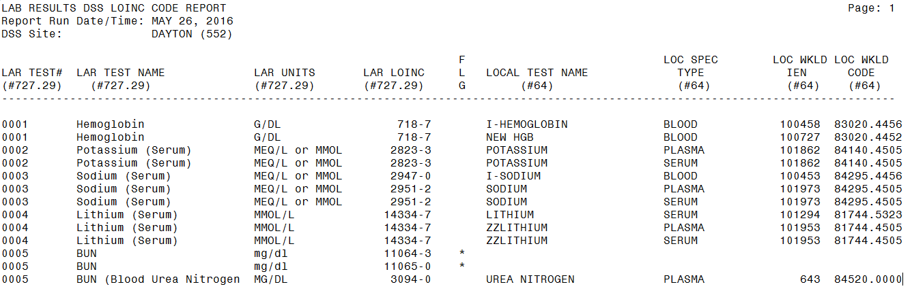

FLG ('*'=site not using LOINC code that DSS collects)

Guidance for capturing exported data into spreadsheets and the additional DSS application steps required to produce exportable versions of reports are located in Appendix F: Exporting a Report to a Spreadsheet.

The following example displays the report after it has been produced in an exportable format and imported into a spreadsheet:

1. Example: Exported Lab Results DSS LOINC CODE Report

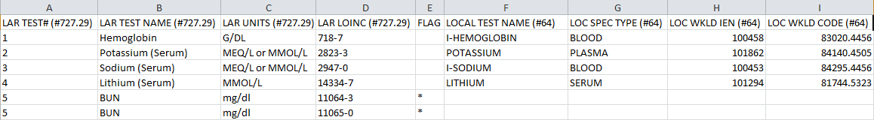

### Pharmacy

When the Pharmacy option is selected, from the Maintenance Menu, the following sub-menu and options are displayed.

1. Example: Pharmacy Options Menu

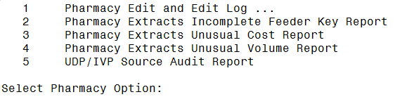

#### Pharmacy Volume Edit and Volume Edit Log

This option consists of Pharmacy Volume Edit and Pharmacy Volume Edit Log.

NOTE: The ECXPVE security key is required.

##### Pharmacy Volume Edit

This option allows authorized users to edit the Pharmacy Extracts (PRE, IVP, UDP and BCM). Corrections may be made to the:

* Quantity and Unit of Issue fields for PRE.
* Quantity and Total Doses per Day fields for IVP.
* Quantity field for UDP.
* Component Dose Given and Component Units fields for BCM.

1. The extract must be reran if changes are made after the extract is transmitted. Please contact the MCAO Customer Service Help Desk (CSHD).
2. If a patient’s SSN is entered and a question mark (?) is entered for the extract sequence number, only records including that patient’s SSN will appear in the results.

The following steps is an example of the Pharmacy Volume Edit, for making changes to the Quantity and Unit of Issue for a PRE extract:

Select Pharmacy Option: 1 Pharmacy Edit and Edit Log

1 Pharmacy Volume Edit

2 Pharmacy Volume Edit Log

Select Pharmacy Edit and Edit Log Option: 1 Pharmacy Volume

Edit

Select one of the following:

P PRE

I IVP

U UDP

B BCM

Enter response: PRE

Select PRE EXTRACT NUMBER: ?

Select from one of the following extract numbers:

If no numbers appear then there are no extracts that can

be edited.

4413

Select PRE EXTRACT NUMBER: 4413

Enter patient's SSN, if known, or press ENTER to continue: ??

Enter patient's SSN, if known. The SSN will be used to find sequence numbers

associated with this patient. Enter 9 digits or 9 digits and P, no

hyphens or spaces. Entry is optional.

Enter patient's SSN, if known, or press ENTER to continue:

Select PRE EXTRACT SEQUENCE NUMBER: ?

Select from one of the following sequence numbers:

SEQUENCE # SSN FILL DT QUANTITY UNIT OF ISSUE

----------------------------------------------------------------

10682344 XXXXXXXXX JAN 01, 2016 6 TAB

10682345 XXXXXXXXX JAN 01, 2016 20 CAP

10682346 XXXXXXXXX JAN 01, 2016 20 TAB

Select PRE EXTRACT SEQUENCE NUMBER: 10682344

QUANTITY: 6// 10

UNIT OF ISSUE: TAB// CAP

The following steps is an example of the Pharmacy Volume Edit, for making changes to the Quantity and Total Doses per Day, for an IVP extract:

Select Pharmacy Option: 1 Pharmacy Edit and Edit Log

1 Pharmacy Volume Edit

2 Pharmacy Volume Edit Log

Select Pharmacy Edit and Edit Log Option: 1 Pharmacy Volume

Edit

Select one of the following:

P PRE

I IVP

U UDP

B BCM

Enter response: IVP

Select IVP EXTRACT NUMBER: ?

Select from one of the following extract numbers:

If no numbers appear then there are no extracts that can

be edited.

2908

3570

Select IVP EXTRACT NUMBER: 3570

Enter patient's SSN, if known, or press ENTER to continue: ??

Enter patient's SSN, if known. The SSN will be used to find sequence numbers

associated with this patient. Enter 9 digits or 9 digits and P, no

hyphens or spaces. Entry is optional.

Enter patient's SSN, if known, or press ENTER to continue:

Select IVP EXTRACT SEQUENCE NUMBER: ?

Select from one of the following sequence numbers:

SEQUENCE # SSN DISPENS DT QUANTITY TOTAL DOSES/DAY

---------------------------------------------------------------

202327 XXXXXXXXX JAN 01, 2010 6 100 ML

202328 XXXXXXXXX JAN 01, 2010 20 1 GM

Select IVP EXTRACT SEQUENCE NUMBER: 202327

QUANTITY: 1// 2

TOTAL DOSES PER DAY: 100 ML// 150 ML

The following steps is an example of the Pharmacy Volume Edit, for making changes to the Quantity, for a UDP extract:

Select Pharmacy Option: 1 Pharmacy Edit and Edit Log

1 Pharmacy Volume Edit

2 Pharmacy Volume Edit Log

Select Pharmacy Edit and Edit Log Option: 1 Pharmacy Volume

Edit

Select one of the following:

P PRE

I IVP

U UDP

B BCM

Enter response: UDP

Select UDP EXTRACT NUMBER: ?

Select from one of the following extract numbers:

If no numbers appear then there are no extracts that can

be edited.

2024

2921

3581

Select UDP EXTRACT NUMBER: 3581

Enter patient's SSN, if known, or press ENTER to continue: ??

Enter patient's SSN, if known. The SSN will be used to find sequence numbers

associated with this patient. Enter 9 digits or 9 digits and P, no

hyphens or spaces. Entry is optional.

Enter patient's SSN, if known, or press ENTER to continue:

Select UDP EXTRACT SEQUENCE NUMBER: ?

Select from one of the following sequence numbers:

SEQUENCE # SSN DISPENS DT QUANTITY

------------------------------------------------

1364046 XXXXXXXXX JAN 01, 2010 1

1364047 XXXXXXXXX JAN 01, 2010 1

Select IVP EXTRACT SEQUENCE NUMBER: 1364046

QUANTITY: 1// 2

The following steps is an example of the Pharmacy Volume Edit, for making changes to the Component Dose Given, for a BCM extract:

Select Pharmacy Edit and Edit Log Option: pharmacy volume edit

Select one of the following:

P PRE

I IVP

U UDP

B BCM

Enter response: B BCM

Select BCM EXTRACT NUMBER: ?

Select from one of the following extract numbers:

If no numbers appear then there are no extracts that can

be edited.

5143

Select BCM EXTRACT NUMBER: 5143

Enter patient's SSN, if known, or press ENTER to continue: ??

Enter patient's SSN, if known. The SSN will be used to find sequence numbers

associated with this patient. Enter 9 digits or 9 digits and P, no

hyphens or spaces. Entry is optional.

Enter patient's SSN, if known, or press ENTER to continue:

Select BCM EXTRACT SEQUENCE NUMBER: ?

Select from one of the following sequence numbers:

SEQUENCE # SSN DISPENSE DT COMPONENT DOSE GIVEN COMPONENT UNITS

------------------------------------------------------------------------------

1323905 XXXXXXXXX MAR 26, 2016 1 1 drop

1323906 XXXXXXXXX MAR 26, 2016 1 TAB

1323907 XXXXXXXXX MAR 26, 2016 1 CAP,ORAL

Select BCM EXTRACT SEQUENCE NUMBER: 1323905

COMPONENT DOSE GIVEN: 1// 5

##### Pharmacy Volume Edit Log

All versions (PRE, IVP, UDP and BCM), of the Pharmacy Volume Edit Logs can only be produced in screen print format and require 132 columns for output.

The following steps produce a Pharmacy Volume Edit Log for PRE:

Select Pharmacy Edit and Edit Log Option: pharmacy volume edit log

This option prints a log of the changes made to the Pharmacy

Extracts: PRE, IVP, UDP or BCM

Select one of the following:

P PRE

I IVP

U UDP

B BCM

Which extract log do you need?: p PRE

Select one of the following:

1 USER NAME

2 DATE CHANGED

Select sort for Pharmacy Volume Edit Log: 1// USER NAME

** REPORT REQUIRES 132 COLUMNS TO PRINT CORRECTLY **

Starting with Date: 8/1/15 (AUG 01, 2015)

Ending with Date: 8/31/15 (AUG 30, 2015)

DEVICE: 0;132 HOME (CRT)

1. Example: Pharmacy Volume Edit Log for PRE Screen Print

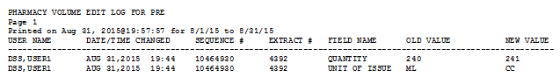

The following steps produce a Pharmacy Volume Edit Log for IVP:

Select Pharmacy Edit and Edit Log Option: pharmacy volume edit log

This option prints a log of the changes made to the Pharmacy

Extracts: PRE, IVP, UDP or BCM

Select one of the following:

P PRE

I IVP

U UDP

B BCM

Which extract log do you need?: i IVP

Select one of the following:

1 USER NAME

2 DATE CHANGED

Select sort for Pharmacy Volume Edit Log: 1// USER NAME

** REPORT REQUIRES 132 COLUMNS TO PRINT CORRECTLY **

Starting with Date: 10/20/2006 (OCT 20, 2006)

Ending with Date: 10/24/2006 (OCT 24, 2006)

DEVICE: 0;132 HOME (CRT)

1. Example: Pharmacy Volume Edit Log for IVP Screen Print

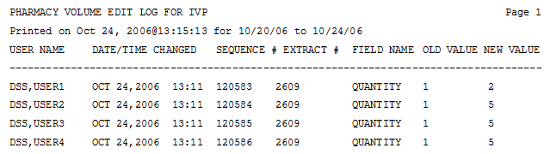

The following steps produce a Pharmacy Volume Edit Log for UDP:

Select Pharmacy Edit and Edit Log Option: pharmacy volume edit log

This option prints a log of the changes made to the Pharmacy

Extracts: PRE, IVP, UDP or BCM

Select one of the following:

P PRE

I IVP

U UDP

B BCM

Which extract log do you need?: u UDP

Select one of the following:

1 USER NAME

2 DATE CHANGED

Select sort for Pharmacy Volume Edit Log: 1// USER NAME

** REPORT REQUIRES 132 COLUMNS TO PRINT CORRECTLY **

Starting with Date: 8/1/15 (AUG 01, 2015)

Ending with Date: 8/31/15 (AUG 30, 2015)

DEVICE: 0;132 HOME (CRT)

1. Example: Pharmacy Volume Edit Log for UDP Screen Print

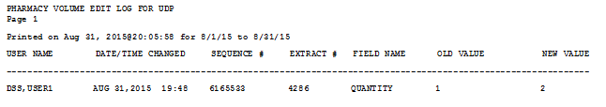

The following steps produce a Pharmacy Volume Edit Log for BCM:

Select Pharmacy Edit and Edit Log Option: pharmacy volume edit log

This option prints a log of the changes made to the Pharmacy

Extracts: PRE, IVP, UDP or BCM

Select one of the following:

P PRE

I IVP

U UDP

B BCM

Which extract log do you need?: b BCM

Select one of the following:

1 USER NAME

2 DATE CHANGED

Select sort for Pharmacy Volume Edit Log: 1// USER NAME

** REPORT REQUIRES 132 COLUMNS TO PRINT CORRECTLY **

Starting with Date: 8/1/15 (AUG 01, 2015)

Ending with Date: 8/31/15 (AUG 30, 2015)

DEVICE: 0;132 HOME (CRT)

1. Example: Pharmacy Volume Edit Log for BCM Screen Print

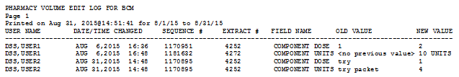

#### Pharmacy Extracts Incomplete Feeder Key Reports

There are three separate reports IVP, PRE and UPD generated for the Incomplete Feeder Key Reports. The IM/KM Reference Tool is a good source for field descriptions and overall report overview. This report is designed to generate, before the extract, for a specified date range and can be used as a tool to identify and fix DRUG file (#50) entries that have incomplete Feeder Keys. Only drugs that would be included, on the Extract, for the specified date range are listed on the report, for the Pharmacy Extract selected (PRE, IVP or UDP).

This report prints a listing of DRUG file (#50) entries that have incomplete Feeder Keys, based on one of the following conditions:

* No PSNDF VA Product Name Entry (first 5 digits are zero, but the National Drug Code (NDC) portion is valid.)
* No National Drug Code (NDC) (last 12 digits are zeros, ‘N/A’, or ‘S”). Indicates the PSNDF VA Product Name portion is valid, but either the last 12 characters of the Feeder Key are zero =OR= the NDC portion is prefaced with an 'S' (possibly indicating a supply item number or UPC) =OR= the NDC portion contains "N/A".
* No PSNDF VA Product Name Entry or NDC (all 17 digits are zero). Indicates both the PSNDF VA Product Name Entry portion =AND= the NDC portion of Feeder Key are invalid (as described above).

This report has no effect on the actual extracts and can be generated as needed. It is very useful, when generated as pre-extract validation, to identify and correct DRUG file (#50) entries that have incomplete Feeder Keys.

**ECXMGR Option name**: ECX PHA FKEY

**Selection Criteria and Pre-processing Information:**

The Pharmacy Extracts Incomplete Feeder Key Report prints a listing of DRUG file (#50) entries that would generate incomplete Feeder Keys, in the Pharmacy extracts: PRE, IVP or UDP. The user is prompted to select which report to generate: "1 PRE", "2 IVP" or "3 UDP". Select desired report.

The User is then prompted to enter the "Starting with Date:" After the start date of the report is selected, the User is then prompted to enter the "Ending with Date:" The end date of the report cannot be earlier than the start date of the report, and both must fall within the same month and year.

Finally, the User is asked whether or not the output should be placed in an exportable format, by selecting a response of "NO" (default) or "Y".

**Report Data:**

**Header Information:**

The report header, displays on every page of the report, and contains the following:

* "Prescription Extract Incomplete Feeder Key Report" (Title).
* Page: The page is a counter, incremented for each page of the report.
* Start Date: The source is the user-selected start date.
* End Date: The source is the user-selected end date.
* Report Run Date/Time: The source is the system date and time when the report was run.

Column headers - "Drug Entry", "Generic Name", "Feeder Key", "# of Records", "Total Quantity", "Unit Price" and "Total Cost".

**Detail Line:**

Section headers - each page displays one of the following:

* “No PSNDF VA Product Name Entry (Five leading zeros)”
* "No National Drug Code (NDC) (Last 12 zeros, 'N/A', or 'S' prefix)"
* "No PSNDF VA Product Name Entry or National Drug Code (NDC)"

All fields are contained on one 132-character line.

1. Incomplete Feeder Key Report Description

| Field Name | POS# | Description | Source |
| --- | --- | --- | --- |
| DRUG ENTRY | 0 | The Internal Entry Number (IEN) of the record (right-justified) is in the first column. | The source is the record's IEN in the DRUG file (#50). |
| GENERIC NAME | 8 | The generic name of the drug is in the second column. | The source is the DRUG file (#50), GENERIC NAME field (#.01). |
| FEEDER KEY | 60 | The Feeder Key is in the third column. The Feeder Key for the drug, which is the first 5 characters of the PSNDF VA PRODUCT NAME ENTRY field (#22) concatenated with the 12 characters NDC field (#31) from the DRUG file (#50). |  |
| NUMBER OF AFFECTED RECORDS | 79 | Computed - The number of Extract records that would contain this drug for the date range specified if the extract were run.  The number of affected records (right-justified) is in the fourth column. | The Number of Records field is computed, with the amount incremented by 1 for each record that has the same Feeder Key |
| Total Quantity Value | 87 | Computed The sum of the quantities of the drug from all of the Extract records.  The total quantity value for all affected records (right-justified) is in the fifth column.  This is the same as the QUANTITY field for the PRE and UDP Extracts.  For the IVP Extract the Total Quantity is the sum of the values taken from the ADDITIVE STRENGTH field (#7) or SOLUTION VOLUME field (#9) of the IV EXTRACT DATA file (#728.113).  Each record's quantity value is determined by the transaction type. When a drug is dispensed, the quantity is set to 1; if the transaction was cancelled, the quantity is set to zero; drugs that are destroyed or returned result in a quantity of -1. | The Total Quantity value is a computed field, with the quantities for all records having the same Feeder Key added together.  The total quantity is the sum of these values for all records that contain the Feeder Key displayed in the detail line. |
| Unit Price | 99 | The unit price (right-justified) is in the sixth column.  The value is calculated by multiplying the total doses per day by the average drug cost per unit.  For Additives, total doses per day is derived from the ADDITIVE STRENGTH field (#6) and the ADDITIVE STRENGTH UNITS field (#7) from the IV EXTRACT DATA file (#728.113).  For Solutions, total doses per day is derived from the SOLUTION VOLUME field (#8), recorded in MLs, from the IV EXTRACT DATA file (#728.113).  The average drug cost per unit comes from the AVERAGE DRUG COST PER UNIT field (#7) of the IV ADDITIVES file (#52.6). | The PRICE PER DISPENSE UNIT field (#16) from the DRUG file (#50) for the PRE and UDP Extracts.  For the IVP Extract Unit Price is the COST field (#12) of the IV EXTRACT DATA file (#728.113). |
| Total Cost | 117 | Computed The total cost of the drug for the Extract (Total Quantity x Unit Price).  The (right-justified) is in the last column.  It is calculated by multiplying the total quantity by the unit price.  The total cost displayed on the report represents the sum of costs for all records that have the Feeder Key shown | For all three Pharmacy Extracts, the Total Cost is the same as the sum of the COST field, from all Extract records containing the drug. |
| Total |  | The "Total" line displays the total cost for the section for the selected date range. | Each section displays a Total amount, representing the sum of the total costs for all records with that type of incomplete Feeder Key. |
| Grand Total |  | The "Grand Total" line displays the overall total cost for all records for the selected date range. | The Grand Total is the sum of the total costs for all records in the report. |

This report requires a 132-column output. The steps commonly used to produce all versions (PRE, IVP and UDP), of the report are as follows:

Select Pharmacy Option: Pharmacy Extracts Incomplete Feeder Key Report

This report prints a listing of Drug File (#50) entries that will generate incomplete Feeder keys in the three Pharmacy Extracts. This listing can be used to identify and fix Drug File entries. The number of extract records, total, quantity, unit price and total cost for each drug are included to aid in determining the impact of the incomplete Feeder Keys.

This report is broken into 3 sections as follows:

Section 1: No PSNDF VA Product Name Entry (first 5 digits are zero).

Section 2: No National Drug Code (NDC) (last 12 digits are zero) or the NDC is prefixed with an 'S', indicating possible supply item number or UPC.

Section 3: No PSNDF VA Product Name Entry, and

a. no NDC (all 17 digits are zero), or

b. The NDC is prefixed with an 'S', indicating possible supply item number or UPC.

Section 3: No PSNDF VA Product Name Entry or NDC.

Run times for this report will vary depending upon the size of the extract and could take as long as 30 minutes or more to complete. This report has no effect on the actual extracts and can be run as needed.

Choose the report you would like to run.

**Processing:**

All records in the UNIT DOSE EXTRACT DATA file (#728.904), within the selected date range are evaluated. Those with an invalid PSNDF VA Product Name (all zeroes) or invalid National Drug Code ("N/A", "S" prefix or all zeroes) undergo additional processing, preparing the records that will appear on the report.

**Exported Data:**

The data exported can subsequently be imported into a tool (e.g. Microsoft Excel), for additional manipulation and analysis. Section totals and grand totals are not included in the exported data.

##### PRE Extracts Incomplete Feeder Key Report

This report generates a listing of DRUG file (#50) entries that would generate incomplete Feeder Keys, in the PRE extract. This listing can be used to identify and correct DRUG file entries. The number of affected extract records, along with their unit price, total quantity and total cost, are included to aid in determining the impact of the incomplete Feeder Keys.

**Processing:**

All fill, refill and partial refill records, in the PRESCRIPTION file (#52) within the selected date range are evaluated. Records with an invalid PSNDF VA Product Name (all zeroes) or invalid National Drug Code ("N/A", "S" prefix or all zeroes) undergo additional processing, preparing the records that will appear on the report.

This report has no effect on the actual extracts and can be run as needed, but can be most useful when run pre-extract to identify and correct DRUG file (#50) entries that have incomplete Feeder Keys.

**Exported Data Format:**

Exported raw data appears in the following format:

 TYPE^DRUG ENTRY^GENERIC NAME^FEEDER KEY^NUMBER OF RECORDS^TOTAL QTY^UNIT PRICE^TOTAL COST^ERROR

Prescription^10132^INCONTINENCE UNDERGARMENT BLT KEN#171B10^00000090891030030^1^120^0.2823^33.88^No PSNDF VA Product Name Entry (Five leading zeros)

Prescription^11023^LIDO-DIPHEN-ALUM/MAG HYD SUSP 300ML^00000COUMPOUNDED000000^2^2^5.0000^10.00^No PSNDF VA Product Name Entry (Five leading zeros)

Prescription^12926^ADHESIVE, BODY ROLL-ON 'IT STAYS' LIQUID^00000003566412013^1^180^0.1198^21.56^No PSNDF VA Product Name Entry (Five leading zeros)

Prescription^11334^MED ORGANIZER 7DAY/4 SLOT APEX#70027^14472000000000000^1^1^2.8700^2.87^No National Drug Code (NDC) (Last 12 zeros, 'N/A', or 'S' prefix)

Prescription^11901^STRAP, LEG BAG BARD, LWRLG #162110^19531000000000000^1^1^5.6480^5.65^No National Drug Code (NDC) (Last 12 zeros, 'N/A', or 'S' prefix)

Prescription^12445^STRAP, LEG BAG BARD, MIDLG #162210/6345^19532000000000000^1^1^7.7700^7.77^No National Drug Code (NDC) (Last 12 zeros, 'N/A', or 'S' prefix)

Prescription^12537^OXYGEN 100%^07305000000000000^2^4^0.0000^0.00^No National Drug Code (NDC) (Last 12 zeros, 'N/A', or 'S' prefix)

Prescription^12638^CATHETER,SPEEDICATH 14FR CDE MALE #28494^22905000000000000^1^240^1.2000^288.00^No National Drug Code (NDC) (Last 12 zeros, 'N/A', or 'S' prefix)

Prescription^12813^UNDERWEAR PROTECT+ SUPR MED #MSC33005^16420000000000000^1^80^0.4846^38.77^No National Drug Code (NDC) (Last 12 zeros, 'N/A', or 'S' prefix)

Prescription^13231^CATHETER,SPEEDICATH 16FR MALE #284160^22908000000000000^2^240^0.9500^228.00^No National Drug Code (NDC) (Last 12 zeros, 'N/A', or 'S' prefix)

Prescription^13232^CATHETER,SPEEDICATH 14FR MALE #284140^22907000000000000^1^240^0.9500^228.00^No National Drug Code (NDC) (Last 12 zeros, 'N/A', or 'S' prefix)

Prescription^13393^UNDERWEAR PROTECT+ SUPR LRG #MSC33505^16421000000000000^2^144^0.5385^77.54^No National Drug Code (NDC) (Last 12 zeros, 'N/A', or 'S' prefix)

Prescription^13429^SECURING DEVICE, CATH STATLOCK #FOL0102^22473000000000000^2^3^2.8520^8.56^No National Drug Code (NDC) (Last 12 zeros, 'N/A', or 'S' prefix)

Prescription^13464^CATHETER,SPEEDICATH 12FR FEMALE #285120^20154000000000000^1^150^0.9500^142.50^No National Drug Code (NDC) (Last 12 zeros, 'N/A', or 'S' prefix)

Prescription^10534^URINARY EXTENSION TUBE/CNCT STRL R#46161^00000000000000000^1^5^0.3983^1.99^No PSNDF VA Product Name Entry or National Drug Code (NDC)

Prescription^12552^CATHETER,SUCTION SL 14FR 21IN #22705^00000000000000000^1^1^7.0350^7.04^No PSNDF VA Product Name Entry or National Drug Code (NDC)

Prescription^13432^SECURING DEVICE, CATH STATLOCK #PIC0220^00000000000000000^1^1^4.0376^4.04^No PSNDF VA Product Name Entry or National Drug Code (NDC)

Prescription^13875^INCONT PAD, SURE CARE SPR ABS #23246A^00000000000000000^3^252^0.3123^78.70^No PSNDF VA Product Name Entry or National Drug Code (NDC)

Prescription^14225^DRESSING,IV COVER 9X9IN AQUA GUARD^00000000000000000^1^28^1.8586^52.04^No PSNDF VA Product Name Entry or National Drug Code (NDC)

The steps to produce the PRE version of the report, in screen print format is as follows:

Select one of the following:

1 PRE

2 IVP

3 UDP

Selection: 1// 1 PRE

Enter the date range for which you would like to scan the Prescription

Extract records.

Starting with Date: 3/1 (MAR 01, 2014)

Ending with Date: 3/3 (MAR 03, 2014)

Do you want the output in exportable format? NO// n NO

This report requires 132 column format.

DEVICE: HOME// 0;132 HOME (CRT)

1. Example: PRE Extracts Incomplete Feeder Key Report Screen Print

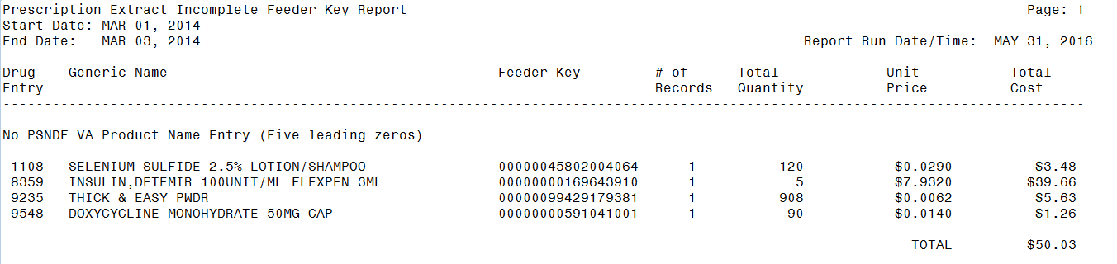

1. Example: PRE Header

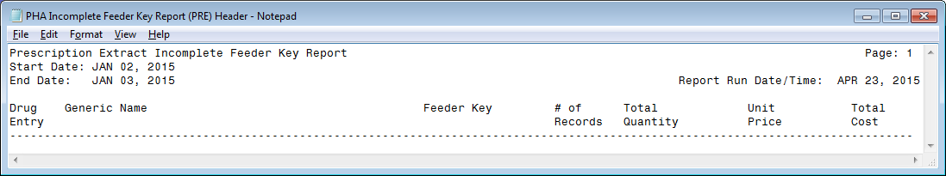

1. Example: PRE Detail-1

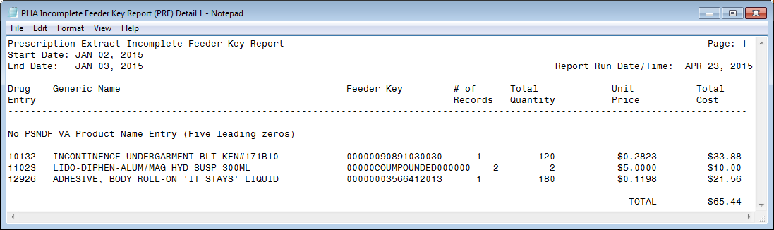

1. Example: PRE Detail-2

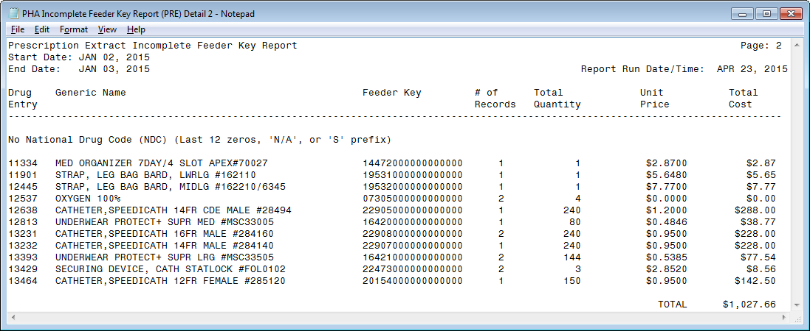

1. Example: PRE Detail-3

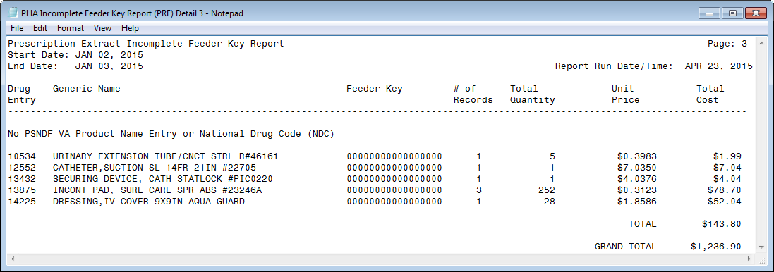

Guidance for capturing exported data into spreadsheets and the additional DSS application steps required to produce exportable versions of reports is located in Appendix F: Exporting a Report to a Spreadsheet.

The following example displays the report, after it has been produced in an exportable format and imported into a spreadsheet:

1. Example: Exported PRE Extracts Incomplete Feeder Key Report

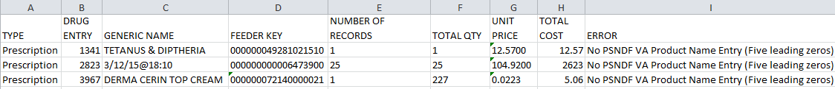

##### IVP Extracts Incomplete Feeder Key Report

This report prints a listing of DRUG file (#50) entries that would generate incomplete Feeder Keys in the IVP extract. This listing can be used to identify and correct DRUG file entries. The number of affected extract records, along with their unit price, total quantity and total cost, are included to aid in determining the impact of the incomplete Feeder Keys.

This report has no effect on the actual extracts and can be generated as needed, but can be most useful, when run pre-extract to identify and correct DRUG file (#50) entries that have incomplete Feeder Keys.

**Report Data:**

**Header Information:**

1. Incomplete Feeder Key Report (IVP) Header

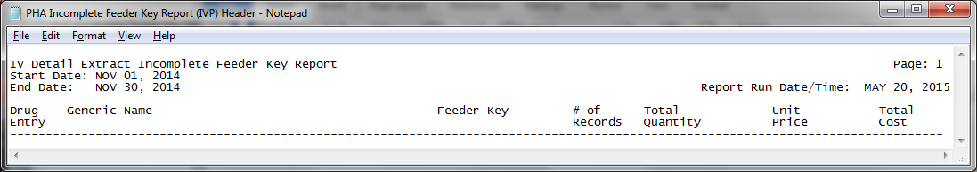

1. Incomplete Feeder Key Report (IVP) – Detail-1

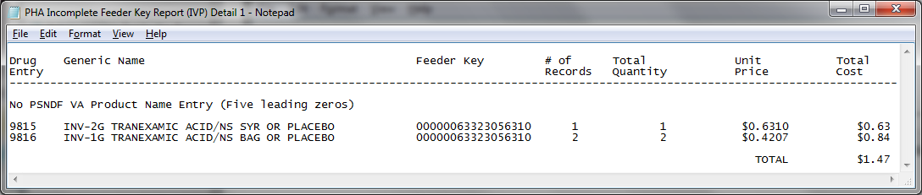

1. Incomplete Feeder Key Report (IVP) – Detail-2

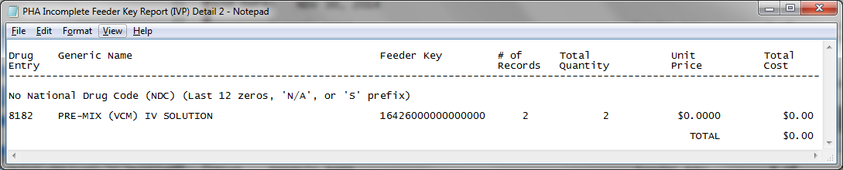

1. Incomplete Feeder Key Report (IVP) – Detail-3

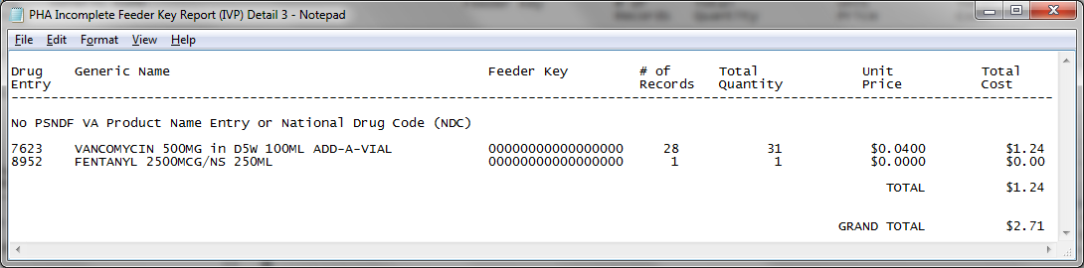

**Exported Data Format:**

Exported raw data appears in the following format:

TYPE^DRUG ENTRY^GENERIC NAME^FEEDER KEY^NUMBER OF RECORDS^TOTAL QTY^UNIT PRICE^TOTAL COST^ERROR

IV DETAIL^9815^INV-2G TRANEXAMIC ACID/NS SYR OR PLACEBO^00000063323056310^1^1^0.6310^0.63^No PSNDF VA Product Name Entry (Five leading zeros)

IV DETAIL^9816^INV-1G TRANEXAMIC ACID/NS BAG OR PLACEBO^00000063323056310^2^2^0.4207^0.84^No PSNDF VA Product Name Entry (Five leading zeros)

IV DETAIL^8182^PRE-MIX (VCM) IV SOLUTION^16426000000000000^2^2^0.0000^0.00^No National Drug Code (NDC) (Last 12 zeros, 'N/A', or 'S' prefix)

IV DETAIL^7623^VANCOMYCIN 500MG in D5W 100ML ADD-A-VIAL^00000000000000000^28^31^0.0400^1.24^No PSNDF VA Product Name Entry or National Drug Code (NDC)

IV DETAIL^8952^FENTANYL 2500MCG/NS 250ML^00000000000000000^1^1^0.0000^0.00^No PSNDF VA Product Name Entry or National Drug Code (NDC)

**Notes/Logic:**

**ECXMGR Option name**: ECX PHA FKEY

**Processing:**

All records, in the IV EXTRACT DATA file (#728.113), within the selected date range are evaluated. Additional processing is performed for records with an invalid PSNDF VA Product Name (all zeroes) or invalid National Drug Code ("N/A", "S" prefix or all zeroes), to prepare the records to appear on the appropriate report.

The steps to produce the IVP version, of the report in screen print format is as follows:

Choose the report you would like to run.

Select one of the following:

1 PRE

2 IVP

3 UDP

Selection: 1// 2 IVP

Enter the date range for which you would like to scan the IV Detail

Extract records.

Starting with Date: 3/1 (MAR 01, 2014)

Ending with Date: 3/3 (MAR 03, 2014)

Do you want the output in exportable format? NO// n NO

This report requires 132 column format.

DEVICE: HOME// 0;132 HOME (CRT)

1. Example: IVP Extracts Incomplete Feeder Key Report Screen Print

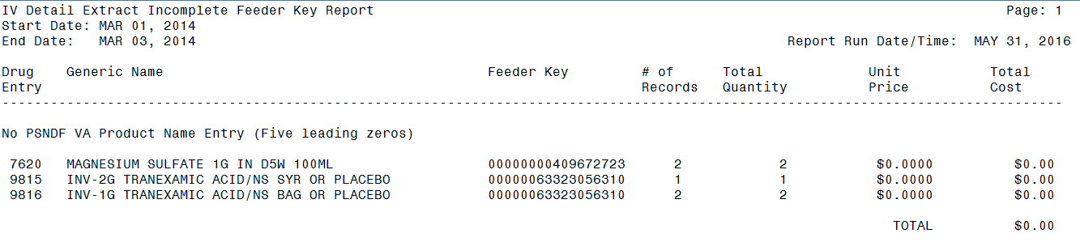

1. Example: IVP Header



1. Example: IVP Detail-1



1. Example: IVP Detail-2



1. Example: IVP Detail-3



Guidance for capturing exported data into spreadsheets and the additional DSS application steps required to produce exportable versions of reports is located in Appendix F: Exporting a Report to a Spreadsheet.

The following example displays the report, after it has been produced in an exportable format and imported into a spreadsheet:

1. Example: Exported IVP Extracts Incomplete Feeder Key Report



##### UDP Extracts Incomplete Feeder Key Report

This report prints a listing of DRUG file (#50) entries that would generate incomplete Feeder Keys in the UDP extract. This listing can be used to identify and correct DRUG file entries. The number of affected extract records, along with their unit price, total quantity and total cost, are included to aid in determining the impact of the incomplete Feeder Keys.

**Exported Data Format:**

Exported raw data is formatted as follows:

TYPE^DRUG ENTRY^GENERIC NAME^FEEDER KEY^NUMBER OF RECORDS^TOTAL QTY^UNIT PRICE^TOTAL COST^ERROR

Unit Dose Local^2929^CMP-HC 0.5% CRM/MICONAZ 2% CRM 1:1^00000000000000326^1^60^0.0400^2.40^No PSNDF VA Product Name Entry (Five leading zeros)

Unit Dose Local^5204^CMP-LIDOCAINE VISC/MAALOX 1:3^00000000000000167^1^1^0.0400^0.04^No PSNDF VA Product Name Entry (Five leading zeros)

Unit Dose Local^2139^METOPROLOL TARTR 12.5MG (1/2 X 25MG) TAB^16581000000000000^31^65^0.0120^0.78^No National Drug Code (NDC) (Last 12 zeros, 'N/A', or 'S' prefix)

Unit Dose Local^4284^TETRABENAZINE 25MG TAB^19956000000000000^65^160^2.0000^320.00^No National Drug Code (NDC) (Last 12 zeros, 'N/A', or 'S' prefix)

Unit Dose Local^94366^FUROSEMIDE 10MG (1/2 X 20MG) TAB^01784000000000000^42^98^0.0029^0.28^No National Drug Code (NDC) (Last 12 zeros, 'N/A', or 'S' prefix)

Unit Dose Local^94378^WARFARIN 3.75MG (1/2x7.5) TAB^04653000000000000^1^1^0.1527^0.15^No National Drug Code (NDC) (Last 12 zeros, 'N/A', or 'S' prefix)

Unit Dose Local^94393^TRAZODONE HCL  25MG (1/2 X 50MG) TAB^06132000000000000^20^23^0.0600^1.38^No National Drug Code (NDC) (Last 12 zeros, 'N/A', or 'S' prefix)

Unit Dose Local^94318^NEW DRUG ENTRY #1^00000000000000000^2^3^12.0510^36.15^No PSNDF VA Product Name Entry or National Drug Code (NDC)

**Processing:**

All records in the UNIT DOSE EXTRACT DATA file (#728.904) within the selected date range are evaluated. Records with an invalid PSNDF VA Product Name (all zeroes) or invalid National Drug Code ("N/A", "S" prefix or all zeroes) undergo additional processing, preparing the records that will appear on the report.

The steps to produce the UDP version of the report, in screen print format is as follows:

Choose the report you would like to run.

Select one of the following:

1 PRE

2 IVP

3 UDP

Selection: 1// 3 UDP

Enter the date range for which you would like to scan the Unit Dose Local

Extract records.

Starting with Date: 3/1 (MAR 01, 2014)

Ending with Date: 3/5 (MAR 05, 2014)

Do you want the output in exportable format? NO// n NO

This report requires 132 column format.

DEVICE: HOME// 0;132 HOME (CRT)

1. Example: UDP Extracts Incomplete Feeder Key Report Screen Print

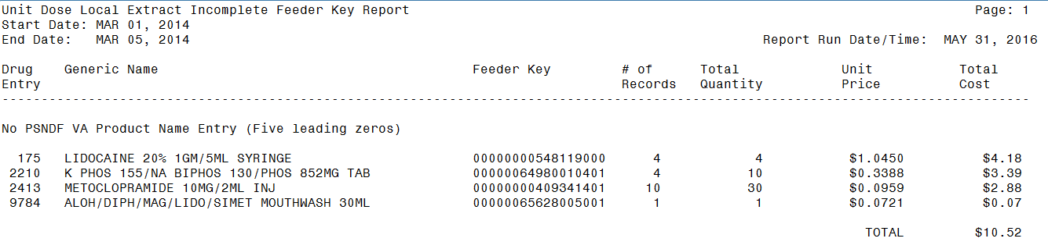

Guidance for capturing exported data into spreadsheets and the additional DSS application steps required to produce exportable versions of reports is located in Appendix F: Exporting a Report to a Spreadsheet.

1. Example: UDP Header

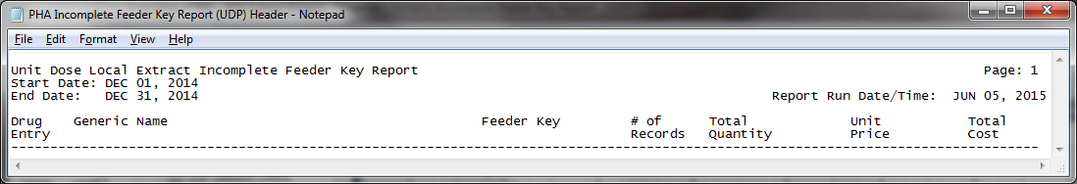

1. Example: UDP-Detail-1

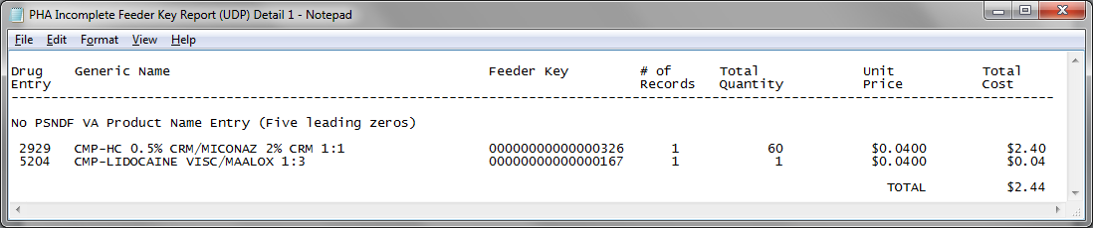

1. Example: UDP-Detail-2

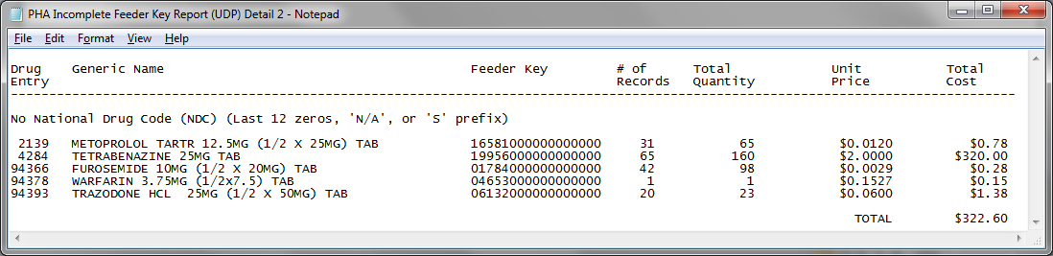

1. Example: UDP-Detail-3

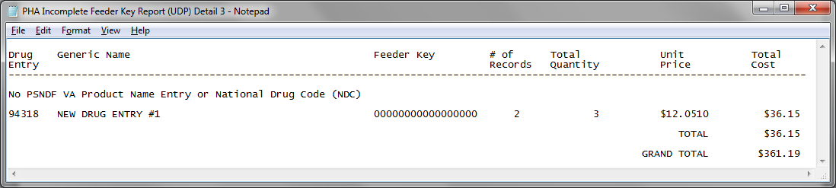

The following example displays the report after it has been produced in an exportable format and imported into a spreadsheet:

1. Example: Exported UDP Extracts Incomplete Feeder Key Report

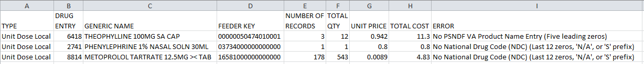

#### Pharmacy Extracts Unusual Cost Report

Users with the ECXMGR Security Key can export data, for all reports, under the Pharmacy Extracts Unusual Cost Report option, into an external spreadsheet. Users also have the option to view the report on the screen.

This report requires a 132-column output. The following steps are used to producing all versions (PRE, IVP and UDP), of the report are as follows:

This report prints a listing of unusual costs that would be generated by the pharmacy extracts (PRE, IVP, and UDP) as determined by a user defined threshold value. It should be run prior to the generation of the actual extract(s) to identify and fix as necessary any costs determined to be erroneous.

Note: The threshold can be set after a report is selected.

Run times for this report will vary depending upon the size of the extract and could take as long as 30 minutes or more to complete. This report has no effect on the actual extracts and can be run as needed.

The report is sorted by Feeder Key, Descending Cost, and SSN.

Enter RETURN to continue or '^' to exit:

Choose the report you would like to run.

##### PRE Unusual Cost Report

The steps to produce the PRE version of the report in screen print format are as follows:

Select one of the following:

1 PRE

2 IVP

3 UDP

Selection: 1// PRE

The default threshold cost for the Prescription extract is $50.

Would you like to change the threshold? NO// y YES

Enter the new threshold cost: (0-100000): 500

Enter the date range for which you would like to scan the Prescription

Extract records.

Starting with Date: 2/1/13 (FEB 01, 2013)

Ending with Date: 2/15/13 (FEB 15, 2013)

Do you want the output in exportable format? NO// n NO

This report requires 132 column format.

DEVICE: HOME// 0;132 HOME (CRT)

1. Example: PRE Unusual Cost Report Screen Print

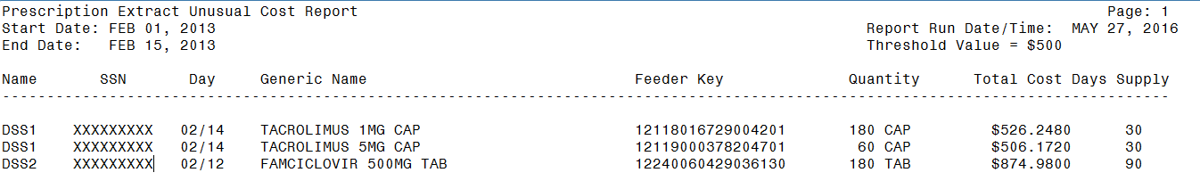

Guidance for capturing exported data into spreadsheets and the additional DSS application steps required to produce exportable versions of reports is located in Appendix F: Exporting a Report to a Spreadsheet.

The following example shows the report, after it has been produced in an exportable format and imported into a spreadsheet:

1. Example: Exported PRE Unusual Cost Report

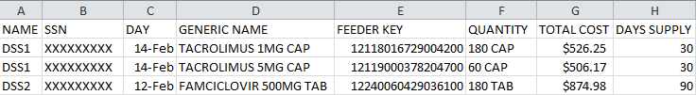

##### IVP Unusual Cost Report

The steps to produce the IVP version of the report, in screen print format are as follows:

Select one of the following:

1 PRE

2 IVP

3 UDP

Selection: 1// 2 IVP

The default threshold cost for the IV Detail extract is $100.

Would you like to change the threshold? NO// y YES

Enter the new threshold cost: (0-100000): 500

Enter the date range for which you would like to scan the IV Detail

Extract records.

Starting with Date: 2/1/13 (FEB 01, 2013)

Ending with Date: 2/10/13 (FEB 10, 2013)

Do you want the output in exportable format? NO// n NO

This report requires 132 column format.

DEVICE: HOME// 0;132 HOME (CRT)

1. Example: IVP Unusual Cost Report Screen Print

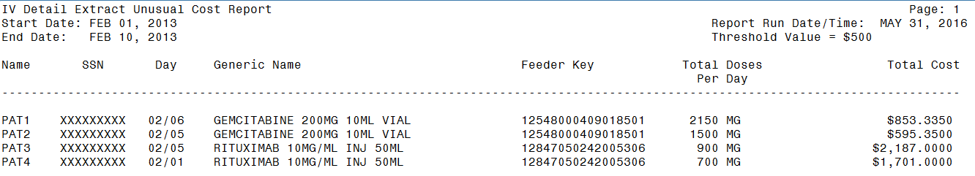

Guidance for capturing exported data into spreadsheets and the additional DSS application steps required to produce exportable versions of reports is located in Appendix F: Exporting a Report to a Spreadsheet.

The following example shows the report after it has been produced in an exportable format and imported into a spreadsheet:

1. Example: Exported IVP Unusual Cost Report

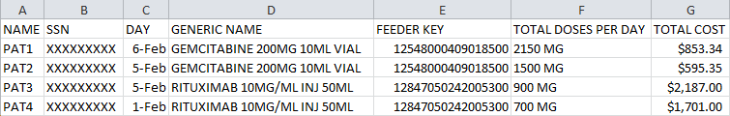

##### UDP Unusual Cost Report

NOTE: Users can choose to add the SIG/Order Directions on the second line of this report. SIG/Order Direction information is produced by combining Prescription Unit Dose and Schedule information. This field assists pharmacists that are responsible for audits to distinguish dispensing errors.

The steps to produce the UDP version of the report, with SIG directions in screen print format are as follows:

Choose the report you would like to run.

Select one of the following:

1 PRE

2 IVP

3 UDP

Selection: 1// 3 UDP

The default threshold cost for the Unit Dose Local extract is $20.

Would you like to change the threshold? NO// y YES

Enter the new threshold cost: (0-100000): 500

Include SIG/Order Direction on line 2 of report? NO// y YES

Enter the date range for which you would like to scan the Unit Dose Local

Extract records.

Starting with Date: 2/1/13 (FEB 01, 2013)

Ending with Date: 2/10/13 (FEB 10, 2013)

Do you want the output in exportable format? NO// n NO

This report requires 132 column format.

DEVICE: HOME// 0;132 HOME (CRT)

1. Example: UDP Unusual Cost Report with SIG/Order Directions Added Screen Print

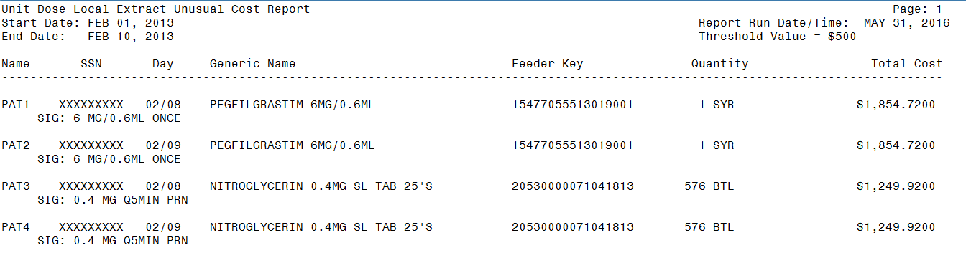

Guidance for capturing exported data into spreadsheets and the additional DSS application steps required to produce exportable versions of reports is located in Appendix F: Exporting a Report to a Spreadsheet.

The following example displays the report, after it has been produced in an exportable format and imported into a spreadsheet:

1. Example: Exported UDP Unusual Cost Report with SIG/Order Directions Added

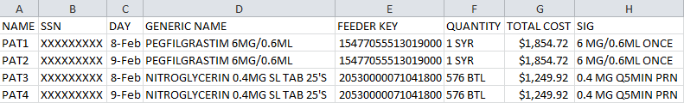

The steps to produce the UDP version of the report, without SIG directions in screen print format are as follows:

Choose the report you would like to run.

Select one of the following:

1 PRE

2 IVP

3 UDP

Selection: 1// 3 UDP

The default threshold cost for the Unit Dose Local extract is $20.

Would you like to change the threshold? NO// y YES

Enter the new threshold cost: (0-100000): 500

Include SIG/Order Direction on line 2 of report? NO// n NO

Enter the date range for which you would like to scan the Unit Dose Local

Extract records.

Starting with Date: 2/1/13 (FEB 01, 2013)

Ending with Date: 2/10/13 (FEB 10, 2013)

Do you want the output in exportable format? NO// n NO

This report requires 132 column format.

DEVICE: HOME// 0;132 HOME (CRT)

1. Example: UDP Unusual Cost Report without SIG/Order Directions Added Screen Print

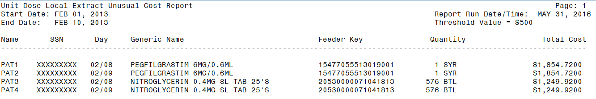

Guidance for capturing exported data into spreadsheets and the additional DSS application steps required to produce exportable versions of reports is located in Appendix F: Exporting a Report to a Spreadsheet.

The following example shows the report, after it has been produced in an exportable format and imported into a spreadsheet:

1. Example: Exported UDP Unusual Cost Report without SIG/Order Directions Added

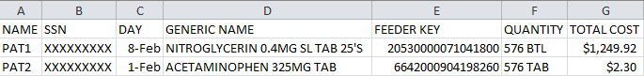

#### Pharmacy Extracts Unusual Volume Report

This report requires a 132-column output. The following steps are used to produce all versions (PRE, IVP, UDP and BCM), of the report:

This report prints a listing of unusual volumes that would be generated by the pharmacy extracts (PRE, IVP, UDP and BCM) as determined by a user defined threshold value. It should be run prior to the generation of the actual extract(s) to identify and fix as necessary any volumes determined to be erroneous.

Unusual volumes are defined as follows:

PRE Extract: Quantity field greater than the threshold value.

IVP Extract: Total Doses Per Day field greater than the threshold

or less than the negative of the threshold value.

UDP Extract: Quantity field greater than threshold value.

BCM Extract: Component Dose Given field greater than threshold value.

Note: The threshold can be set after a report is selected.

Run times for this report will vary depending upon the size of the extract and could take as long as 30 minutes or more to complete. This report has no effect on the actual extracts and can be run as needed.

The report is sorted by Feeder Key, Descending Volume, and SSN.

Enter RETURN to continue or '^' to exit: **<RET>**

Choose the report you would like to run.

##### PRE Unusual Volume Report

The steps to produce the PRE version, of the report in screen print format are as follows:

Select one of the following:

1 PRE

2 IVP

3 UDP

4 BCM

Selection: 1// 1 PRE

The default threshold volume for the Prescription extract is 500.

Would you like to change the threshold? NO// y YES

Quantity > threshold

Enter the new threshold volume: (0-100000): 500

Enter the date range for which you would like to scan the Prescription

Extract records.

Starting with Date: 01012002 (JAN 01, 2002)

Ending with Date: 01312002 (JAN 31, 2002)

Do you want the output in exportable format? NO// n NO

This report requires 132 column format.

DEVICE: HOME// 0;132 HOME (CRT)

1. Example: PRE Extract Unusual Volume Report Screen Print

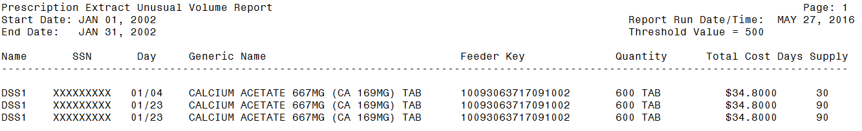

Guidance for capturing exported data into spreadsheets and the additional DSS application steps required to produce exportable versions of reports is located in Appendix F: Exporting a Report to a Spreadsheet.

The following example displays the report, after it has been produced in an exportable format and imported into a spreadsheet:

1. Example: Export PRE Extract Unusual Volume Report

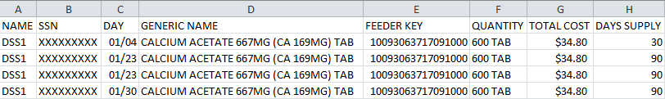

##### 

##### IVP Unusual Volume Report

The steps to produce the IVP version of the report, in screen print format are as follows:

Select one of the following:

1 PRE

2 IVP

3 UDP

4 BCM

Selection: 1// 2 IVP

The default threshold volume for the IV Detail extract is 1000.

Would you like to change the threshold? NO// y YES

threshold > Total Doses Per Day < -threshold

Enter the new threshold volume: (0-100000): 20

Enter the date range for which you would like to scan the IV Detail

Extract records.

Starting with Date: 02012012 (FEB 01, 2012)

Ending with Date: 02292012 (FEB 29, 2012)

Do you want the output in exportable format? NO// n NO

This report requires 132 column format.

DEVICE: HOME// 0;132 HOME (CRT)

1. Example: IV Detail Extract Unusual Volume Report Screen Print

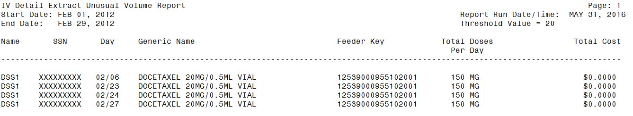

Guidance for capturing exported data into spreadsheets and the additional DSS application steps required to produce exportable versions of reports is located in Appendix F: Exporting a Report to a Spreadsheet.

The following example shows the report, after it has been produced in an exportable format and imported into a spreadsheet:

1. Example: Exported IV Detail Extract Unusual Volume Report

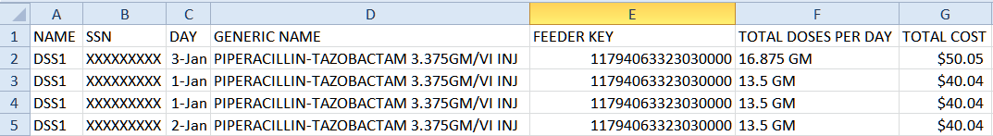

NOTE: The Total Cost column displays 4 decimal places and is calculated by multiplying the Average Drug Cost per Unit by the Total Doses per Day.

##### UDP Unusual Volume Report

NOTE: Users can choose to add the SIG/Order Directions on the second line of this report. SIG/Order Direction information is produced by combining Prescription Unit Dose and Schedule information. This field assists pharmacists that are responsible for audits to distinguish dispensing errors.

The steps to produce the UDP version of the report, with Sig/Order directions in screen print format are as follows:

Select one of the following:

1 PRE

2 IVP

3 UDP

Selection: 1// **3** UDP

The default threshold volume for the Unit Dose Local extract is 500.

Would you like to change the threshold? NO// **Y** YES

Quantity > threshold

Enter the new threshold volume: (0-100000): **20**

Include SIG/Order Direction on line 2 of report? NO// y **YES**

Enter the date range for which you would like to scan the Unit Dose Local

Extract records.

Starting with Date: February 1, 2012 (FEB 01, 2012)

Ending with Date: February 29, 2012 (FEB 29, 2012)

Do you want the output in exportable format? NO// n NO

This report requires 132 column format.

DEVICE: HOME// 0;132 HOME (CRT)

1. Example: UDP Detail Extract Unusual Volume Report with SIG/Order Directions Added Screen Print

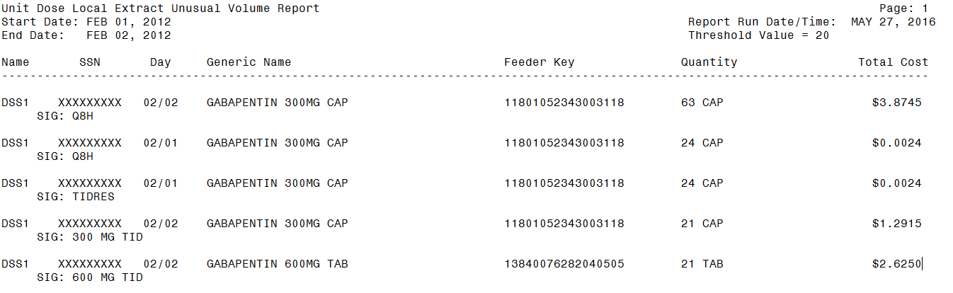

Guidance for capturing exported data into spreadsheets and the additional DSS application steps required to produce exportable versions of reports is located in Appendix F: Exporting a Report to a Spreadsheet.

The following example shows the report, after it has been produced in an exportable format and imported into a spreadsheet:

1. Example: Exported UDP Detail Extract Unusual Volume Report with SIG/Order Directions Added

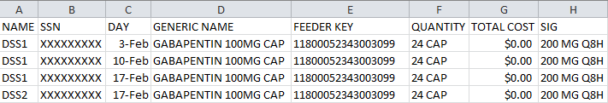

An example of the UDP Detail Extract Unusual Volume Report, without SIG/Order Directions added displayed on screen below:

Select one of the following:

1 PRE

2 IVP

3 UDP

Selection: 1// **3** UDP

The default threshold volume for the Unit Dose Local extract is 500.

Would you like to change the threshold? NO// **Y** YES

Quantity > threshold

Enter the new threshold volume: (0-100000): **20**

Include SIG/Order Direction on line 2 of report? NO// n **NO**

Enter the date range for which you would like to scan the Unit Dose Local

Extract records.

Starting with Date: February 1, 2012 (FEB 01, 2012)

Ending with Date: February 29, 2012 (FEB 29, 2012)

Do you want the output in exportable format? NO// n NO

This report requires 132 column format.

DEVICE: HOME// 0;132 HOME (CRT)

1. Example: UDP Detail Extract Unusual Volume Report without SIG/Order Directions Added Screen Print

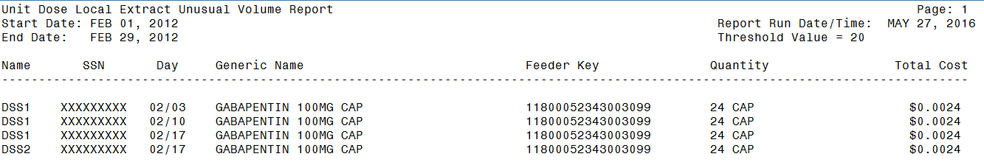

Guidance for capturing exported data into spreadsheets and the additional DSS application steps required to produce exportable versions of reports is located in Appendix F: Exporting a Report to a Spreadsheet.

The following example shows the report, after it has been produced in an exportable format and imported into a spreadsheet:

1. Example: Exported UDP Detail Extract Unusual Volume Report without SIG/Order Directions Added

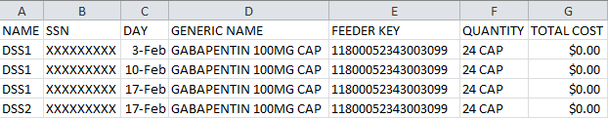

##### BCM Unusual Volume Report

The steps to produce the BCM Non-IV version of the report, in screen print format are as follows:

NOTE: Users can choose to add the SIG/Order Directions, on the second line of this report. SIG/Order Direction information is produced by combining Prescription Unit Dose and Schedule information. This field assists pharmacists responsible for audits to distinguish dispensing errors.

Select one of the following:

1 PRE

2 IVP

3 UDP

4 BCM

Selection: 1// 4 BCM

Select one of the following:

I IV

N NON-IV

Select type of BCM record: N

The default threshold volume for the BCM-NON IV Entries extract is 5.

Would you like to change the threshold? NO// n NO

Include SIG/Order Direction on line 2 of report? NO// y YES

Enter the date range for which you would like to scan the BCM-NON IV Entries

Extract records.

Starting with Date: 02012013 (FEB 01, 2013)

Ending with Date: 02282013 (FEB 28, 2013)

Do you want the output in exportable format? NO// N NO

1. Example: BCM Detail Extract Unusual Volume Report without SIG/Order Directions Added Screen Print (IV)

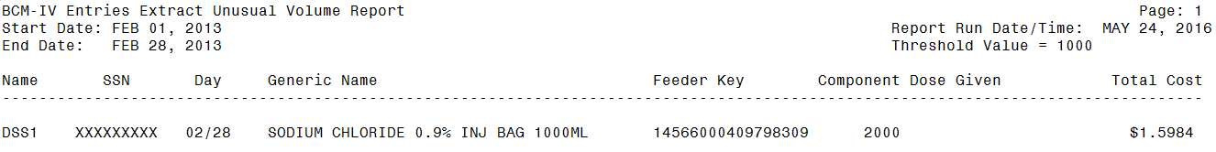

Guidance for capturing exported data into spreadsheets and the additional DSS application steps required to produce exportable versions of reports is located in Appendix F: Exporting a Report to a Spreadsheet.

The following example shows the report, after it has been produced in an exportable format and imported into a spreadsheet:

1. Example: Exported BCM Detail Extract Unusual Volume Report without SIG/Order Directions Added (IV)

Spreadsheet includes Name, SSN, Day, Generic Name, Feeder Key, Component Dose Given and Total Cost.

1. Example: BCM Detail Extract Unusual Volume Report with SIG/Order Directions Added Screen Print (Non-IV)

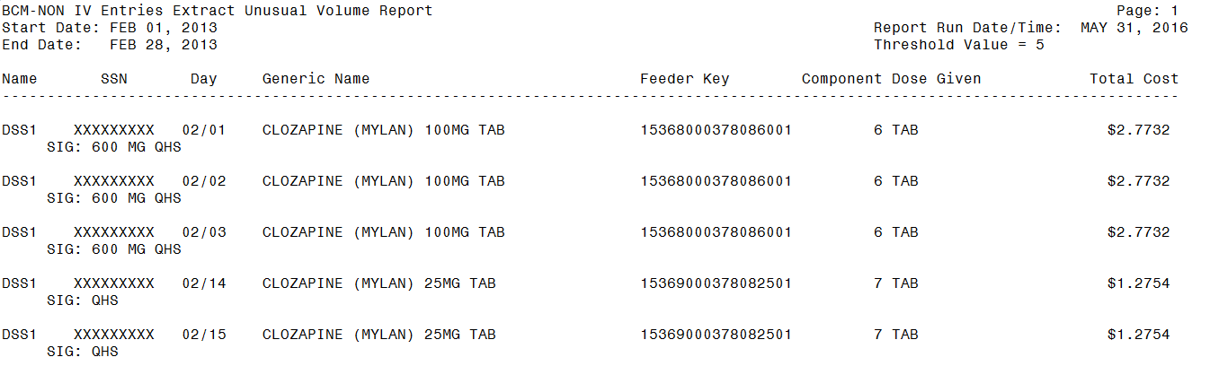

Guidance for capturing exported data into spreadsheets and the additional DSS application steps required to produce exportable versions of reports is located in Appendix F: Exporting a Report to a Spreadsheet.

The following example shows the report, after it has been produced in an exportable format and imported into a spreadsheet:

1. Example: Exported BCM Detail Extract Unusual Volume Report with SIG/Order Directions Added (Non-IV)

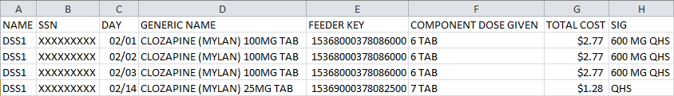

The steps to produce the BCM IV version of the report in screen print format are as follows:

NOTE: This report does not have an option to include SIG/Order directions.

Select one of the following:

I IV

N NON-IV

Select type of BCM record: i IV

The default threshold volume for the BCM-IV Entries extract is 1000.

Would you like to change the threshold? NO//

Enter the date range for which you would like to scan the BCM-IV Entries

Extract records.

Starting with Date: 2/1/13 (FEB 01, 2013)

Ending with Date: 2/28/13 (FEB 28, 2013)

Do you want the output in exportable format? NO//

This report requires 132-column format.

DEVICE: HOME// 0;132 HOME (CRT)

#### UDP/IVP Source Audit Report

The UDP/IVP Source Audit Reports provide a record count, for each Division and Date combination chosen. The reports extract data, from the UDP and IVP Intermediate source files, within the DSS name space: UNIT DOSE EXTRACT DATA file (#728.904) and the IV EXTRACT DATA file (#728.113).

The steps to produce the UDP version of the report are as follows:

Select Pharmacy Option: 5 UDP/IVP Source Audit Report

Select one of the following:

1 UDP

2 IVP

Select Source Audit Report: 1 UDP

Select division: ALL//

Enter Report Start Date: May 24, 2016// 4/1/06 (APR 01, 2006)

Enter Report End Date: May 24, 2016// 4/30/06 (APR 30, 2006)

Do you want the output in exportable format? NO//

DEVICE: HOME// 0;132 HOME (CRT)

1. Example: UDP Source Audit Report Screen Print

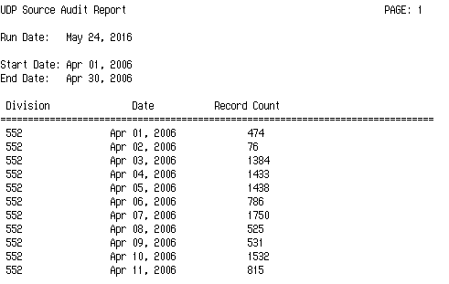

Guidance for capturing exported data into spreadsheets and the additional DSS application steps required to produce exportable versions of reports is located in Appendix F: Exporting a Report to a Spreadsheet.

The following example displays the report, after it has been produced in an exportable format and imported into a spreadsheet:

1. Example: Exported UDP Source Audit Report

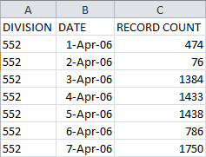

The steps to produce the IVP version of the report are as follows:

Select Pharmacy Option: 5 UDP/IVP Source Audit Report

Select one of the following:

1 UDP

2 IVP

Select Source Audit Report: 2 IVP

Select division: ALL//

Enter Report Start Date: May 31, 2016// 3/1/06 (MAR 01, 2006)

Enter Report End Date: May 31, 2016// 3/31/06 (MAR 31, 2006)

Do you want the output in exportable format? NO//

DEVICE: HOME// 0;132 HOME (CRT)

1. Example: IVP Source Audit Report Screen Print

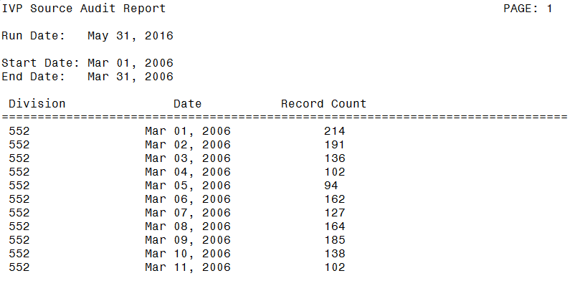

Guidance for capturing exported data into spreadsheets and the additional DSS application steps required to produce exportable versions of reports is located in Appendix F: Exporting a Report to a Spreadsheet.

The following example displays the report, after it has been produced in an exportable format and imported into a spreadsheet:

1. Example: Exported IVP Source Audit Report

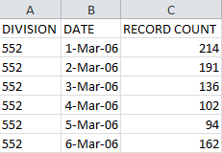

### Print Feeder Keys

Refer to Appendix D: Feeder Key Transmission for information about Feeder Key Transmission.

This option is used to print a list of Feeder Keys, for a selected individual feeder system or a range of feeder systems. For some feeder systems, the user is prompted to select the sort method (old or new). All feeder systems prompt for a device. The output varies, depending on the version of National Drug File (NDF) utilized at the users’ site.

The steps to produce the PRO version of the report are as follows:

Select Maintenance Option: 8 Print Feeder Keys

Do you want the output in exportable format? NO//

Print list of Feeder Keys:

Select : 1. CLI

2. ECS

3. LAB

4. PHA

5. RAD

6. SUR

7. PRO

Enter a list or range of numbers (1-7): 7

DEVICE: 0;132 HOME (CRT)

1. Example: Print Feeder Keys Screen Print

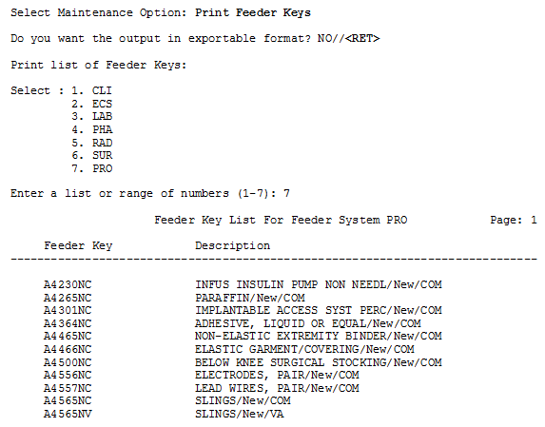

Guidance for capturing exported data into spreadsheets and the additional DSS application steps required to produce exportable versions of reports is located in Appendix F: Exporting a Report to a Spreadsheet.

The following example displays the report, after it has been produced in an exportable format and imported into a spreadsheet:

1. Example: Exported Print Feeder Keys - PRO

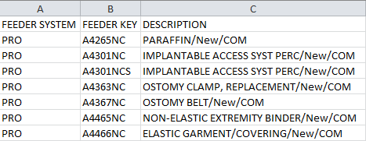

### Print Feeder Locations

Use this option to print a list of feeder locations, for all feeder systems. The output is sorted by feeder location, within each feeder system. This report should be generated (queue to print), during non-peak hours, due to of its length. The only prompt is for a device.

The steps to produce the PRO version of the report are as follows:

Select Maintenance Option: 9 Print Feeder Locations

Do you want the output in exportable format? NO//

DEVICE: 0;132 HOME (CRT)

1. Example: Print List of Feeder Locations Screen Print

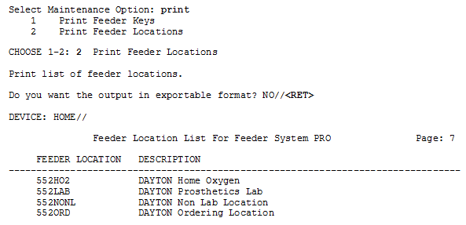

Guidance for capturing exported data into spreadsheets and the additional DSS application steps required to produce exportable versions of reports is located in Appendix F: Exporting a Report to a Spreadsheet.

The following example shows the report, after it has been produced in an exportable format and imported into a spreadsheet:

1. Example: Exported Print List of Feeder Locations

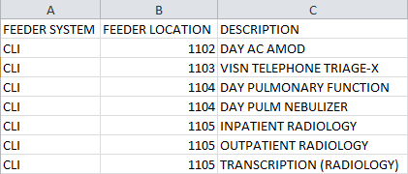

### Prosthetics

When the Prosthetics option is selected, from the Maintenance Menu, the following sub-menu and options will display:

1. Example: Prosthetics Menu Options

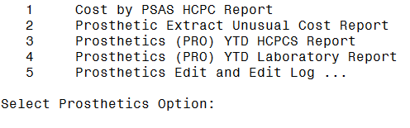

#### Cost by PSAS HCPC Report

This menu option creates the Cost by Prosthetic and Sensory Aids Service (PSAS) Healthcare Common Procedure Coding (HCPC) Report. This report includes PSAS HCPC coded expenditures, for a specified time frame.

The Cost by PSAS HCPC Report consists of the following fields:

* PSAS HCPC
* Feeder Key
* Description *(Free text field of 64 characters)*
* Form
* Form Description *(included in the exported version only)*
* QTY
* Unit of issue
* Cost
* Grand Total (not included in the exported version)

The steps to produce the report are as follows:

Select Prosthetics Option: 1 Cost by PSAS HCPC Report

Enter Report Start Date: 3/1/15 (MAR 01, 2015)

Enter Report Ending Date: (3/15/2015 - 6/29/2016): 3/15/15 (MAR 15, 2015)

Do you want the output in exportable format? NO// n NO

** REPORT REQUIRES 132 COLUMNS TO PRINT CORRECTLY **

DEVICE: HOME// 0;132 HOME (CRT)

1. Example: Cost by PSAS HCPC Report Screen Print

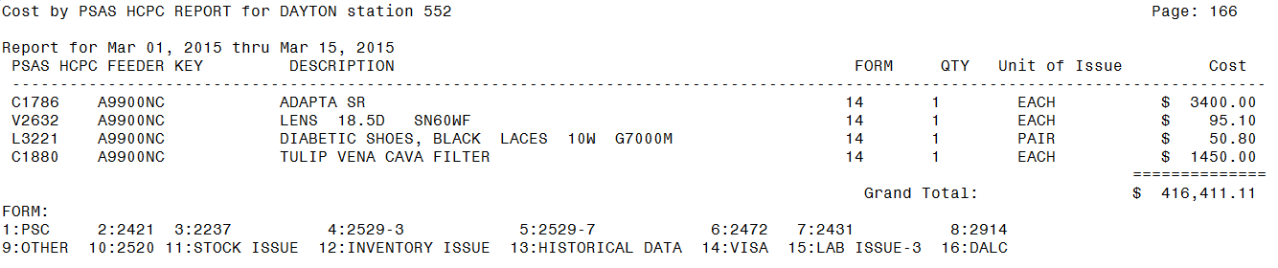

Guidance for capturing exported data into spreadsheets and the additional DSS application steps required to produce exportable versions of reports is located in Appendix F: Exporting a Report to a Spreadsheet.

The following example shows the report, after it has been produced in an exportable format and imported into a spreadsheet:

1. Example: Exported Cost by PSAS HCPC Report

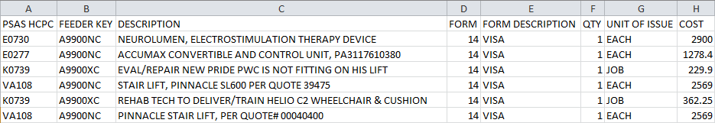

#### Prosthetic Extracts Unusual Cost Report

The steps to produce the report are as follows:

Select Prosthetics Option: Prosthetic Extract Unusual Cost Report

This report prints a listing of unusual costs that would be

generated by the Prosthetic extract (PRO) as determined by a

user-defined threshold value. It should be run prior to the

generation of the actual extract(s) to identify and fix, as

necessary, any costs determined to be erroneous.

Unusual costs are those where the Cost of Transaction is

greater than the threshold value.

Note: The threshold can be set after a report is selected.

Run times for this report will vary depending upon the size of

the extract and could take as long as 30 minutes or more to

complete. This report has no effect on the actual extracts and

can be run as needed.

The report is sorted by Feeder Key, then by descending Cost of

Transaction and SSN.

**NOTE: The feeder key on this report will match what appears in DSS.

However, the feeder key on the report will be different than the feeder

key on the PRO extract.

Enter RETURN to continue or '^' to exit:

The default threshold cost for the Prosthetic extract is $500.00.

Would you like to change the threshold?? NO// n NO

Enter the date range for which you would like to scan the Prosthetic

Extract records.

Starting with Date: 2/1/13 (FEB 01, 2013)

Ending with Date: 2/8/13 (FEB 08, 2013)

Do you want the output in exportable format? NO// n NO

This report requires 132-column format.

DEVICE: HOME// 0;132 HOME (CRT)

1. Example: PRO Extracts Unusual Cost Report Screen Print

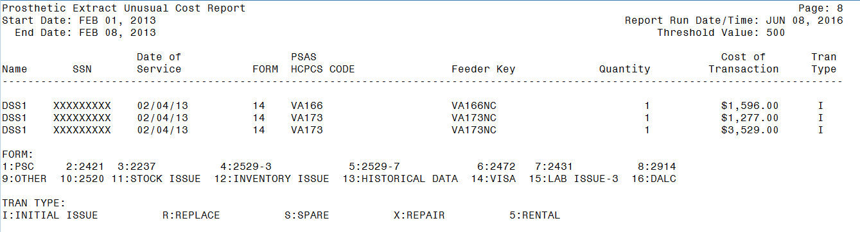

Guidance for capturing exported data into spreadsheets and the additional DSS application steps required to produce exportable versions of reports is located in Appendix F: Exporting a Report to a Spreadsheet.

The following example shows the report, after it has been produced in an exportable format and imported into a spreadsheet:

1. Example: Export PRO Extracts Unusual Cost Report

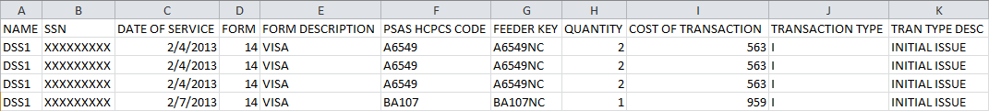

#### Prosthetics (PRO) YTD HCPCS Report

The Prosthetics YTD HCPCS Report displays data, from Prosthetics extracts, from the beginning of the fiscal year to the ending date of the last extract. Data, from the current or previous fiscal year, may also be selected for the report. The report is divided into three sections: New (i.e., Initial, Replacement or Spare items), Repairs and Rentals.

Multidivisional Prosthetics Sites must specify the Primary Prosthetics Division, for the report. Users may choose to generate a specific report, for one division or a combined report for all divisions. The report is sorted by PSAS HCPCS Code. A print device capable of displaying a 132-character line is required for output.

Setup for PRO Extract YTD HCPCS Report --

If you belong to more than one Primary Division, you must

select a Primary Division for the report.

Example of prompts to the user if the user needs to select a division.


Select C(urrent) or P(revious) Fiscal Year: CURRENT// c CURRENT

Do you want the output in exportable format? NO// n NO

Please note: The PRO Extract YTD HCPCS Report requires 132 columns.

Select an appropriate device for output.

DEVICE: HOME// 0;132 HOME (CRT)

1. Example: PRO Extract YTD HCPCS Report Screen Print

New Prosthetics Activities Section

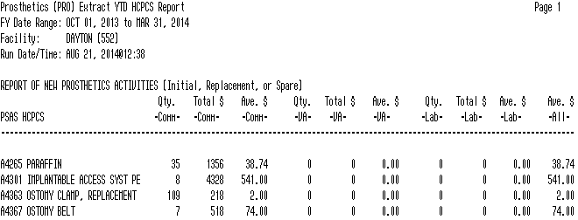

Repair Prosthetics Activities Section

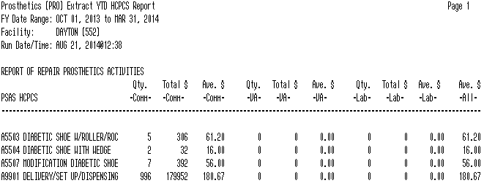

Rental Prosthetics Activities Section

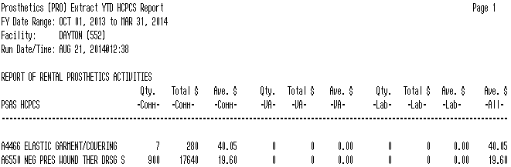

Guidance for capturing exported data into spreadsheets and the additional DSS application steps required to produce exportable versions of reports is located in Appendix F: Exporting a Report to a Spreadsheet.

The following example shows the report, after it has been produced in an exportable format and imported into a spreadsheet:

1. Example: Exported PRO Extract YTD HCPCS Report

Spreadsheet includes Report Type, PSAS HCPCS, Ouantity Com, Total Com, Average Com, Quantity VA, Total VA, Average VA, Quantity LAB, Total LAB, Averagae LAB and All Average.


#### Prosthetics (PRO) YTD Laboratory Report

The Prosthetics YTD Laboratory Report displays data, from the Prosthetics extracts, from the beginning of the fiscal year to the ending date of the last extract. Its intended users are sites with on-site prosthetics laboratories. Data from the current or previous fiscal year may be selected for the report. The report is divided into three sections: New (i.e., Initial, Replacement, or Spare items), Repairs and Rentals. Multidivisional Prosthetics Sites must specify the Primary Prosthetics Division, for the report.

The report is sorted by PSAS HCPCS Code. It shows quantity, labor and material costs, for items, within each PSAS HCPCS Code. Two sets of totals are displayed on each line: totals for items produced for use at the local site and totals for items produced for other VA stations.

NOTE: The data for the example below only include sections for New and Repair Prosthetics Activities.

The steps to produce the report are as follows:

Select Prosthetics Option: Prosthetics (PRO) YTD Laboratory Report

Setup for PRO Extract YTD Laboratory Report --

If you belong to more than one Primary Division, you must

select a Primary Division for the report.

Select C(urrent) or P(revious) Fiscal Year: CURRENT// c CURRENT

Do you want the output in exportable format? NO//

Please note: The PRO Extract YTD Laboratory Report requires 132 columns.

Select an appropriate device for output.

DEVICE: HOME// 0;132 HOME (CRT)

1. Example: PRO Extract YTD Laboratory Report Screen Print

New Prosthetics Activities Section

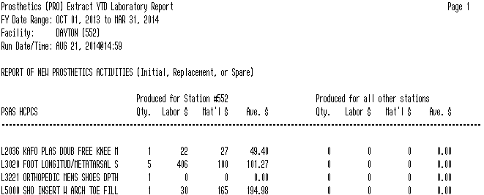

Repair Prosthetics Activities Section

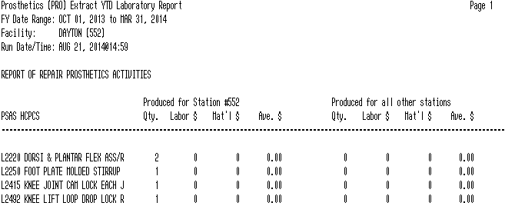

Guidance for capturing exported data into spreadsheets and the additional DSS application steps required to produce exportable versions of reports are located in Appendix F: Exporting a Report to a Spreadsheet.

The following example shows the report, after it has been produced in an exportable format and imported into a spreadsheet:

1. Example: Exported PRO Extract YTD Laboratory Report



#### Prosthetics Edit and Edit Log

This option consists of Prosthetics Edit and Prosthetics Edit Log.

1. Example: Prosthetics Edit and Edit Log Menu Options

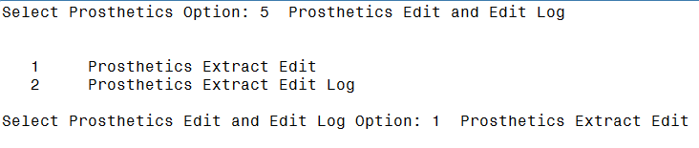

##### Prosthetics Edit

This option allows authorized users to edit Quantity information in the Prosthetics Extracts.

NOTE: The extract must be rerun if changes are made, after the extract is transmitted. Please contact the MCAO Customer Service Help Desk (CSHD).

NOTE: If a patient’s SSN is entered and a question mark (?) is entered, for the extract sequence number, only records with the patient’s SSN will appear in the results.

The following steps displays an example of the Prosthetics Edit for making changes to the Quantity for a PRO extract:

Select Prosthetics Edit and Edit Log Option: 1 Prosthetics Extract Edit

Select PRO EXTRACT NUMBER: ?

Select from one of the following extract numbers:

If no numbers appear then there are no extracts that can

be edited.

4403

4414

4474

Select PRO EXTRACT NUMBER: 4403

Enter patient's SSN, if known, or press ENTER to continue:

Select PRO EXTRACT SEQUENCE NUMBER: ?

Select from one of the following sequence numbers:

SEQUENCE # SSN DELIVERY DATE QUANTITY

------------------------------------------------

731062 XXXXXXXXX JAN 03, 2016 99

731063 XXXXXXXXX JAN 03, 2016 1

731064 XXXXXXXXX JAN 03, 2016 2

731065 XXXXXXXXX JAN 03, 2016 4

731066 XXXXXXXXX JAN 03, 2016 2

Enter RETURN to continue or '^' to exit: ^

SEQUENCE # SSN DELIVERY DATE QUANTITY

------------------------------------------------

Select PRO EXTRACT SEQUENCE NUMBER: 731062

QUANTITY: 99// 98

##### Prosthetics Edit Log

The Prosthetics Extracts Edit Log is only produced in screen print format and requires 132 columns for output.

The following steps produce a Prosthetics Edit Log:

Select Prosthetics Edit and Edit Log Option: 2 Prosthetics Extract Edit Log

This option prints a log of the changes made to the Prosthetics

Extracts.

Select one of the following:

1 USER NAME

2 DATE CHANGED

Select sort for Prosthetics Extract Edit Log: 1// 1 USER NAME

** REPORT REQUIRES 132 COLUMNS TO PRINT CORRECTLY **

Starting with Date: 6/1/16 (JUN 01, 2016)

Ending with Date: 6/1/16 (JUN 01, 2016)

DEVICE: 0;132 HOME (CRT)

1. Example: Prosthetics Extracts Edit Log Screen Print



### Setup for DSS Clinic Information

When the Setup for DSS Clinic Information option is selected, from the Maintenance Menu, the following sub-menu and options will display.

1. Example: DSS Clinic Information Menu Options

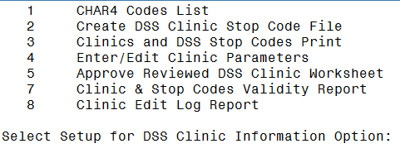

#### CHAR4 Codes List

Use this option to print a list of the CHAR4 codes, with short descriptions, from the NATIONAL CLINIC file (#728.441). The only prompt is for a device. The output generated by this option, may be used as a reference guide, when using the following options:

* 2 Create DSS Clinic Stop Code File
* 3 Clinics and DSS Stop Codes Print
* 4 Enter/Edit Clinic Parameters
* 5 Approve Reviewed DSS Clinic Worksheet

1. Example: CHAR4 Codes List Screen Print

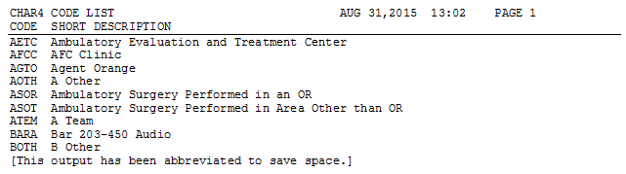

Guidance for capturing exported data into spreadsheets and the additional DSS application steps required to produce exportable versions of reports is located in Appendix F: Exporting a Report to a Spreadsheet.

The following example shows the report, after it has been produced in an exportable format and imported into a spreadsheet:

1. Example: Exported CHAR4 Codes List

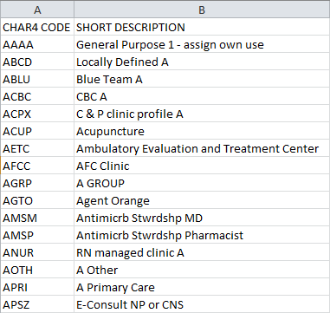

#### Create DSS Clinic Stop Code File

Users have the option of scheduling this report to run immediately or at a later time to add new clinics, created by the Patient Information Management System (PIMS).

Running this option does not affect existing data, in the CLINICS AND STOP CODES file (#728.44). This file includes the RECORD LAST SYNCHED field that identifies the last date the Create DSS Clinic Stop Code File option ran.

It is recommended this option should be utilized on a monthly basis, prior to generating the Clinic Visit Extract.

Use this option to create local entries, in the CLINICS AND STOP CODES file (#728.44).

To run this option without queueing:

Select Setup for DSS Clinic Information Option: **2** Create DSS Clinic Stop Code File

This option creates local entries in the DSS CLINIC AND STOP CODES

file (#728.44).

The CREATE option last ran on 5/10/16.

Run the CREATE option? (N)ow or (Q)ueue for a future date/time: N

Running CREATE.

The CREATE option has completed on May 20, 2016@15:10:24.

Proceed to DSS Clinic and Stop Code Print menu? NO// n

To queue this option to run at a later time (see the screen shot text for assistance with entering valid Requested Start Time entries):

Select Setup for DSS Clinic Information Option: **2** Create DSS Clinic Stop Code File

This option creates local entries in the DSS CLINIC AND STOP CODES

file (#728.44).

The CREATE option last ran on 5/10/16.

Run the CREATE option? (N)ow or (Q)ueue for a future date/time: q

Requested Start Time: NOW//?

Examples of Valid Dates:

JAN 20 1957 or 20 JAN 57 or 1/20/57 or 012057

T (for TODAY), T+1 (for TOMORROW), T+2, T+7, etc.

T-1 (for YESTERDAY), T-3W (for 3 WEEKS AGO), etc.

If the year is omitted, the computer uses CURRENT YEAR. Two digit year

assumes no more than 20 years in the future, or 80 years in the past.

If only the time is entered, the current date is assumed.

Follow the date with a time, such as JAN 20@10, T@10AM, 10:30, etc.

You may enter a time, such as NOON, MIDNIGHT or NOW.

You may enter NOW+3' (for current date and time Plus 3 minutes

*Note--the Apostrophe following the number of minutes)

Seconds may be entered as 10:30:30 or 103030AM.

Time is REQUIRED in this response.

Enter a date which is greater than or equal to NOW.

Requested Start Time: NOW//NOW+1 (MAY 21, 2016@15:22:32)

Task queued [71481]

The software uses the following logic to create entries, in the CLINICS AND STOP CODES file (#728.44).

##### New Clinic Entries

The software searches the HOSPITAL LOCATION file (#44) for all clinics. It does not create entries for clinics that are currently inactive.

New clinic entries are added to the CLINICS AND STOP CODES file (#728.44), with the following field defaults.

1. New Clinic Entry Field Defaults

| Field # | Field Name | Default value |
| --- | --- | --- |
| 1 | STOP CODE | STOP CODE NUMBER field (#8) in the HOSPITAL LOCATION file (#44) |
| 2 | CREDIT STOP CODE | CREDIT STOP CODE field (#2503) in HOSPITAL LOCATION file (#44) |
| 3 | DSS STOP CODE | STOP CODE NUMBER field (#8) in HOSPITAL LOCATION file (#44) |
| 4 | DSS CREDIT STOP CODE | CREDIT STOP CODE field (#2503) in HOSPITAL LOCATION file (#44) |
| 5 | ACTION TO SEND | 5: SEND STOP CODE(S) WITHOUT CHAR4 CODE  (If Clinic is not a Non-Count Clinic)  6: DO NOT SEND (If Clinic is a Non-Count Clinic) |

##### Existing Clinic Entries

All preexisting clinics are checked against their counterparts, in the HOSPITAL LOCATION file (#44) to ensure the STOP CODE field (#1), in the CLINICS AND STOP CODES file (#728.44) matches the STOP CODE NUMBER field (#8), in the HOSPITAL LOCATION file (#44). The same validation check is performed, on the CREDIT STOP CODE field (#2) to ensure it matches the CREDIT STOP CODE field (#2503), in the HOSPITAL LOCATION file (#44).

Any preexisting clinic currently marked as inactive, in the HOSPITAL LOCATION file (#44), is flagged as inactive, in the CLINICS AND STOP CODES file (#728.44). This inactive indicator is displayed as an asterisk (*), beside the clinic name, on the worksheet generated, by the *Clinics and DSS Stop Codes Print* option. Inactive clinics may still have valid past data for DSS.

Any Stop Code changes, to preexisting clinics, deletes the “Last Approved” date, in the CLINICS AND STOP CODES file (#728.44). This ensures the edited clinics print out, as “Unreviewed” the next time the Clinic Worksheet is generated, using the *Clinics and DSS Stop Codes Print* option.

#### Clinics and DSS Stop Codes Print

Use this option to produce the Worksheet, for DSS Clinic Stops showing one of the following:

* All Clinics
* Active Clinics
* Duplicate Clinics
* All Inactive Clinics
* Unreviewed Clinics

1. A clinic is reported as “Unreviewed” if it is newly established or if there is a change to the Stop Code/Credit Stop, Count/Non-Count clinic status or Active/Inactive clinic status.

The columns included on the exported spreadsheets are:

* Internal Entry Number (IEN) (Not in Duplicate Clinics export)
* Clinic (Followed by * if inactive. “Clinic Name” on Duplicate Clinics export)
* Clinic IEN (On Duplicate Clinics export only)
* Stop Code
* Credit Stop Code
* Action (Not in Duplicate Clinics export)
* Last Approved Date (Not in Duplicate Clinics export)
* CHAR4 Code
* Inact Date (Not in Duplicate Clinics export)
* React Date (Not in Duplicate Clinics export)
* Clinic Type (Not in Duplicate Clinics export)
* App Len (“Clinic Appointment Length” in Duplicate Clinics export)
* Div (“Division” in Duplicate Clinics export)

1. The following fields are not included in the Duplicate Clinics export:

* App Type
* Non Cnt
* Occasion of Service (OOS)
* OOS Calling Pkg
* Var Length Appt
* DSS Prod Dept
* DSS Unit ID

Columns listed on the Worksheet for DSS Clinic Stops, printed from the screen, include:

* Last approved date
* Print Date
* Clinic *(Followed by * if inactive. Field name is “Clinic Name” on Duplicate Clinic List screen)*
* Clinic IEN *(On Duplicate Clinic List screen only)*
* Stop Code
* Credit Stop Code
* Action *(Not on Duplicate Clinic List screen)*
* CHAR4 Code
* Clinic Appt Length *(On Duplicate Clinic List screen only)*
* Div *(On Duplicate Clinic List screen only)*
* C/N
* DSS Product Department
* DSS Unit Identifier

Column “C / N”, on the printed report, and column “Non Cnt”, on the Export report, captures changes to the Clinic’s Count / Non Count status. Values displayed, in the column are “C”, for Count or “N”, for Non-Count, on the printed report; and “YES” or “NO”, on the exported report.

Inactive clinics have an asterisk “*” after the clinic’s name, on the printed reports only. On the exported reports, the date the clinic was placed in inactive status is displayed.

NOTE: If an inactive clinic was reactivated the reactivation date is shown.

The steps to produce the report are as follows:

Select Setup for DSS Clinic Information Option: 3 Clinics and DSS Stop Codes Print

This option produces a worksheet of (A) All Clinics, (C) Active, (D) Duplicate,

(I) Inactive, or only the (U) Unreviewed Clinics that are awaiting approval.

Clinics that were defined as "inactive" by MAS the last time the option

"Create DSS Clinic Stop Code File" was run will be indicated with an "*".

Choose (X) for exporting the CLINICS AND STOP CODES FILE to a text file for

spreadsheet use.

**REMINDER - The CREATE option last ran on 8/28/13.

If the most recent clinic changes from the HOSPITAL LOCATION file #44

are desired, run the CREATE option before running a report.**

Select one of the following:

A ALL CLINICS

C ALL ACTIVE CLINICS

D DUPLICATE CLINICS

I ALL INACTIVE CLINICS

U UNREVIEWED CLINICS

X EXPORT TO TEXT FILE FOR SPREADSHEET USE

Enter "A", "C", "D", "I", "U", or "X":

Example: All Clinics Option Screen Print

1. Example: All Clinics Option Screen Print

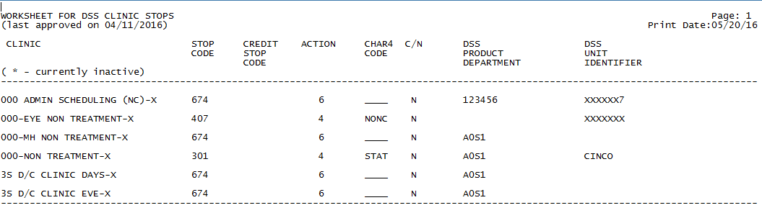

Example: Active Clinics Option Screen Print

1. Example: Active Clinics Option Screen Print

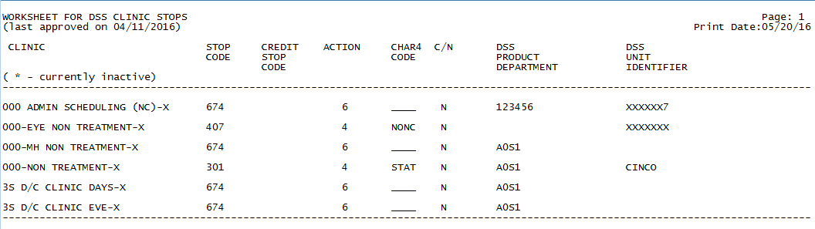

Example: Duplicate Clinics Option Screen Print

1. Example: Duplicate Clinics Option Screen Print

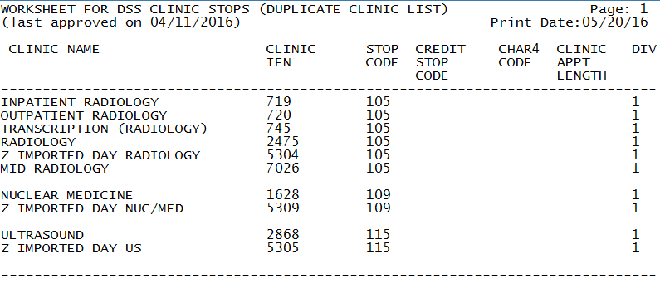

Example: Inactive Clinics Option Screen Print

1. Example: Inactive Clinics Option Screen Print

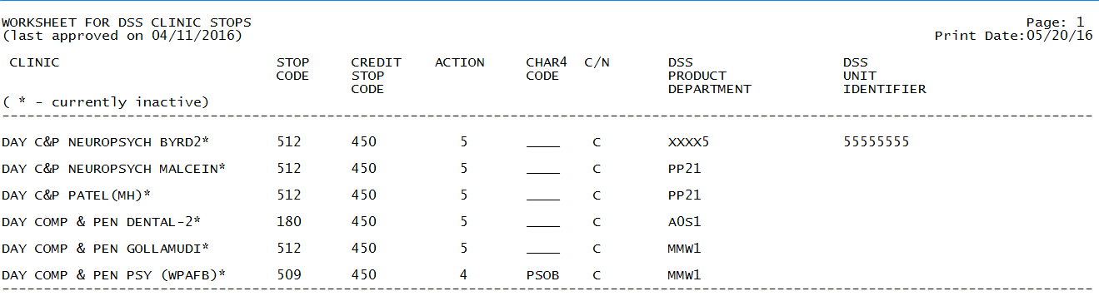

##### Example: Unreviewed Clinics Option Screen Print

1. Example: Unreviewed Clinics Option Screen Print

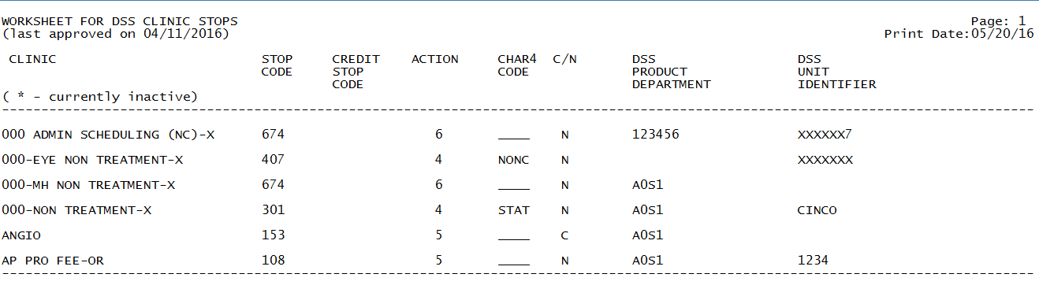

##### Example: Export to Text File for Spreadsheet Use Option

The steps to produce exportable versions of these reports are as follows:

Select Setup for DSS Clinic Information Option: Clinics and DSS Stop Codes Print

Choose (X) for exporting the CLINICS AND STOP CODES FILE to a text file for

spreadsheet use.

Select one of the following:

A ALL CLINICS

C ALL ACTIVE CLINICS

D DUPLICATE CLINICS

I ALL INACTIVE CLINICS

U UNREVIEWED CLINICS

X EXPORT TO TEXT FILE FOR SPREADSHEET USE

Enter "A", "C", "D", "I", "U", or "X": X EXPORT TO TEXT FILE FOR SPREADSHEET USE

Select which clinics to include on the spreadsheet for exporting.

Select (A)ll, a(C)tive, (D)uplicate, (I)nactive,

or (U)nreviewed clinics for export: ALL CLINICS

Gathering data for export...

From here, additional guidance for capturing exported data into spreadsheets and the additional DSS application steps required to produce exportable versions of reports are located in Appendix F: Exporting a Report to a Spreadsheet.

The following example shows the report after it has been produced in an exportable format and imported into a spreadsheet:

NOTE: For clinics that are inactive, the date they were inactivated is listed. If an Inactive Clinic was reactivated, the Reactivation Date is listed.

1. Example: Exported All Clinics Spreadsheet

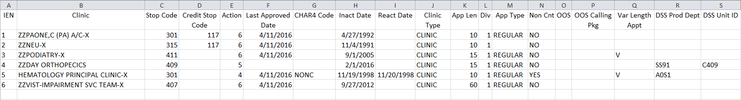

1. Example: Exported Active Clinics Spreadsheet

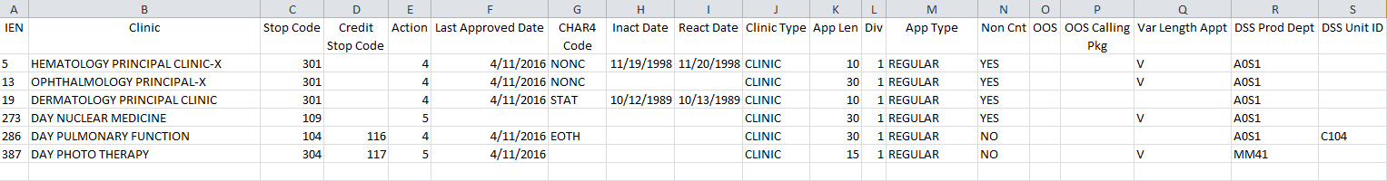

1. Example: Exported Duplicate Clinics Spreadsheet

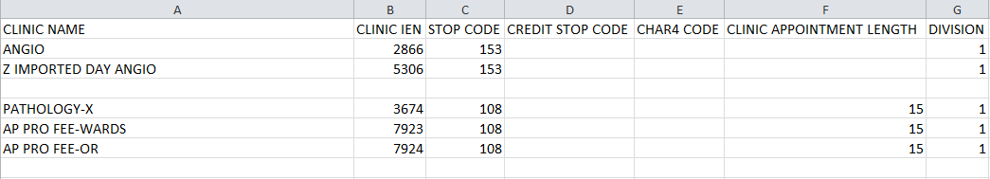

1. Example: Exported Inactive Clinics Spreadsheet

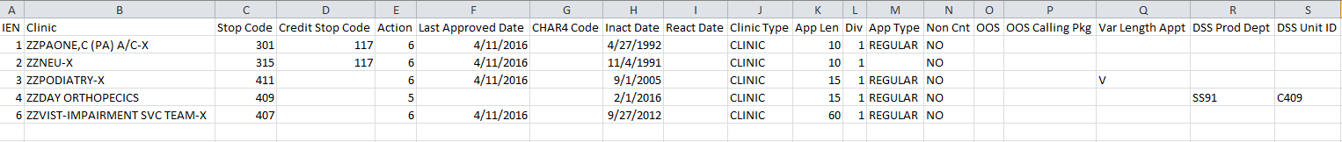

1. Example: Exported Unreviewed Clinics Spreadsheet

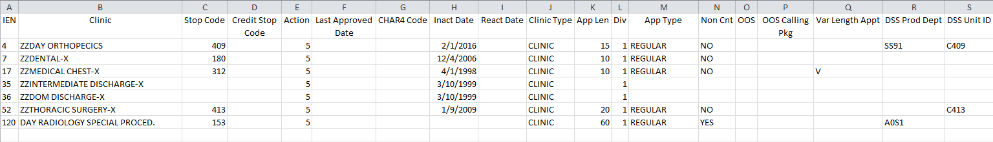

#### Enter/Edit Clinic Parameters

Use this option to enter or edit the ACTION TO SEND codes and other parameters associated with each clinic, for the DSS extract.

The option to select how the Stop Codes and/or Credit Stop Codes are sent can be changed. The default is set to SEND STOP CODE(S) WITH CHAR4 CODE, unless it is a NON-COUNT clinic, then the default is DO NOT SEND. The example below displays the available options.

Modifying the DSS PRODUCT DEPARTMENT information will not cause a clinic to be place in an “Unreviewed” status.

An example of the steps to edit the Action to Send Code is displayed below:

Select Setup for DSS Clinic Information Option: 4 Enter/Edit

Clinic Parameters

Select CLINICS AND STOP CODES CLINIC NAME: ?

Answer with CLINICS AND STOP CODES CLINIC NAME, or RECORD LAST SYNCHED

Do you want the entire CLINICS AND STOP CODES List? y (Yes)

Choose from:

000 ADMIN SCHEDULING (NC)-X

000-EYE NON TREATMENT-X

000-MH NON TREATMENT-X

000-NON TREATMENT-X

^

Select CLINICS AND STOP CODES CLINIC NAME: 000-eYE NON TREATMENT-X

EXISTING CLINIC FILE DATA:

STOP CODE: 407

CREDIT STOP CODE:

ACTION TO SEND: SEND STOP CODE(S) WITH CHAR4 CODE

// ??

This determines how alternate stop code and alternate credit stop

codes are combined to form a feeder key for this clinic.

Choose from:

4 SEND STOP CODE(S) WITH CHAR4 CODE

5 SEND STOP CODE(S) WITHOUT CHAR4 CODE

6 DO NOT SEND

ACTION TO SEND: SEND STOP CODE(S) WITH CHAR4 CODE

//

Through prompts, the user can add or edit the CHAR4 Code, DSS Unit Identifier and DSS Product Department fields.

An example of the steps to edit the CHAR4 Code, DSS Unit Identifier and DSS Product Department follows:

Select Setup for DSS Clinic Information Option: 4 Enter/Edit Clinic Parameters

Select CLINICS AND STOP CODES CLINIC NAME: Ambulatory Surgery

EXISTING CLINIC FILE DATA:

STOP CODE: 401

CREDIT STOP CODE: 117

ACTION TO SEND: SEND STOP CODE(S) WITH CHAR4 CODE

//

CHAR4 CODE: NONC//

DSS UNIT IDENTIFIER:

DSS PRODUCT DEPARTMENT: ??

The nationally defined DSS Intermediate Department Number designated to

the patient care product being provided.

DSS PRODUCT DEPARTMENT:

#### Approve Reviewed DSS Clinic Worksheet

Use this option to approve all Stop Codes and Credit Stop Codes, as defined in the CLINICS AND STOP CODES file (#728.44); and to mark all existing entries, in this file, as reviewed.

The steps to perform this option are as follows:

Select Setup for DSS Clinic Information Option: 5 Approve Reviewed DSS Clinic Worksheet

This option allows you to mark the current clinic entries in the CLINICS AND

STOP CODES file (#728.44) as "reviewed". Those entries will then be omitted

from the list printed from the "Clinic and DSS Stop Codes Print" when you

choose to print only "unreviewed" clinics.

Are you ready to approve the reviewed information provided by the

"Clinic and DSS Stop Codes Print"? NO// y YES

Requested Start Time: NOW// (JUN 01, 2016@14:19:13)

...approval queued

#### Clinic and Stop Codes Validity Report

The Clinic & Stop Codes Validity Report is used to identify invalid clinic setups, due to Stop Codes, Credit Stop Codes and/or CHAR4 codes changes, subsequent to the initial clinic setup.

Stop Codes are assigned a Restriction Type of primary, secondary or either. Primary types are restricted to the Primary Stop Code position; secondary types are restricted to the Secondary Stop Code position; and those with a type of either can be used in either the Primary or Secondary Stop Code positions. Stop Codes, with a Primary or Secondary Restriction Type, will also have a Restriction Date to track, when the Stop Code was designated as restricted. Clinics are validated to ensure the Stop Codes are in compliance with restriction types.

The clinic’s Stop Codes and Credit Stop Codes must be active, valid and conform to the Restriction Types. If any of the following conditions are not met, the clinic will be listed on the report, with a descriptive message explaining what needs to be updated.

* Must be present *(not missing).*
* Must be active.
* Must not have an inactive date in the future.
* Must be three numeric characters in length and valid.
* Must be in the correct position for the restriction type.
* Must not have matching Stop and Credit Stop Codes.
* Must not have an inactive CHAR4 Code.

NOTE: CHAR4 Codes cannot be added, deleted or modified by users.

This report lists the clinics that do not conform to the Stop Code and Four-Character Code (CHAR4) Restriction Types.

The steps to produce the report are as follows:

Select Setup for DSS Clinic Information Option: Clinic & Stop Codes Validity Report

This report will display stop code information of the ACTIVE

clinics in the Clinics and Stop Code file (#728.44). It will

display stop codes that do not conform to the Business Rules for

Valid Stop Codes.

**REMINDER - The CREATE option last ran on 5/20/16.

If the most recent clinic changes from the HOSPITAL LOCATION file #44

are desired, run the CREATE option before running a report.**

Do you want the output in exportable format? NO// n NO

DEVICE: HOME// 0;132 HOME (CRT)

1. Example: Clinic and Stop Codes Validity Report Screen Print

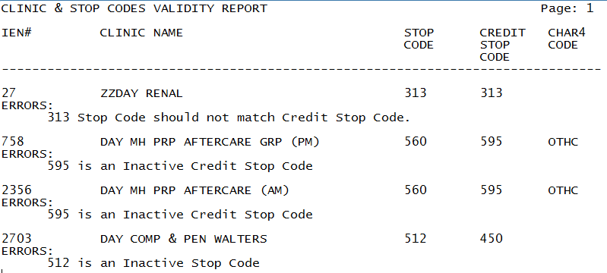

Guidance for capturing exported data into spreadsheets and the additional DSS application steps required to produce exportable versions of reports are located in Appendix F: Exporting a Report to a Spreadsheet.

The following example shows the report after it has been produced in an exportable format and imported into a spreadsheet:

1. Example: Exported Clinic and Stop Codes Validity Report

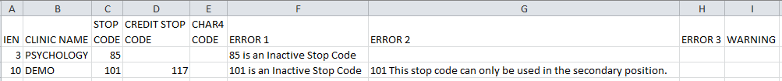

#### Clinic Edit Log Report

The steps to produce this report are as follows:

Select Setup for DSS Clinic Information Option: 8 Clinic Edit Log Report

This option prints a log of the changes made to Clinic Locations

Select one of the following:

1 USER NAME

2 DATE CHANGED

Select sort for Clinic Edit Log: 1// USER NAME

Starting with Date: 5/1/16 (MAY 01, 2016)

Ending with Date: 5/30/16 (MAY 30, 2016)

Do you want the output in exportable format? NO//

** REPORT REQUIRES 132 COLUMNS TO PRINT CORRECTLY **

DEVICE: 0;132 HOME (CRT)

1. Example: Clinic Edit Log Report Screen Print

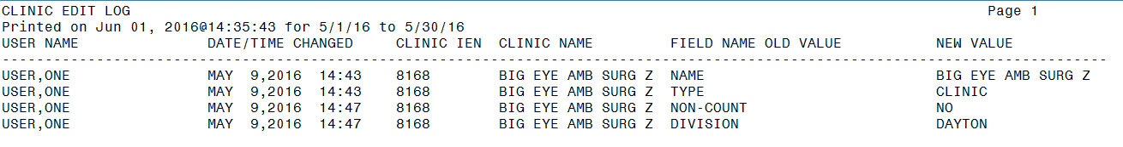

Guidance for capturing exported data into spreadsheets and the additional DSS application steps required to produce exportable versions of reports are located in Appendix F: Exporting a Report to a Spreadsheet.

The following example shows the report after it has been produced in an exportable format and imported into a spreadsheet:

1. Example: Exported Clinic Edit Log Report

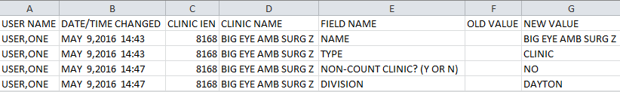

### Setup for Inpatient Census Information

When the user selects, the Setup for Inpatient Census Information option, from the Maintenance Menu, the following sub-menu and options displays.

1. Example: Patient Census Information Menu Options

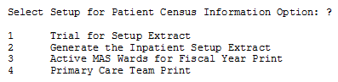

#### Trial for Setup Extract

Use this option to generate a printed report, of the Inpatient Population, for a specified date. The report is sorted by Inpatient Ward. Within each ward, the data is sorted by patient name, SSN and admit date. This report can be compared to PIMS reports to eliminate any problems, in the ADMISSION SETUP EXTRACT file (#727.82).

An example of the steps to run this report follows:

Select Setup for Inpatient Census Information Option: 1 Trial for Setup Extract

WARNING.

This is very resource intensive and should be queued to run at slack time.

This option will print the admission data and data for the last

transfer and treating specialty change for all patients who

were in the hospital on the day you select.

NOTE - This will generate a report of your inpatient population on the

BEGINNING of the day you select, not the end of the day as MAS reports do.

For example, for this report, if you choose October 1, 1994, the report will

start at midnight at the beginning of the day. For the MAS report, you would

choose September 30, 1994. The MAS report begins at midnight at the end

of the day.

Select the date : May 31, 2016//

This report must be queued to a 132 column printer.

DEVICE: HOME// NOTE: Queue to a 132 column print device

Requested Start Time: NOW// 3/1/16 (MAR 01, 2016@15:10:29)

1. Example: Inpatient Population Report on a Selected Date Screen Print

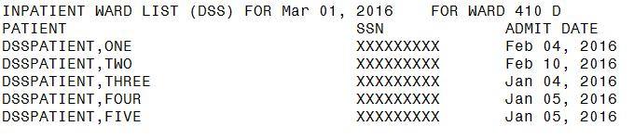

#### Generate the Inpatient Setup Extract

This option should *only* be utilized for sites that have *never* sent any DSS Extract data to the AITC to initialize the setup extract files listed below. Once this is performed, this option should not be used again.

This option generates the Inpatient Setup Extract, which creates the hospital population, for the selected DSS start date. This data is stored in the following files, until transmitted to the AITC.

* ADMISSION SETUP EXTRACT file (#727.82)
* PHYSICAL MOVEMENT SETUP EXTRACT file (#727.821)
* TREATING SPECIALTY CHANGE SETUP EXTRACT file (#727.822)

An example of the steps to produce the extract follows:

Select Setup for Inpatient Census Information Option: 2 Generate the Inpatient Setup Extract

WARNING.

This is very resource intensive and should be queued to run at slack time.

This option will extract the admission data and data for the last

transfer and treating specialty change for all patients who

were in the hospital on the day you select.

NOTE - This will generate a report of your inpatient population on the

BEGINNING of the day you select, not the end of the day as MAS reports do.

For example, for this report, if you choose October 1, 1994, the report will

start at midnight at the beginning of the day. For the MAS report, you would

choose September 30, 1994. The MAS report begins at midnight at the end

of the day.

Select the date: Oct 01, 1996// <RET> (OCT 01, 1996)

Requested Start Time: NOW// <RET> (DEC 17, 1996@09:43:16)

#### Active MAS Wards for Fiscal Year Print

This option provide assistance, for building wards in the commercial database at the AITC.

Use this option to print a list of all MAS wards that were active at any time, during the current fiscal year. The only prompt is for a device. The output is formatted for 132 columns, sorted by Medical Center Division and displays the following information:

* Pointer to the HOSPITAL LOCATION file (#44)
* Service and specialty associated with the ward in the WARD LOCATION file (#42)
* DSS Product Department associated with the ward in the DSS WARD file (#727.4)

The steps to produce the list are:

1. Example: Active MAS Wards for Fiscal Year Print – Screen Print

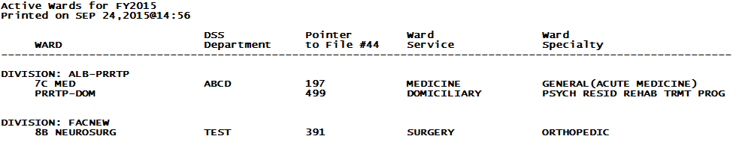

Guidance for capturing exported data into spreadsheets and the additional DSS application steps required to produce exportable versions of reports are located in Appendix F: Exporting a Report to a Spreadsheet.

The following example shows the report after it has been produced in an exportable format and imported into a spreadsheet:

1. Example: Exported Active MAS Wards for Fiscal Year Print

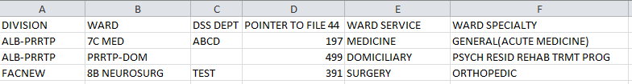

#### Primary Care Team Print

Use this option to print a list of all Primary Care Teams. The list is sorted alphabetically, by team name and displays the pointer to the TEAM file (#404.51). This option allows the user to build Primary Care Teams, on the Commercial DSS system.

The steps to produce this list are:

Select Setup for Inpatient Census Information Option: 4 Primary Care Team Print

This option prints a list of all Primary Care Teams. The list is sorted

alphabetically by TEAM name and displays the pointer to the TEAM file (#404.51).

Do you want the output in exportable format? NO//

The right margin for this report is 80.

DEVICE: HOME (CRT) Right Margin: 80//

1. Example: Primary Care Team Print- Screen Print

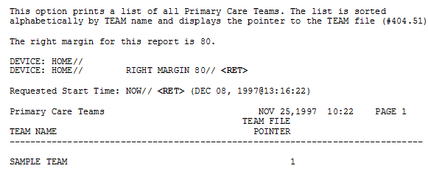

Guidance for capturing exported data into spreadsheets and the additional DSS application steps required to produce exportable versions of reports are located in Appendix F: Exporting a Report to a Spreadsheet.

The following example shows the report after it has been produced in an exportable format and imported into a spreadsheet:

1. Example: Exported Primary Care Team Print

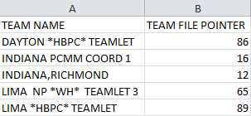

### Setup for Inpatient Medications Information

When the Setup for Inpatient Medications Information option is selected, from the Maintenance Menu, the following sub-menu and options are displayed.

1. Example: Inpatient Medications Information Option Menu

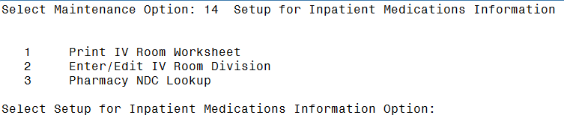

#### Print IV Room Worksheet

Use this option to print a worksheet listing of all the entries, in the IV ROOM file (#59.5), of the Inpatient Medications package. This worksheet is used by the MCA Manager to define the DIVISION (as a pointer to the MEDICAL CENTER DIVISION file [#40.8]), for each IV room, for MCA purposes. The report can be displayed online screen format or in an exported format.

The steps to produce the worksheet are:

Select Setup for Inpatient Medications Information Option: 1 Print IV Room Worksheet

This option will produce a worksheet listing all entries in the IV Room file

(#59.5). It should be used to help DSS and Pharmacy services define and

review the DIVISION assignments for each IV Room.

Do you want the output in exportable format? NO//

DEVICE: HOME// 0;132 HOME (CRT)

1. Example: IV Room Worksheet Screen Print

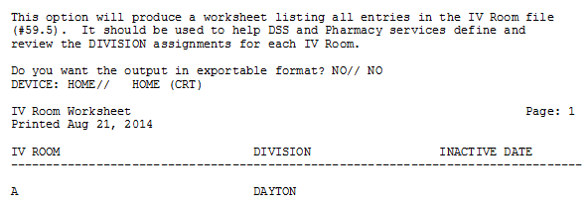

Guidance for capturing exported data into spreadsheets and the additional DSS application steps required to produce exportable versions of reports are located in Appendix F: Exporting a Report to a Spreadsheet.

The following example shows the report after it has been produced in an exportable format and imported into a spreadsheet:

1. Example: Exported IV Room Worksheet

Spreadsheet includes IV Room, Division and Inactivation Date.


#### Enter/Edit IV Room Division

This option is used to create or edit entries, in the DIVISION field (#.02), of the IV ROOM file (#59.5). The DIVISION field allows users to tie Outpatient IV data to a Medical Center Division, for MCA purposes.

An example of the steps for this option follows:

Select Setup for Inpatient Medications Information Option: 2 Enter/Edit IV Room Division

This option allows editing of the DIVISION field for IV Rooms.

Select IV ROOM NAME: ?

Answer with IV ROOM NAME:

A

Select IV ROOM NAME: A

DIVISION: DAYTON//

#### Pharmacy NDC Lookup

This option is used to search for NDCs, from DSS Pharmacy Feeder Keys that have been rejected because first five characters are zeros in a 17-character Feeder Key. (Ex. "00000051079014120") OR the first seven characters are zeros in a 19-character Feeder Key. (Ex. "0000000051079014120"). This option allow the user to search the local DRUG file (#50), using NDCs from DSS Pharmacy Feeder Keys that have been rejected. This occurs when a pharmacy item has not been matched to the NDF. The output varies slightly, depending on the version of the NDF running at the requestor’s site:

Refer to Appendix D: Feeder Key Transmission for information about Feeder Key transmission.

The software prompts the user to enter the NDC (last twelve characters), from a rejected Feeder Key, to display the following information, from the local DRUG file (#50), for any drug assigned the specified NDC.

* Local Generic Name
* NDC
* Dispense Unit
* VA Classification
* Price Per Dispense Unit

An example of the steps for this option follows:

Pharmacy Feeder Keys for DSS are built in the following manner.

Your site is running NATIONAL DRUG FILE (NDF) v4.0.

If Pharmacy data is dated after September 30, 1998,

then PHA Feeder Keys are composed of 17 numeric characters.

Ex. "12006000003073531" where characters:

1-5 (12006) = pointer to VA PRODUCT NAME file (#50.68)

6-17 (000003073531) = NDC from the local DRUG file (#50)

If Pharmacy data is dated prior to October 1, 1998,

then PHA Feeder Keys are composed of 19 numeric characters.

Ex. "0016006000003073531" where characters:

1-4 (0016) = pointer to the NATIONAL DRUG file (#50.6)

5-7 (006) = pointer to VA PRODUCT NAME subfile (#50.68)

of the NATIONAL DRUG file (#50.6)

8-19 (000003073531) = NDC from the local DRUG file (#50)

This option will allow lookups on the local DRUG file (#50) using

NDCs from DSS Pharmacy Feeder Keys that have been rejected because

the first five characters are zeros in a 17 character Feeder Key.

(Ex. "00000051079014120")

OR

the first seven characters are zeros in a 19 character Feeder Key.

(Ex. "0000000051079014120")

This would occur when a pharmacy item has not been matched to the

the National Drug File (NDF).

Enter the NDC (last twelve characters) from a rejected feeder key

to display information from the local DRUG file for any drug which

has that NDC.

Enter 12 numeric characters at the prompt or <cr> to exit.

Select NDC: 990000200000 VALVE PORT LEUR-LOCK ALARIS #2000E XA900 N

/F 01-28-16 This drug will not be processed without Drug Request Form 10

-7144

1. Example: Selecting a NDC

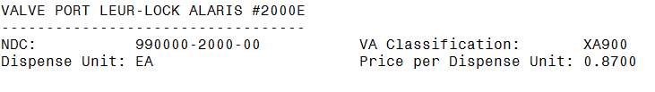

### Surgery

When the Surgery option is selected, from the Maintenance Menu, the following sub-menu and options are displayed.

1. Example: Surgery Menu Options

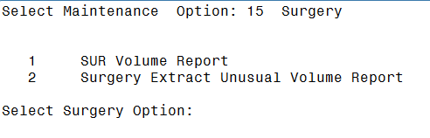

#### SUR Volume Report

This menu option generates a report listing all surgical cases appearing on the Surgery Extract, for transmission to the AITC for review.

An example of the steps to produce this report follows:

Select Surgery Option: 1 SUR Volume Report

Enter the date range for which you would like to scan the

Surgery Extract records.

Starting with Date: 1/1/04 (JAN 01, 2004)

Ending with Date: 1/15/04 (JAN 15, 2004)

Do you want the output in exportable format? NO//

This report requires 132-column format.

DEVICE: HOME// 0;132 HOME (CRT)

1. Example: SUR Volume Report Screen Print

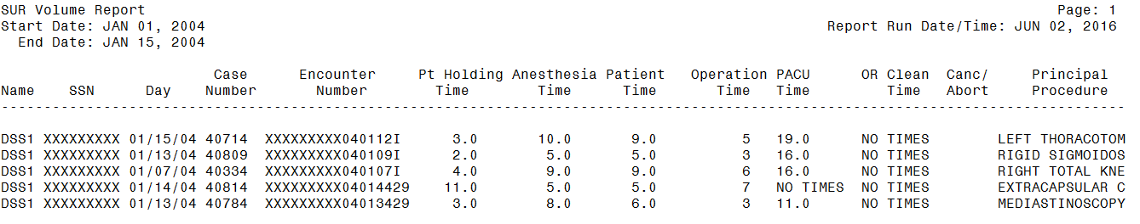

Guidance for capturing exported data into spreadsheets and the additional DSS application steps required to produce exportable versions of reports is located in Appendix F: Exporting a Report to a Spreadsheet.

The following example shows the report after it has been produced in an exportable format and imported into a spreadsheet:

1. Example: Exported SUR Volume Report

Spreadsheet includes Name, SSN, Day, Case Number, Encounter Number, Patient Holding Time, Anesthesia Time, Patient Time, Operation Time, Post Anesthesia Care Unit Time, OR Clean Time, Cancer/Abort Indicator and Principal Procedure.


#### Surgery Extract Unusual Volume Report

The Surgery Extract Unusual Volume Report prints a listing of high hourly volume surgery cases. The report lists unusual volumes generated, by the Surgery Extract determined by a user-defined threshold value. Users should run this report prior to generating the Surgery extract. The unusual volumes captured, in the report, are defined by the Operation Time, Patient Time, Anesthesia Time, Recovery Room Time, OR Clean Time and Pt Holding Time fields, with a value greater than the defined threshold value. The default threshold volume is 25, which equates to 6 hours. The report is sorted in descending Volume and Case Number order.

The Surgery Extract Unusual Volume Report print records, even if a time segment is missing.

An example of the steps to produce the report follows:

This report prints a listing of unusual volumes that would be

generated by the Surgery extract (SUR) as determined by a

user-defined threshold value. It should be run prior to the

generation of the actual extract(s) to identify and fix, as

necessary, any volumes determined to be erroneous.

Unusual volumes are those where either the Operation Time,

Patient Time, Anesthesia Time, Recovery Room Time, OR Clean Time

or Pt Holding Time field is greater than the threshold value.

Note: The threshold can be set after a report is selected.

Run times for this report will vary depending upon the size of

the extract and could take as long as 30 minutes or more to

complete. This report has no effect on the actual extracts and

can be run as needed.

The report is sorted by descending Volume and Case Number.

Enter RETURN to continue or '^' to exit:

The default threshold volume for the Surgery extract is 25.

The default threshold volume (25) equates to 6 hours.

Would you like to change the threshold?? NO// **YES**

Volume > threshold

Enter the new threshold volume: (0-99): **5**

Enter the date range for which you would like to scan the

Surgery Extract records.

Starting with Date: 03012014 (MAR 01, 2014)

Ending with Date: 03082014 (MAR 08, 2014)

Do you want the output in exportable format? NO//

This report requires 132-column format.

DEVICE: HOME// 0;132;

1. Example: Surgery Extract Unusual Volume Report Screen Print

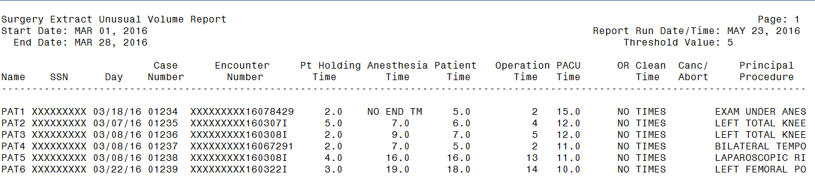

Guidance for capturing exported data into spreadsheets and the additional DSS application steps required to produce exportable versions of reports is located in Appendix F: Exporting a Report to a Spreadsheet.

The following example shows the report after it has been produced in an exportable format and imported into a spreadsheet:

1. Example: Exported Surgery Extract Unusual Volume Report

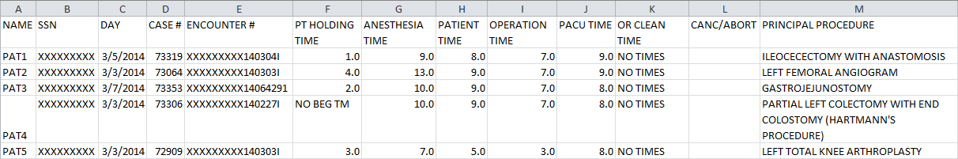

## Package Extracts

The Package Extracts Option was modified to enable users, with the Security Key ECXMGR access, to rerun an extract without Information Resource Management (IRM) assistance. The user can reschedule an extract to run, even if it has scheduled run, rerun of an extract that was previously run, or cancelled an extract that is currently running. The user should use caution when rerunning an extract because multiple extracts can run simultaneously.

NOTE: The DSS application removes tildes (~) from extract record data, prior to transmitting in order to avoid sending extract record data that could be recognized as an end-of-record indicator to the AITC, except when intended.

Also, please refer to the current DSS Extracts Version 3.0 Data Definitions Guide listed, in the References and Resources section, of this document and the Extract File Formats Manual, for extract record layouts for the extracted fields.

When the Package Extracts option is selected, from the Extract Managers Menu, the following menu and options will display.

1. Example: Package Extracts Options

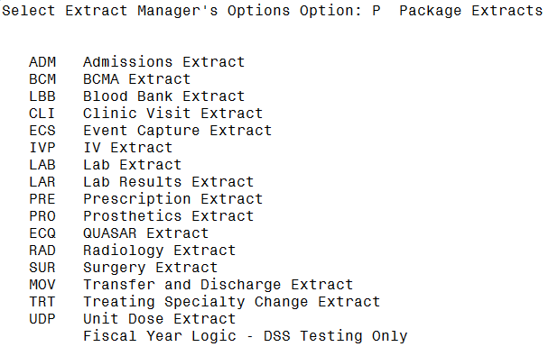

The following example shows the steps to rerun a PRO extract, from the Package Extracts Option Menu. These steps are similar for every extract, so only one example is presented, for all Package Extracts menu options:

Select Package Extracts Option: pro Prosthetics Extract

Extract Prosthetics Information for DSS

Starting with Date: 2/1/13 (FEB 01, 2013)

Ending with Date: 2/28/13 (FEB 28, 2013)

The Prosthetics information has already been extracted

through Feb 28, 2013.

Do you want to continue processing the PRO extract? NO// y YES

Make sure you have checked that your selected dates are correct

before answering yes to the next question.

Are you SURE you want to run the PRO extract? NO// y YES

Requested Start Time: NOW// (JUN 12, 2013@122:02:16)

Request queued as Task #12804

### Admissions Extract (ADM)

This option is used to extract Patient Admissions data, for a selected date range. This data is stored, in the ADMISSION EXTRACT file (#727.802), until it is transmitted to AITC.

The mail group for this extract is DSS-ADMS. The purpose of this mail group is to receive messages, when the extract is complete and the data is transmitted to the AITC.

### BCMA Extract (BCM)

This option is used to extract BCMA data, for a selected date range. This data is stored, in the BCMA EXTRACT file (#727.833), until it is transmitted to the AITC.

The mail group for this extract is DSS-BCM. The purpose of this mail group is to receive messages, when the extract is complete and the data is transmitted to the AITC.

### Blood Bank Extract (LBB)

This option is used to extract Blood Bank data, for a selected date range. This data is stored, in the BLOOD BANK EXTRACT file (#727.829), until the data is transmitted to the AITC. This extract enables MCA staff to view and manage the true economic costs of blood product usage, by the Veterans Health Administration (VHA).

The mail group for this extract is DSS-LBB. The purpose of this mail group is to receive messages, when the extract is complete and the data is transmitted to the AITC.

### Clinic Visit Extract (CLI)

This option is used to extract data, for all scheduled Clinic Visits, add and/or edit walk-ins, for theselected date range, with the following exceptions.

* Non-Count Clinics are excluded, unless specifically assigned to a DSS Action Code other than 6.
* Cancelled Clinic appointments are excluded. Clinics, with an ACTION TO SEND code of 6, in CLINICS AND STOP CODES file (#728.44) are also excluded.

This data is stored in the CLINIC EXTRACT file (#727.827), until it is transmitted to the AITC.

The mail group for this extract is DSS-SCX. The purpose of this mail group is to receive messages, when the extract is complete and the data is transmitted to the AITC.

### Event Capture Local Extract (ECS)

This option is used to extract the Event Capture data, for a selected date range. This data is stored in the EVENT CAPTURE LOCAL EXTRACT file (#727.815), until it is transmitted to the AITC.

The mail group for this extract is DSS-EC. The purpose of this mail group is to receive messages, when the extract is complete and the data is transmitted to the AITC.

### IV Extract (IVP)

This option is used to extract the Pharmacy IV data, for a selected date range. This data is stored in the IV DETAIL EXTRACT file (#727.819), until it is transmitted to the AITC.

The mail group for this extract is DSS-IV. The purpose of this mail group is to receive messages, when the extract is complete and the data is transmitted to the AITC.

### Lab Extract (LAB)

This option to extract the Laboratory data, including referrals and research tests, for a selected date range. This data is stored in the LABORATORY EXTRACT file (#727.813), until it is transmitted to the AITC.

All inpatient, outpatient and referral Lab Tests accessioned, within the selected date range are extracted. Lab tests can be performed, on a patient in the PATIENT file (#2) or a referral patient in the REFERRAL PATIENT file (#67). The identifying number is the SSN, for in-house patients or a selected non-SSN ID constant, for referrals and research.

The mail group for this extract is DSS-LAB. The purpose of this mail group is to receive messages, when the extract is complete and the data is transmitted to the AITC.

### Lab Results Extract (LAR)

This option is used to extract the Laboratory Results data, for a selected date range. This data is stored, in the LAB RESULTS EXTRACT file (#727.824), until it is transmitted to the AITC.

The mail group for this extract is DSS-LAB. The purpose of this mail group is to receive messages, when the extract is complete and the data is transmitted to the AITC.

### Prescription Extract (PRE)

This option is used to extract the Prescription (pharmacy outpatient) data, for a selected date range. This data is stored in the PRESCRIPTION EXTRACT file (#727.81), until it is transmitted to the AITC.

The mail group for this extract is DSS-PRES. The purpose of this mail group is to receive messages, when the extract is complete and the data is transmitted to the AITC.

### Prosthetics Extract (PRO)

This option is used to extract the Prosthetics data, for a selected date range. The data is stored, in the PROSTHETICS EXTRACT file (#727.826), until transmitted to the AITC.

The following information is required to extract a Prosthetics record:

* Station
* Requesting Station
* Patient Name (in Prosthetics)
* SSN
* Receiving Station
* Name (in PATIENT file (#2))
* Type of Transaction
* Delivery Date
* Source
* HCPS

For Prosthetics records that could not be extracted, the user will receive a Prosthetics DSS Exception message, indicating the record’s IEN, in the record of pros appliance/repair file (#660) and the missing critical information.

The records identified, in this message, were not extracted and should be reviewed to determine if they should be corrected and the extract regenerated to ensure the proper DSS credit is received.

When extracting data for a specific division, only select a primary division (defined in the PROSTHETICS SITE PARAMETERS file (#669.9) and the NEW PERSON file (#200)).

The mail group for this extract is DSS-PRO. The purpose of this mail group is to receive messages, when the extract is complete and the data is transmitted to the AITC.

### QUASAR Extract (ECQ)

This option is used to extract Audiology and Speech Pathology clinic visit data, for a selected date range. This data is stored, in the Quality: Audiology and Speech Pathology Audit & Review (QUASAR) EXTRACT (#727.825) file, until it is transmitted to the AITC.

The mail group for this extract is DSS-QSR. The purpose of this mail group is to receive messages, when the extract is complete and the data is transmitted to the AITC.

### Radiology Extract (RAD)

This option is used to extract the Radiology data, for a selected date range. This data is stored in the RADIOLOGY EXTRACT file (#727.814), until it is transmitted to the AITC.

The mail group for this extract is DSS-RAD. The purpose of this mail group is to receive messages, when extract is complete and the data is transmitted to the AITC.

### Surgery Extract **(**SUR)

This option is used to extract the Surgery data, for a selected date range. This data is stored in the SURGERY EXTRACT file (#727.811), until it is transmitted to the AITC. Secondary procedures and prostheses are also extracted.

The mail group for this extract is DSS-SURG. The purpose of this mail group is to receive messages, when the extract is complete and the data is transmitted to the AITC.

### Transfer and Discharge Extract (MOV)

This option is used to extract all Patient Movement (transfers and discharge) data, for the selected date range. This data is stored in the PHYSICAL MOVEMENT EXTRACT file (#727.808), until it is transmitted to the AITC.

The mail group for this extract is DSS-MOVS. The purpose of this mail group is to receive messages, when the extract is complete and the data is transmitted to the AITC.

### Treating Specialty Change Extract (TRT)

This option is used to extract Treating Specialty Change data, for a selected date range. This data is stored in the TREATING SPECIALTY CHANGE EXTRACT file (#727.817), until it is transmitted to the AITC.

The mail group for this extract is DSS-TREAT. The purpose of this mail group is to receive messages, when the extract is complete and the data is transmitted to the AITC.

### Unit Dose Extract (UDP)

This option is used to extract all Unit Dose Orders, for the selected date range. Data is extracted from the UNIT DOSE EXTRACT DATA file (#728.904), which is populated by theInpatient Medications package, when a pick list is filed. This data is stored in the UNIT DOSE LOCAL EXTRACT file (#727.809), until it is transmitted to the AITC.

The mail group for this extract is DSS-UD. The purpose of this mail group is to receive messages, when the extract is complete and the data is transmitted to the AITC.

### Fiscal Year Logic – DSS Testing Only

The **Fiscal Year Logic - DSS Testing Only** option allows selection of a fiscal year that may not have the DSS logic implemented for that year. If a future year (e.g. 2017) is entered and the user does not have the ECX DSS TEST Security Key, the software does not allow selection of a future fiscal year.

An example of the steps to run this option follows:

Select Package Extracts Option: fiscal year logic - DSS Testing Only

****************************************************************

* *

* Use this option with caution since it will allow you to *

* run any supported DSS extract using specific fiscal year *

* logic. By running this option you may negatively impact *

* your extract data. *

* *

* DO NOT USE this option unless you are an official test site *

* for the DSS Fiscal Year Conversion. *

*--------------------------------------------------------------*

* *

* Note that this option does not update the last date used for *

* the given extraction. It also does not verify that the time *

* frame selected is after the last date used for the extract. *

* *

****************************************************************

Select DSS Extract to queue: CLINIC I (CLI)

Starting with Date: 3/1/14 (MAR 01, 2014)

Ending with Date: 3/31/2014// 3/31/14 (MAR 31, 2014)

Select one of the following:

2014 Fiscal Year 2014

2015 Fiscal Year 2015

2016 Fiscal Year 2016

2017 Fiscal Year 2017

Select fiscal year logic to use for extract: 2017 Fiscal Year 2017

WARNING: Logic has not been released for this year. Do not use unless directed

by DSO. Do you want to continue? YES//

## SAS Extract Audit Reports

This section contains a brief description followed by a sample output for each SAS Extract Audit Report option. To execute any of the SAS Extract Audit Reports options, enter the DSS Extract Log Record Number and a printer device.

Refer to the current DSS Extracts Version 3.0 Data Definitions Guide listed, in the References and Resources section, of this document and the Extract File Formats Manual, for more information regarding the record layout for the extracted fields.

1. Example: SAS Extracts Audit Reports Menu Options

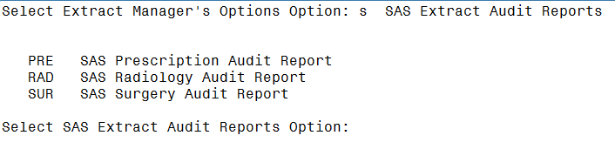

### SAS Prescription Audit Report

This option emulates the SAS routine at the AITC, which creates new records, from the Prescription (pharmacy outpatient) Extract. Users also have the ability to print a Summary Report, for all records sorted, by Feeder Location and Feeder Key.

Refer to Appendix D: Feeder Key Transmission for information about Feeder Key transmission.

An example of the steps to produce this report follows:

Select SAS Extract Audit Reports Option: pre SAS Prescription Audit Report

Prescription Extract SAS Report

Select DSS EXTRACT LOG RECORD NUMBER: ?

Answer with DSS EXTRACT LOG RECORD NUMBER, or TYPE, or

HEADER FOR MESSAGE

Do you want the entire DSS EXTRACT LOG List? y (Yes)

Choose from:

4348 01-08-16 Prescription

4364 02-08-16 Prescription

4380 03-08-16 Prescription

Select DSS EXTRACT LOG RECORD NUMBER: 4348 01-08-16 Prescription

Extract: Prescription #4348

Start date: DEC 01, 2015

End date: DEC 31, 2015

# of Records: 71254

The extract which you have chosen to audit

was transmitted to Austin/DSS on JAN 08, 2016.

Do you want to continue with this audit report? NO// y YES

Do you want the output in exportable format? NO// n NO

DEVICE: HOME// 0;132 HOME (CRT)

1. Example: SAS Audit Report for Prescription (PRE) Extract Screen Print

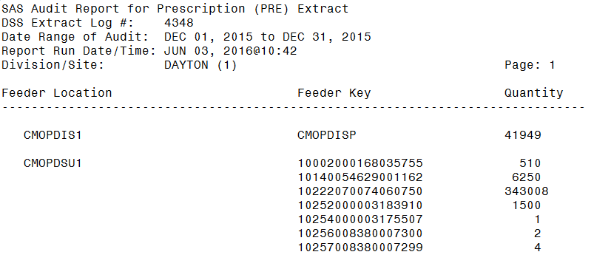

Guidance for capturing exported data into spreadsheets and the additional DSS application steps required to produce exportable versions of reports are located in Appendix F: Exporting a Report to a Spreadsheet.

The following example shows the report after it has been produced in an exportable format and imported into a spreadsheet:

1. Example: Exported SAS Audit Report for Prescription (PRE) Extract

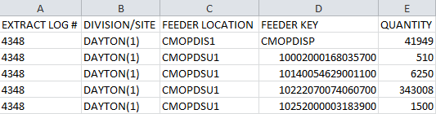

### SAS Radiology Audit Report

This option emulates the SAS routine at the AITC, which creates new records from the Radiology extract. Users may print a Summary Report, for all records sorted by Feeder Location and Feeder Key. Bilateral modifiers will increase volumes.

Refer to Appendix D: Feeder Key Transmission for information about Feeder Key transmission.

An example of the steps to produce this report follows:

Select SAS Extract Audit Reports Option: rad SAS Radiology Audit Report

Radiology Extract SAS Report

Select DSS EXTRACT LOG RECORD NUMBER: ?

Answer with DSS EXTRACT LOG RECORD NUMBER, or TYPE, or

HEADER FOR MESSAGE

Do you want the entire DSS EXTRACT LOG List? y (Yes)

Choose from:

4350 01-08-16 Radiology

4366 02-08-16 Radiology

4382 03-08-16 Radiology

Select DSS EXTRACT LOG RECORD NUMBER: 4350 01-08-16 Radiology

Extract: Radiology #4350

Start date: DEC 01, 2015

End date: DEC 31, 2015

# of Records: 6188

The extract which you have chosen to audit

was transmitted to Austin/DSS on JAN 08, 2016.

Do you want to continue with this audit report? NO// y YES

Do you want the output in exportable format? NO//

DEVICE: HOME// 0;132 HOME (CRT)

1. Example: SAS Audit Report for Radiology (RAD) Extract Screen Print

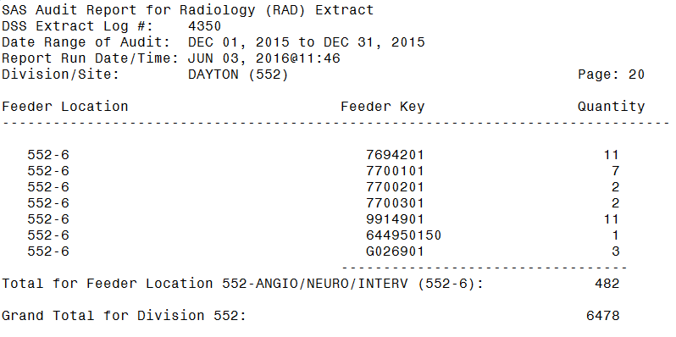

Guidance for capturing exported data into spreadsheets and the additional DSS application steps required to produce exportable versions of reports are located in Appendix F: Exporting a Report to a Spreadsheet.

The following example shows the report after it has been produced in an exportable format and imported into a spreadsheet:

1. Example: Exported SAS Audit Report for Radiology (RAD) Extract

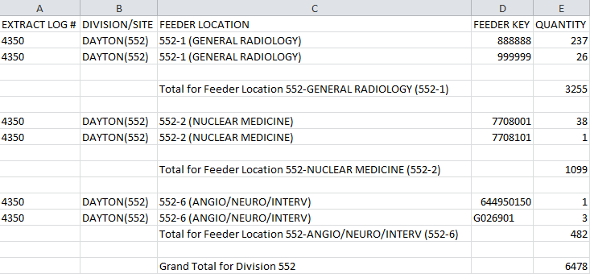

### SAS Surgery Audit Report

This option emulates the SAS routine at the AITC, which creates new records from the surgery extract. Users can print a Summary Report, for all records sorted by Feeder Location and Feeder Key.

Refer to Appendix D: Feeder Key Transmission for information about Feeder Key transmission.

An example of the steps to produce this report follows:

Select SAS Extract Audit Reports Option: sur SAS Surgery Audit Report

Surgery Extract SAS Report

Select DSS EXTRACT LOG RECORD NUMBER: ?

Answer with DSS EXTRACT LOG RECORD NUMBER, or TYPE, or

HEADER FOR MESSAGE

Do you want the entire DSS EXTRACT LOG List? y (Yes)

Choose from:

4354 01-08-16 Surgery

4370 02-09-16 Surgery

4383 03-08-16 Surgery

^

Select DSS EXTRACT LOG RECORD NUMBER: 4354 01-08-16 Surgery

Extract: Surgery #4354

Start date: DEC 01, 2015

End date: DEC 31, 2015

# of Records: 486

The extract which you have chosen to audit

was transmitted to Austin/DSS on JAN 08, 2016.

Do you want to continue with this audit report? NO// y YES

Do you want the output in exportable format? NO//

DEVICE: HOME// 0;132 HOME (CRT)

1. Example: SAS Audit Report for Surgery (SUR) Extract Screen Print

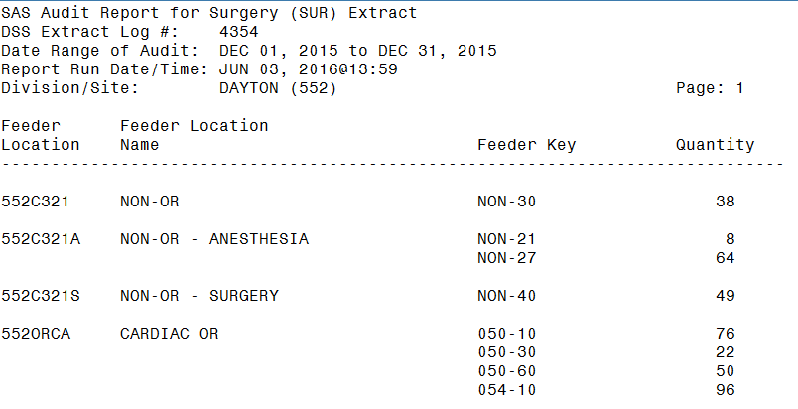

Guidance for capturing exported data into spreadsheets and the additional DSS application steps required to produce exportable versions of reports are located in Appendix F: Exporting a Report to a Spreadsheet.

The following example shows the report after it has been produced in an exportable format and imported into a spreadsheet:

1. Example: Exported SAS Audit Report for Surgery (SUR) Extract

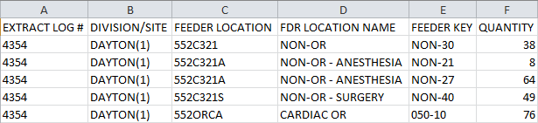

## Extract Audit Reports

This section contains a brief description followed by a sample output for each Extract Audit Reports option. To execute any of the Extract Audit Reports options, enter the DSS Extract Log Record Number, starting and ending dates, divisions, locations, or accession areas (as appropriate), and a printer device. There is also a narrative portion of each report that prints *only* if the report is sent to a printer device. The format of the narrative is the same for all Extract Audit Reports, but the content varies for each report.

Refer to the current DSS Extracts Version 3.0 Data Definitions Guide listed, in the References and Resources section of this document and the Extract File Formats Manual, for more information about the record layout, for the extracted fields.

When the Extract Audit Reports option, from the Extract Managers Menu, is selected the following menu and options are displayed:

1. Example: Extract Audit Reports Menu on Extract Managers Menu

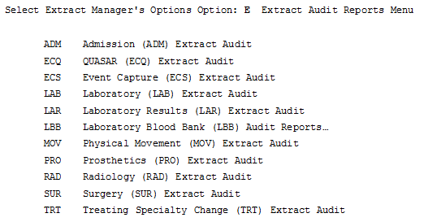

The following example of the steps required to produce the Admission (ADM) Extract Audit Reportis typical of all the audit reports, so only one example is presented here for all Extract Audit Report menu options:

Select Extract Audit Reports Menu Option: A Admission (ADM) Extract Audit

Setup for ADM Extract Audit Report --

Select DSS EXTRACT LOG RECORD NUMBER: ?

Answer with DSS EXTRACT LOG RECORD NUMBER, or TYPE, or

HEADER FOR MESSAGE

Do you want the entire DSS EXTRACT LOG List? y (Yes)

Choose from:

4342 01-08-16 Admission

4358 02-08-16 Admission

4374 03-08-16 Admission

Select DSS EXTRACT LOG RECORD NUMBER: 4342 01-08-16 Admission

Extract: Admission #4342

Start date: DEC 01, 2015

End date: DEC 31, 2015

# of Records: 424

The extract which you have chosen to audit

was transmitted to Austin/DSS on JAN 08, 2016.

Do you want to continue with this audit report? NO// y YES

You can narrow the date range, if you wish.

The Start Date can't be earlier than DEC 01, 2015,

or later than DEC 31, 2015.

Select Start Date: DEC 01, 2015// (DEC 01, 2015)

The End Date can't be earlier than DEC 01, 2015

(the Start Date you selected), or later than DEC 31, 2015.

Select End Date: DEC 31, 2015// (DEC 31, 2015)

Do you want the ADM extract audit report for all divisions? NO// y YES

Do you want the output in exportable format? NO//

DEVICE: HOME// 0;132 HOME (CRT)

### Admission (ADM) Extract Audit

This option is used to print a Summary Report, from the ADMISSION EXTRACT file (#727.802), that displays the number of Patient Admissions by ward and ward group.

1. Example: Admission (ADM) Extract Audit Report Screen Print

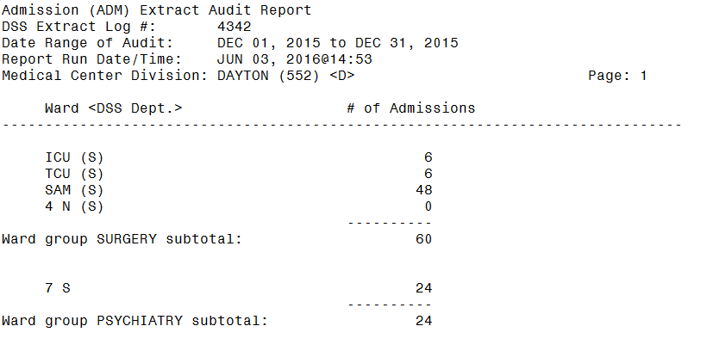

Guidance for capturing exported data into spreadsheets and the additional DSS application steps required to produce exportable versions of reports is located in Appendix F: Exporting a Report to a Spreadsheet.

The following example shows the report after it has been produced in an exportable format and imported into a spreadsheet:

1. Example: Exported Admission Extract Audit Report

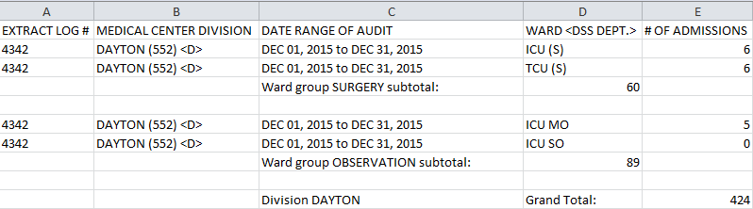

### QUASAR (ECQ) Audit

This option is used to print a report, from the QUASAR EXTRACT file (#727.825) file. The report displays the number of procedures performed, for patient visits to Audiology and Speech Pathology.

1. Example: QUASAR Extract Audit Report Screen Print

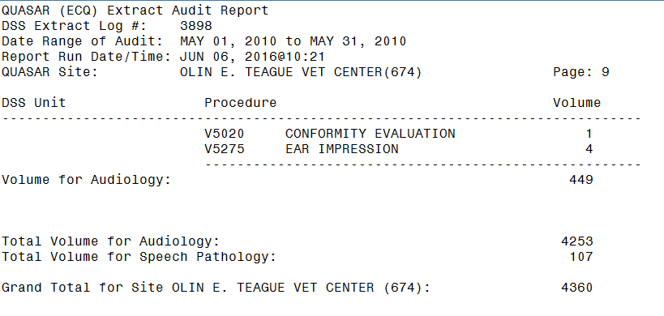

Guidance for capturing exported data into spreadsheets and the additional DSS application steps required to produce exportable versions of reports are located in Appendix F: Exporting a Report to a Spreadsheet.

The following example shows the report after it has been produced in an exportable format and imported into a spreadsheet:

1. Example: Exported QUASAR Extract Audit Report

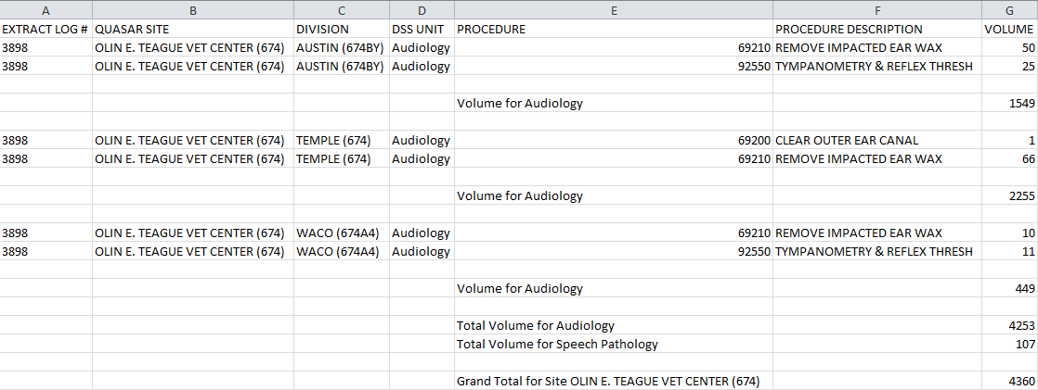

### Event Capture Local (ECS) Extract Audit

This option is used to print a Summary Report, from the EVENT CAPTURE LOCAL EXTRACT file (#727.815), which displays the number of procedures performed within each DSS Unit.

1. Example: ECS Extract Audit Report Screen Print

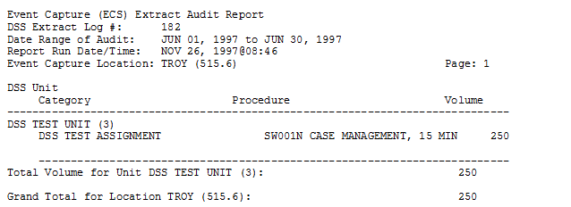

Guidance for capturing exported data into spreadsheets and the additional DSS application steps required to produce exportable versions of reports are located in Appendix F: Exporting a Report to a Spreadsheet.

The following example shows the report after it has been produced in an exportable format and imported into a spreadsheet:

1. Example: Exported ECS Extract Audit Report

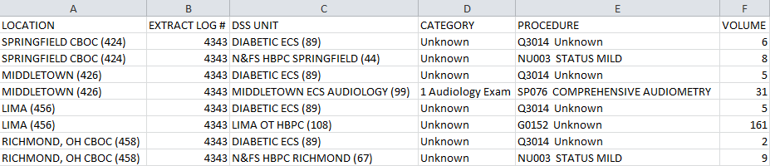

### Laboratory (LAB) Extract Audit

This option is used to print a Summary Report, from the LABORATORY EXTRACT file (#727.813), which displays the volume of tests performed, within each Laboratory accession area.

1. Example: Laboratory Extract Audit Report Screen Print

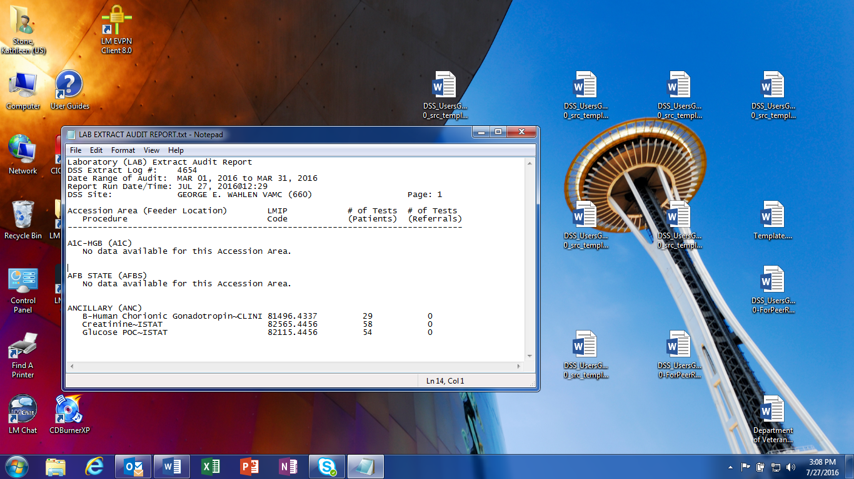

Guidance for capturing exported data into spreadsheets and the additional DSS application steps required to produce exportable versions of reports are located in Appendix F: Exporting a Report to a Spreadsheet.

The following example shows the report after it has been produced in an exportable format and imported into a spreadsheet:

1. Example: Exported Laboratory Extract Audit Report

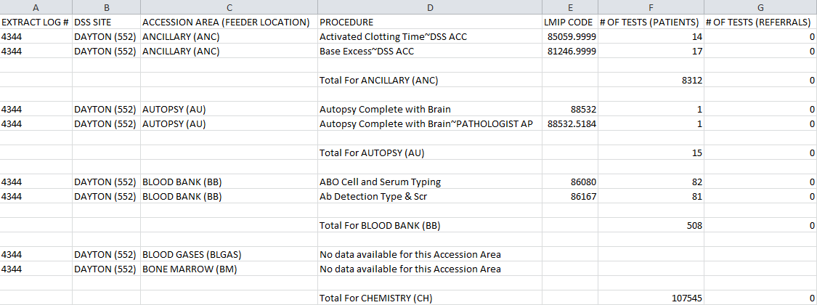

### Laboratory Results (LAR) Extract Audit

DSS collects information on specific LAR tests. The number of tests will continue to increase in accordance with Vista maintenance updates. For a complete list of the tests, users can run the Lab Results DSS LOINC Code Report. “Not in extract” will display in the Total Count column if there has been no workload for a particular DSS LAR test.

1. Example: Laboratory Results Extract Audit Report Screen Print

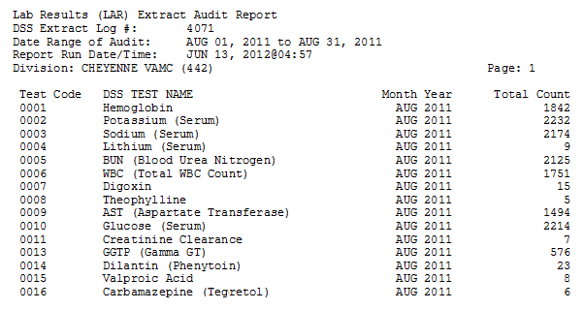

Guidance for capturing exported data into spreadsheets and the additional DSS application steps required to produce exportable versions of reports are located in Appendix F: Exporting a Report to a Spreadsheet.

The following example shows the report after it has been produced in an exportable format and imported into a spreadsheet:

1. Example: Exported Laboratory Results Extract Audit Report

Spreadsheet includes Extract Log Number, Division, Test Code, DSS Test Name, Month and Year, and Total Count.


### Laboratory Blood Bank (LBB) Audit Reports

There are two reports to choose from under the LBB Audit Reports. The LBB Comparative Report can run after the extract has are generated. The LBB Pre-Extract Audit Report, however, can only run prior to the extract, which causes some sites to bypass this audit. If a discrepancy exists, sites can correct the data and run the extract again, prior to transmitting the data to the AITC.

1. Example: LBB Audit Report Options Menu

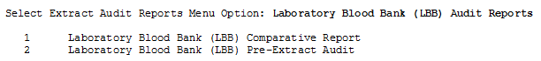

#### Laboratory Blood Bank (LBB) Comparative Report

The Laboratory Blood Bank (LBB) Comparative Report compares the Blood Bank records identified, in the VBECS DSS EXTRACT file, which serves as the source file, for Blood Bank activity reported to DSS, to the extracted records, in the BLOOD BANK EXTRACT file, for the selected extract log number. The user is shown a side-by-side comparison of the information, from the source file to the information in the extract file to verify the extracted data matches the source data.

1. Example: LBB Extract Comparative Audit Report Screen Print

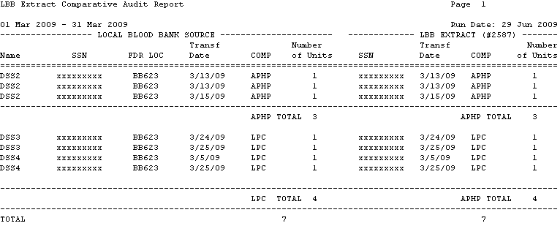

Guidance for capturing exported data into spreadsheets and the additional DSS application steps required to produce exportable versions of reports is located in Appendix F: Exporting a Report to a Spreadsheet.

The following example shows the report after it has been produced in an exportable format and imported into a spreadsheet:

1. Example: LBB Exported Extract Comparative Audit Report

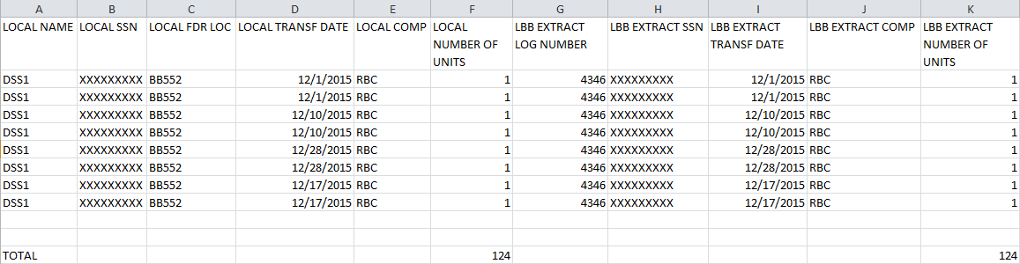

#### Laboratory Blood Bank (LBB) Pre-Extract Audit

This report provides MCA staff with a list of Blood Bank records that will be included on the LBB extract. The MCA staff should collaborate, with the Laboratory Blood Bank staff, to review and correct the data as needed, prior to the generation of the LBB extract.

1. Example: LBB Pre-Extract Audit Report Screen Print

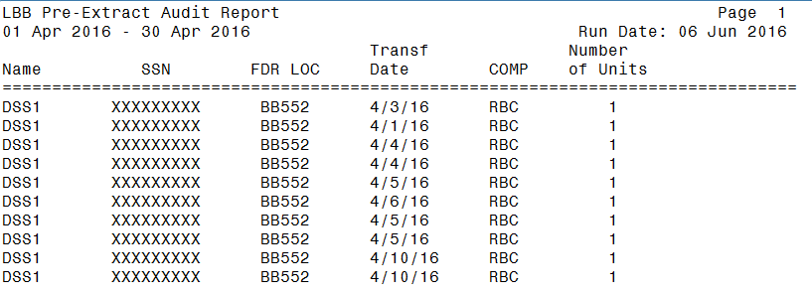

Guidance for capturing exported data into spreadsheets and the additional DSS application steps required to produce exportable versions of reports are located in Appendix F: Exporting a Report to a Spreadsheet.

The following example shows the report after it has been produced in an exportable format and imported into a spreadsheet:

1. Example: Exported LBB Pre-Extract Audit Report

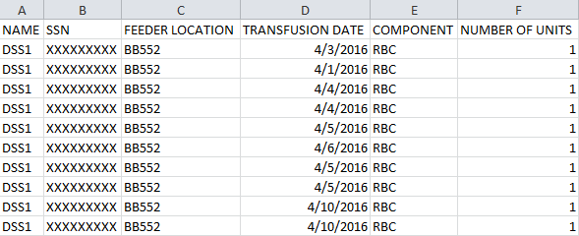

### Physical Movement (MOV) Extract Audit

This option is used to print a Summary Report, from the PHYSICAL MOVEMENT EXTRACT file (#727.808). The report displays the total count, of each PIMS movement type (transfers and discharges), by ward and ward group.

1. Example: Physical Movement Extract Audit Report Screen Print

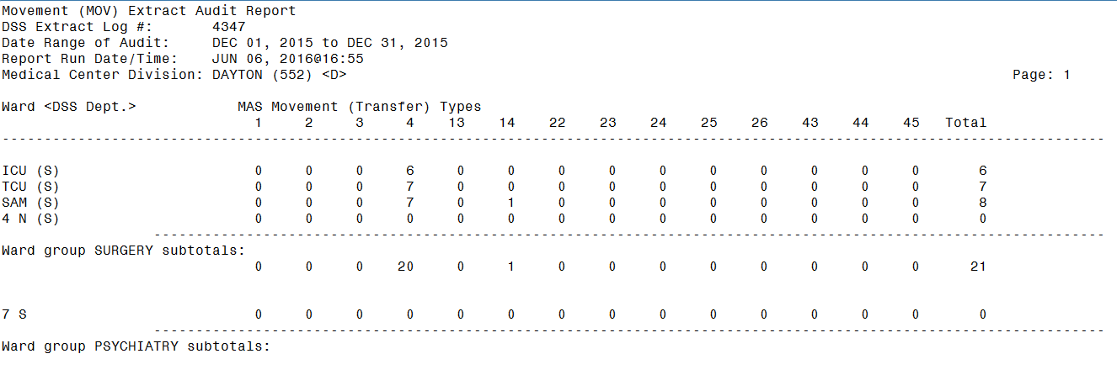

Guidance for capturing exported data into spreadsheets and the additional DSS application steps required to produce exportable versions of reports are located in Appendix F: Exporting a Report to a Spreadsheet.

The following example shows the report after it has been produced in an exportable format and imported into a spreadsheet:

1. Example: Exported Physical Movement Extract Audit Report

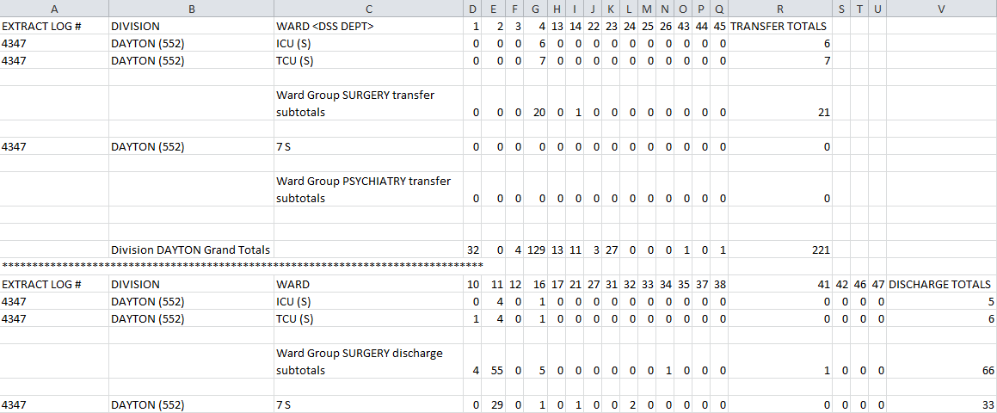

### Prosthetics (PRO) Extract Audit

This option is used to print the Prosthetics Extract Audit Report, based on data found in the PROSTHETICS EXTRACT file (#727.826). Multidivisional Prosthetics Sites may choose to generate a specific report for one division or a combined report for all divisions.

There are two versions of this report; Summary and Detailed. The content of each is described below.

1. PRO Extract Audit Versions

| Summary | Detail |
| --- | --- |
| NPPD group summary.  Data is reported in three sections: New, Rental and Repair | Individual patient detail within an NPPD Line Item. |
| VA, Commercial, and Total quantities.  Total Cost and Average Commercial Cost. | HCPCS code and description.  Delivery Date, Quantity, and Cost.  Type (i.e., VA or Commercial, Initial or Repair).  Station Number is also displayed for multidivisional Prosthetics sites. |
| Within each NPPD Group, the summary data for each NPPD Line Item is displayed, followed by the group totals. Summary totals are also provided for New, Rental and Repair sections. | Sort order is by Delivery Date. |

When the PRO Extract Audit option is selected, from the Extract Audit Options Menu, the following menu and options are displayed:

1. Example: PRO Extract Audit Menu

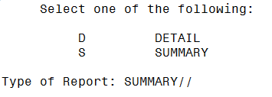

Examples of the summary version PRO Extract Audit printed and exported reports follow.

1. Example: Summary Report for PRO Extract Audit Screen Print

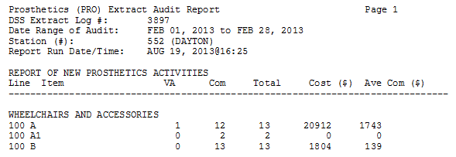

Guidance for capturing exported data into spreadsheets and the additional DSS application steps required to produce exportable versions of reports are located in Appendix F: Exporting a Report to a Spreadsheet.

The following example shows the report after it has been produced in an exportable format and imported into a spreadsheet:

1. Example: Exported Summary Report for PRO Extract Audit

Spreadsheet includes Station Number, Extract Log Number, Type, National Prosthetic Patient Database (NPPD) Group, NPPD Line, Counts per Line Item for VA and Commercial (COM), Total Count per Line Item, Total Cost per Line Item and Average COM per Line Item.  


Examples of the detailed version PRO Extract Audit Report Detail printed and exported reports follow.

1. Example: Pro Extract Audit Detail Report for PRO Extract Audit Screen Print

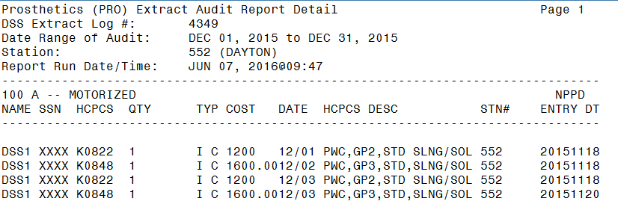

Guidance for capturing exported data into spreadsheets and the additional DSS application steps required to produce exportable versions of reports are located in Appendix F: Exporting a Report to a Spreadsheet.

The following example shows the report after it has been produced in an exportable format and imported into a spreadsheet:

1. Example: Pro Exported Audit Detail Report for PRO Extract Audit

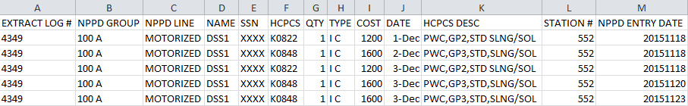

### Radiology (RAD) Extract Audit

This option is used to print a Summary Report, from the RADIOLOGY EXTRACT file (#727.814), which displays the total count of each radiological procedure, within a Feeder Location.

1. Example: Radiology Extract Audit Report Screen Print

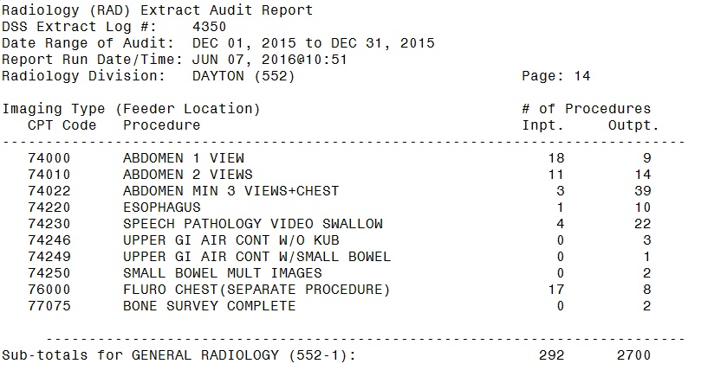

Guidance for capturing exported data into spreadsheets and the additional DSS application steps required to produce exportable versions of reports are located in Appendix F: Exporting a Report to a Spreadsheet.

The following example shows the report after it has been produced in an exportable format and imported into a spreadsheet:

1. Example: Exported Radiology Extract Audit Report

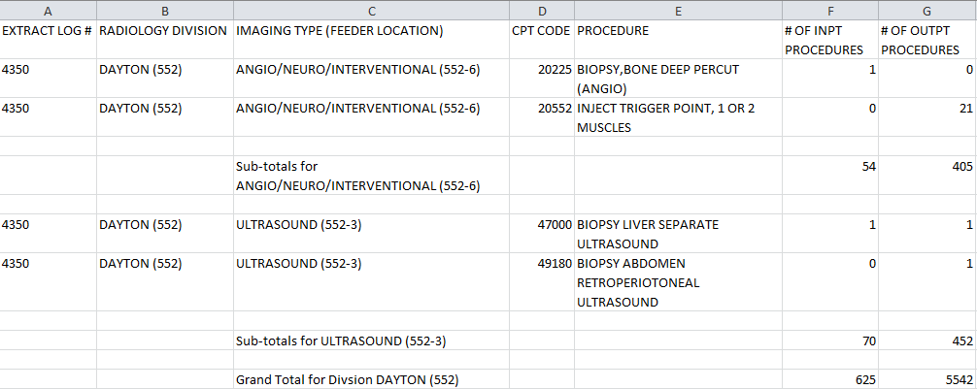

### Surgery (SUR) Extract Audit

This option is used to print a Summary Report, from the SURGERY EXTRACT file (#727.811). The report displays the number of surgical procedures and surgical cases performed in O.R. and Non-O.R. locations.

1. Example: Surgery Extract Audit Report Screen Print

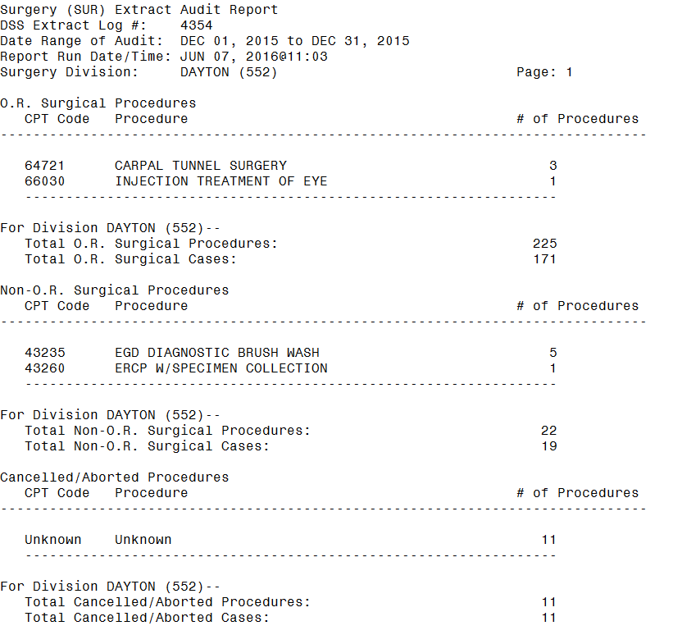

Guidance for capturing exported data into spreadsheets and the additional DSS application steps required to produce exportable versions of reports are located in Appendix F: Exporting a Report to a Spreadsheet.

The following example shows the report after it has been produced in an exportable format and imported into a spreadsheet:

1. Example: Exported Surgery Extract Audit Report

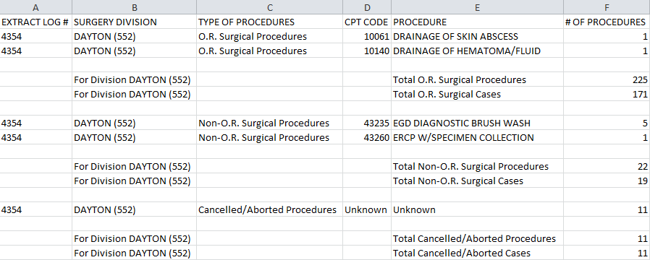

### Treating Specialty Change (TRT) Extract Audit

This option is used to print a Summary Report, from the TREATING SPECIALTY CHANGE EXTRACT file (#727.817), which displays the total number of losses, within each Treating Specialty of a medical center service.

1. Example: Treating Specialty Change Extract Audit Report Screen Print

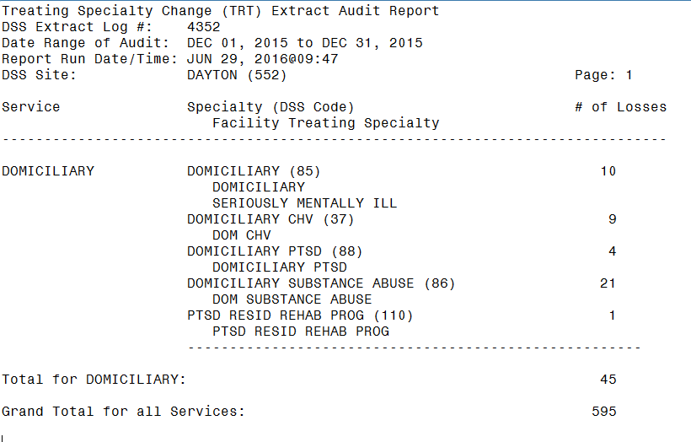

Guidance for capturing exported data into spreadsheets and the additional DSS application steps required to produce exportable versions of reports are located in Appendix F: Exporting a Report to a Spreadsheet.

The following example shows the report after it has been produced in an exportable format and imported into a spreadsheet:

1. Example: Exported Treating Specialty Change Extract Audit Report

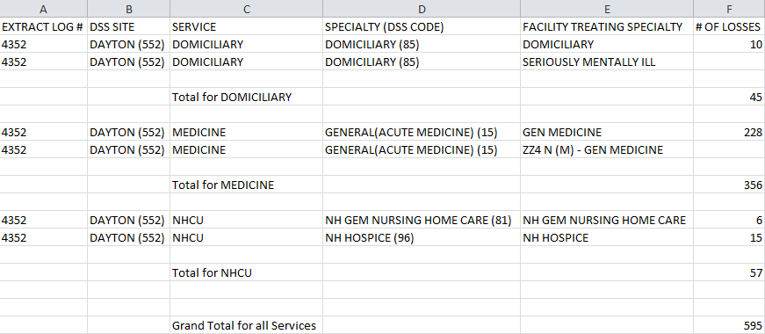

## Transmission Management

This section initiates and controls the transmission of data, from the extract files to the AITC. This menu provides users with the capability to purge the IVP, UDP or VBECS holding files. It also provides users with the capability to delete an individual or range of DSS Extract files.

When the Transmission Management option is selected, from the Extract Managers Menu the following menu and options are displayed.

1. Example: Transmission Management Options Menu

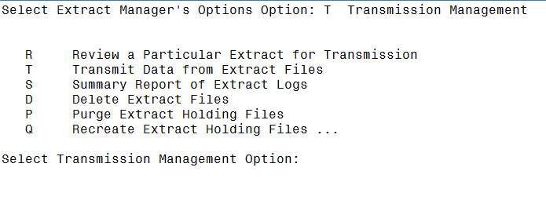

### Review a Particular Extract for Transmission

This option is used to review a particular extract to verify the transmission of messages to the AITC. The only prompts are for the Extract Log Record Number and a print device. The output includes the following information:

* Extract log record number
* Extract name
* Run date
* Division
* Transmission message numbers
* Whether or not the extract was purged
* Message status

An example of the steps to Review a Particular Extract for Transmission follows:

Select Transmission Management Option: R Review a Particular Extract for

Transmission

Select DSS EXTRACT LOG RECORD NUMBER: 4501 06-06-16 Treating specialty

change

TRT Extract (#4501) Records: 977

Generated: JUN 06, 2016 Start date: MAR 01, 2016

Division: DAYTON End date: MAR 31, 2016

DEVICE: HOME// 0;132 HOME (CRT)

1. Example: Review a Particular Extract for Transmission Screen Print

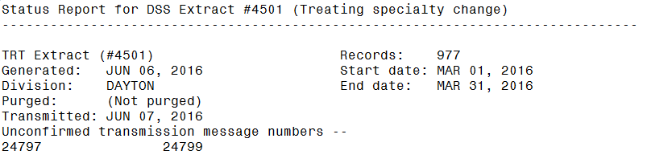

### Transmit Data from Extract Files

To receive mail messages confirming transmission of extract data, the user must be assigned to the DSS mail group, associated with the extract being transmitted.

This option is used to transmit a series of mail messages, containing data from an individual extract to the AITC. Members of the associated mail group(s) receive confirmation messages, indicating that an extract was completed, transmitted and received in Austin. Users can only transmit extracts for their assigned division.

An example of the steps to Transmit Data from Extract Files is as follows:

Select Transmission Management Option: T Transmit Data from Extract Files

Your user setup will only allow you to transmit extracts from the

following divisions:

DAYTON

If you can't select an extract, it is probably from another division.

Enter RETURN to continue or '^' to exit:

Transmit which extract: 4501 06-06-16 Treating specialty change

TRT Extract (#4501) Records: 977

Generated on: JUN 06, 2016 Start date: MAR 01, 2016

Division: DAYTON End date: MAR 31, 2016

The data was extracted using fiscal year 2017 logic.

MailMan transmission of the Treating specialty change extract is set to a

limit of 131,000 bytes per message. Each extract record ends with a ^~.

** This extract is being sent from a field office domain. **

** Extract messages(s) will only be delivered to you and **

** Will be placed into your 'DSSXMIT' mail basket. **

Request Start Time: NOW// (JUN 7, 2016@13:09:14)

Request queued as Task #33798.

1. Example: Sample Mail Message - Completed Extracted Data

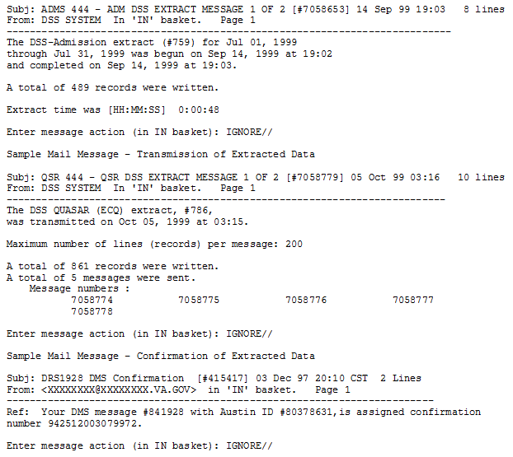

### Summary Report of Extract Logs

This option is used to print a Summary Report, from the EXTRACT LOG file (#727). The only prompts are for starting and ending dates and a print device. The output includes the following information:

* Extract Number
* VistA Package
* Data Set Dates (date range)
* Record Count
* Date Transmitted
* Date Purged
* Date Extracted
* Data Month
* Msg Unconf (Message Number)
* Requestor

The report prints properly to a 132-column output

An example of the steps to produce this report follows:

Select Transmission Management Option: S Summary Report of Extract Logs

Enter Report Start Date: 3/1/06 (MAR 01, 2006)

Enter Report Ending Date: (3/1/2006 - 6/7/2016): 10/21/06 (OCT 21, 2006)

Do you want the output in exportable format? NO//

** REPORT REQUIRES 132 COLUMNS TO PRINT CORRECTLY **

DEVICE: HOME// 0;132 HOME (CRT)

1. Example: Summary Report Extract Logs Screen Print

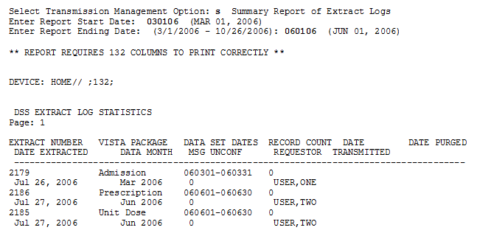

Guidance for capturing exported data into spreadsheets and the additional DSS application steps required to produce exportable versions of reports are located in Appendix F: Exporting a Report to a Spreadsheet.

The following example shows the report after it has been produced in an exportable format and imported into a spreadsheet:

1. Example: Exported Summary Report Extract Logs

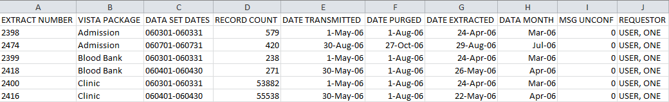

### Delete Extract Files

This option is used to delete individual extracts residing in files #727.802 through #727.833, or a range of extracts. Also, holders of the ECXMGR Security Key may only delete extracts that are associated with a division assigned in the NEW PERSON file (#200).

Any existing extract may be deleted (including transmitted and un-transmitted) and extracts that did not run to completion due to errors or system problems.

Choosing a range of extracts could mean an excessively large number of records to be deleted and may be resource intensive. Users should queue this report during off-peak hours and limit the number of extracts to be deleted, in a single queued session.

The steps for deleting DSS extract files are as follows:

This option will allow you to delete an

individual or a range of DSS extracts files.

Care must be taken for several reasons:

- You can delete ANY existing extract. This includes transmitted and non-

transmitted extracts as well as extracts that did not run to completion

due to errors or system problems.

- Choosing a range of extracts could mean an excessively large number

of records and be very CPU intensive.

Please be sure to queue this deletion for off-hours and

limit the number of extracts to be deleted per a single queued session.

Delete Extract Files?? NO// y  **YES**

...one moment please

Do you want to print a list of extracts that can be deleted? NO//

You will not be able to select an extract that is not from your division.

Select extracts to be deleted: (3794-4071): 3794

I will delete the following extract(s):

#3794 - Event Capture 01/01/2013 to 01/31/2013

Is this OK? NO// **YES**

### Purge Extract Holding Files

This option is used to purge data, in the holding files, for the IVP or UDP extracts, or VBECS. A prompt appears, for the start and end dates. Acceptable date formats are: 10 15 08, 10/15/08, or 10/15/2008.

The IV EXTRACT DATA file (#728.113) and the UNIT DOSE EXTRACT DATA file (#728.904) can become quite large, if appropriate purging is not performed. This option purges data, from these files by date range. It is recommended that records older than two fiscal years old should be purged, from the IV EXTRACT DATA file (#728.113) and the UNIT DOSE EXTRACT DATA file (#728.904).

VBECS holding files can also be purged. Once purged, these files cannot be recreated, for any time period.

Purging of any local VistA extract data or VistA source extract data (i.e., lab data, etc.) is not recommended, until the facility has successfully created extracts, transmitted them to the AITC, audited the counts, loaded the data into DSS and the results have been validated.

The steps for purging extract holding files are as follows:

Select Transmission Management Option: Purge Extract Holding Files

This option will allow you to purge:

1. data that resides in the "holding files" for the IVP and UDP extracts.

2. data that resides in the "holding file" for the VBECS extract

Care must be taken for several reasons:

- The IVP, UDP and VBECS "holding" files are intermediate files that

are populated "realtime" by inpatient pharmacy and VBECS activity.

These files are then used to generate the IVP, UDP and VBECS extracts.

NOTE: The VBECS files CANNOT be regenerated.

Once it is purged for a date range, extracts can no longer be

generated for that time period.

Purge (I)VP data, (U)DP data or (V)BECS data? **IVP Holding File**

This file currently holds IVP data from <Oct 13, 1999> to <Apr 01, 2013>.

Beginning date for purge: 1/1/13 (JAN 01, 2013)

Ending date for purge: 1/31/13 (JAN 31, 2013)

I will purge the IVP holding file from <Jan 01, 2013> to <Jan 31, 2013>.

Is this OK? NO// **y** YES

When the Purge process has been completed, a MailMan message is sent to the user. To view the message, type “MailMan Menu”, at the Transmission Management Option prompt as shown in the steps below:

Select Transmission Management Option: Mailman Menu

VA MailMan 8.0 service for XXXX.XXXX@VISTA.XXXX.XXXX.MED.VA.GOV

You last used MailMan: 10/28/08@11:55

You have 1 new message. (Last arrival:10/28/2008@11:57)

NML New Messages and Responses

RML Read/Manage Messages

SML Send a Message

Query/Search for Messages

AML Become a Surrogate (SHARED,MAIL or Other)

Personal Preferences ...

Other MailMan Functions ...

Help (User/Group Info., etc.) ...

Select MailMan Menu Option: N New Messages and Responses

The following lines will appear:

1. Example: Confirmation Message

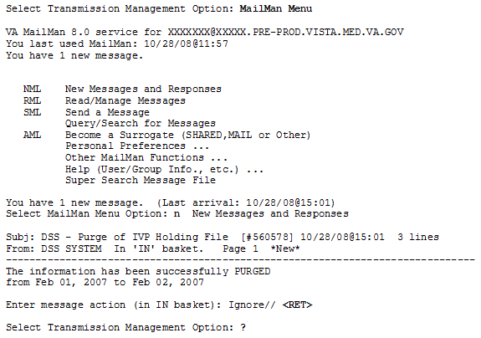

### Recreate Extract Holding Files

This option is used to recreate an IVP or UDP Extract holding file, purged at the local site. The user is prompted for the start and end dates. Afterwards, a background task is launched. When the task ends, it creates a confirmation message on MailMan.

The Recreate applies to the entire parent station.

To recreate an IVP or UDP extract,

1. Run the Purge for the desired date range.
   * Dates can be entered as 10 15 08 or 10/15/08 or 10/15/2008.
2. Check MailMan, for a confirmation message regarding the successful completion of the Purge.
3. Run the Recreate for the same date range.
   * If the Purge was not executed and data exists, for the requested time period, the system will prompt the user to do so.
4. Check MailMan, for a confirmation message regarding the successful completion, of the Recreate.
5. Run the IVP or UDP Extract.
6. Compare the record count, from the recreated extract to the record count of the original extract. The counts should be close but may be slightly different, due to timing issues.

An example of the steps to Recreate Extract Holding Files follows:

Select Transmission Management Option: Q Recreate Extract Holding Files

I Recreate IVP Extract Holding File (#728.113)

U Recreate UDP Extract Holding File (#728.904)

Select Recreate Extract Holding Files Option: I Recreate IVP Extract Holding File (#728.113)

Enter Start Date: 2 1 07

Enter Stop Date: 2 1 07

Requested Start Time: NOW// (SEP 09, 2008@13:31:43)

Request queued as Task #155353

Requested End Time: NOW// (OCT 21, 2008@15:04:37)

Request queued as Task #2607

When the Recreate has completed, a MailMan message, will be sent to the user. To view the message, type “MailMan Menu”, at the Transmission Management Option prompt as shown in the steps below:

Select Transmission Management Option: Mailman Menu

VA MailMan 8.0 service for XXXX.XXXX@VISTA.XXXX.XXXX.MED.VA.GOV

You last used MailMan: 10/28/08@15:00

You have 1 new message. (Last arrival:10/28/2008@15:05)

NML New Messages and Responses

RML Read/Manage Messages

SML Send a Message

Query/Search for Messages

AML Become a Surrogate (SHARED,MAIL or Other)

Personal Preferences ...

Other MailMan Functions ...

Help (User/Group Info., etc.) ...

Select MailMan Menu Option: N New Messages and Responses

A confirmation message similar to the following example will be sent to the user:

1. Example: Confirmation Message for Recreate

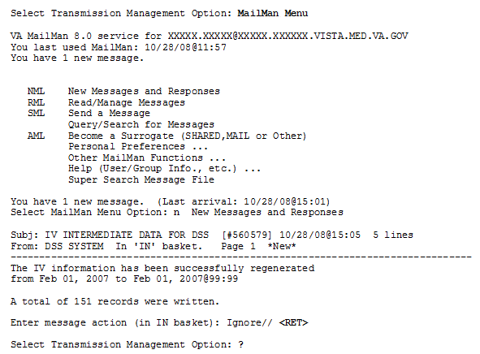

# Troubleshooting

## Special Instructions for Error Correction

Users are encouraged to contact support personnel, when encountering errors in application performance. There are no special facilities provided, for troubleshooting and error correction, by the application. Please refer to the National Service Desk (NSD) and Organizational Contacts section for additional information.

###### Abbreviations and Acronyms

Abbreviations and acronyms used throughout the User Guide.

1. Acronyms

| Acronym | Description |
| --- | --- |
| ADM | Admissions |
| ADPAC | Automated Data Processing Application Coordinator |
| AITC | Austin Information Technology Center |
| AVE | Abbreviation for Average |
| BCM | Bar Code Medication |
| BCMA | Bar Code Medication Administration |
| CBOC | Community Based Outpatient Clinic |
| CLI | Clinic Extract |
| COMP | Component |
| CPT | Current Procedural Terminology |
| CSHD | Customer Support Help Desk |
| DSS | Decision Support System |
| ECQ | Quasar Extract |
| ECS | Event Capture System and Event Capture Extract |
| HCPC | Healthcare Common Procedure Coding |
| HCPCS | Healthcare Common Procedure Coding System |
| IEN | Internal Entry Number |
| IRM | Information Resource Management |
| IVP | IV Extract |
| LAR | Laboratory Results |
| LBB | Laboratory Blood Bank |
| LMIP | Laboratory Management Index Program |
| LOINC | Logical Observation Identifiers, Names, and Codes |
| MAS | Medical Administration Service  Note: Now known as Patient Information Management System (PIMS) |
| MCA | Managerial Cost Accounting |
| MCAO | Managerial Cost Accounting Office (formerly known as the Decision Support Office (DSO)) |
| MOV | Movement Extract (Transfer & Discharge) |
| NDC | National Drug Code |
| NDF | National Drug File |
| NPPD | National Prosthetic Patient Database |
| OR | Operating Room |
| PACU | Post Anesthesia Care Unit |
| PIMS | Patient Information Management System  Note: Formerly Known as Medical Administration Service (MAS) |
| PRE | Prescriptions |
| PRO | Prosthetic |
| PSAS | Prosthetic and Sensory Aids Service |
| QUASAR | Quality: Audiology and Speech Pathology Audit & Review |
| RAD | Radiology |
| SAS | Statistical Analysis System |
| SSN | Social Security Number |
| SUR | Surgery Extract |
| TRT | Treating Specialty Change Extract |
| UDP | Unit Dose Local Extract |
| U.S.C | United States Code |
| VA | Department of Veterans Affairs |
| VDL | VA Software Documentation Library |
| VHA | Veterans Health Administration |
| VistA | Veterans Health Information Systems and Technology Architecture |
| YTD | Year-to-Date |

###### Glossary

The following table lists terms found in this document that may aid the reader in understanding.

1. Glossary

| Term | Definition |
| --- | --- |
| Action to Send Code | Indicates which, if any, code(s) should be sent to the DSS commercial software (e.g., stop code and credit stop code, with or without CHAR4 code). |
| Credit Stop Code | The Credit Stop Code (from the HOSPITAL LOCATION file [#44]) as determined by Medical Administration Service (MAS). |
| DSS Credit Stop Code | The Credit Stop Code as determined by MCA. |
| DSS Product Department | A code associated with products or services, which assists in the categorization and costing of those products. At this time, only medical center wards are being associated with a DSS Product Department in the DSS WARD file (#727.4). The DSS Product Department consists of a minimum of 4 characters as:  ABBCxxx  A = DSS CODE in NATIONAL SERVICE file (#730)  BB = DSS PRODUCTION UNIT CODE in DSS PRODUCTION UNIT file (#729)  C = DSS DIVISION IDENTIFIER in DSS DIVISION IDENTIFIER file (#727.3)  xxx = A suffix of not more than three characters which must be numeric digits or uppercase alpha characters. The first character of the string may be "-", but that is not recommended. |
| DSS Division Identifier | A single character code, either numeric (but not zero) or an uppercase alpha character. The character used in VistA file #727.3 (DSS DIVISION IDENTIFIER) as division identifier should exactly match the identifier associated with a medical center division in DSS/Austin. |
| DSS Production Unit | A two-character code which may contain both numeric and uppercase alphabetic characters. These DSS-compatible codes are based on the FMS sub-cost center scheme to categorize production unit output. The DSS PRODUCTION UNIT file (#729) holds the production unit codes approved for use by DSS. |
| DSS Stop Code | The Stop Code as determined by MCA. |
| Extract | Management tool used to track and account for procedures and delivered services, which are not handled in any existing VistA package. |
| Extract Files | The files that hold the data that has been extracted via the DSS Extract software. |
| Feeder Key | The product for workload extracted. |
| Feeder Location | The site location of data extracted. |
| Provider | The actual provider of care performing the procedure. This provider can be a doctor, nurse, technician or any designated team of medical professionals. |
| Stop Code | The Stop Code (from the HOSPITAL LOCATION file [#44]) as determined by Medical Administration Service (MAS). |
| Volume | Volume is associated with the number of procedures performed or the length of time actually spent performing the procedures. |

###### Reference Materials

The following reference material was used to create this document:

* IM/KM Reference Tool

###### Feeder Key Transmission

The Feeder Key for the Clinic Extract is transmitted in the following format.

SSSCCCTTT4444N

These characters are determined by the ACTION TO SEND code as indicated in the following table.

1. Feeder Key Transmission Table

| Action to Send Code | Description |
| --- | --- |
| 4: SEND STOP CODE(S) WITH CHAR4 CODE | SSS is the Stop Code.  CCC is the Credit Stop Code. If no Credit Stop Code assigned then “000”  TTT is the length of appointment.  4444 is the CHAR4 Code.  N if a no-show, otherwise ‘0’ (zero). |
| 5: SEND STOP CODE(S) WITHOUT CHAR4 CODE | SSS is the Stop Code.  CCC is the Credit Stop Code.  TTT is the length of appointment.  4444 = 0000.  N if a no-show, otherwise ‘0’ (zero). |
| 6: DO NOT SEND | SSS = 000.  CCC = 000.  TTT is the length of appointment or “000” if not present.  4444=0000.  N if a no-show, otherwise ‘0’ (zero). |

###### Create a LAR Translation Table

A translation table is required to convert entries in the results field of the LAR extract from a free text to a numeric value for all types of lab tests. The translation table is a new table for the DSS VistA Extract Package. LAR TRANSLATION TABLE will convert free text results to a numeric value for all lab tests.

The translated numeric values are:

0 - Negative, Non-Reactive.

1 - Positive, Reactive.

2 - Borderline, Indeterminate.

3 - Test not Performed, Qty not sufficient or other reason.

5 - Result cannot be translated.

The Lab Results free-form text field contains many different coding schemes to indicate whether the results are negative or positive. The list of text, with the translated values is as follows:

1. LAR Translation Table

| RAW | Translation | RAW | Translation | RAW | Translation |
| --- | --- | --- | --- | --- | --- |
| Negative | 0 | EQUIV | 2 | REM | 5 |
| Positive | 1 | NRG | 5 | ND | 0 |
| NEGATIVE | 0 | N | 0 | NRE | 5 |
| POSITIVE | 1 | R | 1 | See com | 5 |
| Neg | 0 | Borderline | 2 | See rpt | 5 |
| Pos | 1 | NEG. | 0 | Reac | 1 |
| nonreactive | 0 | POS. | 1 | NREACT | 0 |
| NONREATIVE | 0 | ND | 0 | Type 1 | 5 |
| reactive | 1 | Reactive | 1 | 2b | 5 |
| REACTIVE | 1 | Detected. | 1 | 3a | 5 |
| NEG | 0 | React | 1 | BAS | 5 |
| POS | 1 | Nonreact | 0 | N-I | 5 |
| NOTDET | 0 | WK POS | 1 | Pend | 5 |
| DETEC | 1 | +/-=pos | 2 | RPC | 5 |
| NON REAC | 0 | LSG | 5 | QNS | 3 |
| REAC | 1 | Reactive* | 1 | P | 1 |
| WK.POS | 1 | =+pos | 1 | FFT | 5 |
| WK.POS. | 1 | NEGATIV | 0 | + | 1 |
| NEG# | 0 | ND | 0 | - | 0 |
| POS# | 1 | INCONC. | 2 |  |  |
| BRDLINE | 2 | DONE | 5 |  |  |
| NR | 0 | NEH | 5 |  |  |
| Non-react | 0 | MEG | 5 |  |  |
| BRDLNE | 2 | P | 1 |  |  |
| **pos | 1 | NRG | 5 |  |  |
| ***pos | 1 | Repeat | 2 |  |  |
| BDL | 2 | NE | 5 |  |  |
| EQUIVOCAL | 2 | NGE | 5 |  |  |

NOTE:

Any value not in the table should return a “5”.

The sites will be responsible for maintaining/updating the table.

Translations cannot change the meaning of the free text field.

Non-numeric reported values for all tests would be stored in the translation field and available to Ad Hoc and SQL.

In many cases, it may take a long time to run this report (**possibly more than an hour or two**). Your screen may be tied up for some time once you set the report to run

###### Exporting a Report to a Spreadsheet

The following steps illustrate common actions to produce any exportable version of reports where offered as an alternative to a printable version (e.g. on-screen printed softcopy or hardcopy to a printer) by the DSS application.

NOTE: The terminal emulator examples in the following subparagraphs were produced using Attachmate Reflection for UNIX and OpenVMS within a Microsoft® Windows environment.

1. When prompted for producing an output in an exportable format by the application as shown below enter **Yes**,thenpress the <Enter> key:

Do you want the output in exportable format? NO// YES

Gathering data for export...

To ensure all data is captured during the export:

1. Select 'Logging...' from the File Menu. Select your file, and where to save.

2. On the Setup menu, select 'Display...',then 'screen' tab and modify 'columns' setting to at least 225 characters.

3. The DEVICE input for the columns should also contain a large enough parameter (e.g. 225). The DEVICE prompt is defaulted to 0;225;99999 for you.

You may change it if need be.

Example: DEVICE: 0;225;99999 *Where 0 is your screen, 225 is the margin width and 99999 is the screen length.

NOTE: In order for all number fields, such as SSN and Feeder Key, to be

displayed correctly in the spreadsheet, these fields must be formatted as Text when importing the data into the spreadsheet.

DEVICE: 0;225;99999//

1. Select **Display,** from the Setup menu option in the terminal emulator window.
2. Display selection from Setup Menu Option

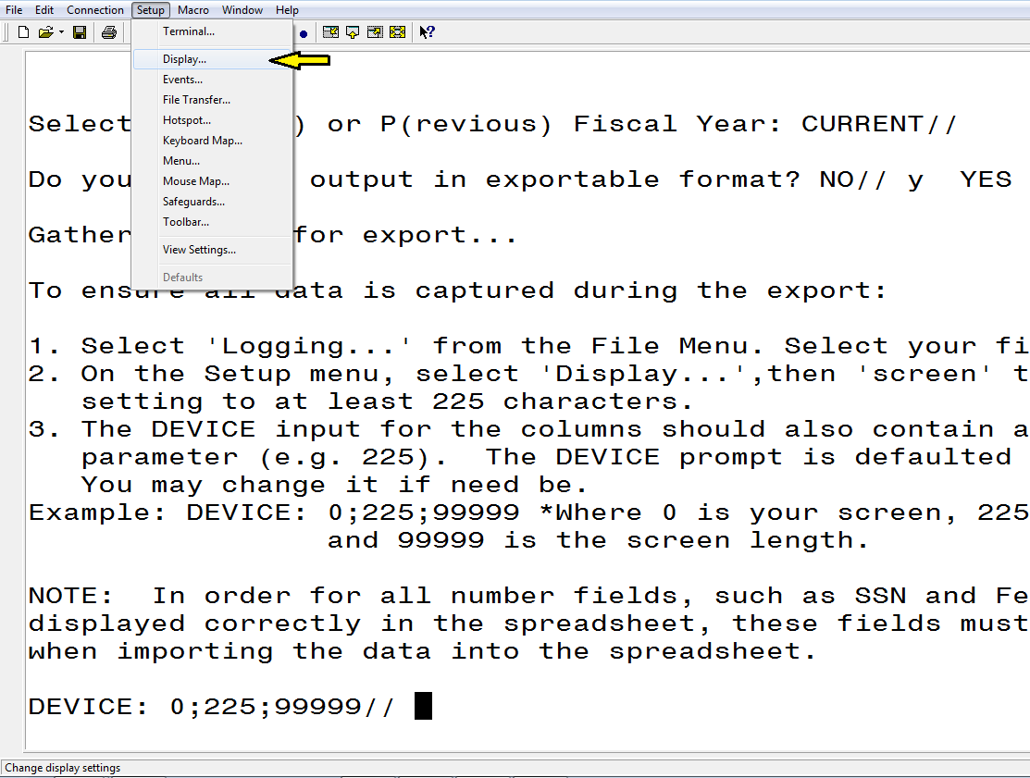

1. On the Screen tab, modify the number of Columns to at least 225. Then, click the <OK> button, in the lower right-hand portion of the screen.
2. Display Setup screen

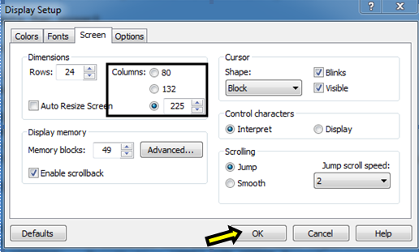

1. Select **Logging…** on the File menu.
2. Logging selection from File Menu

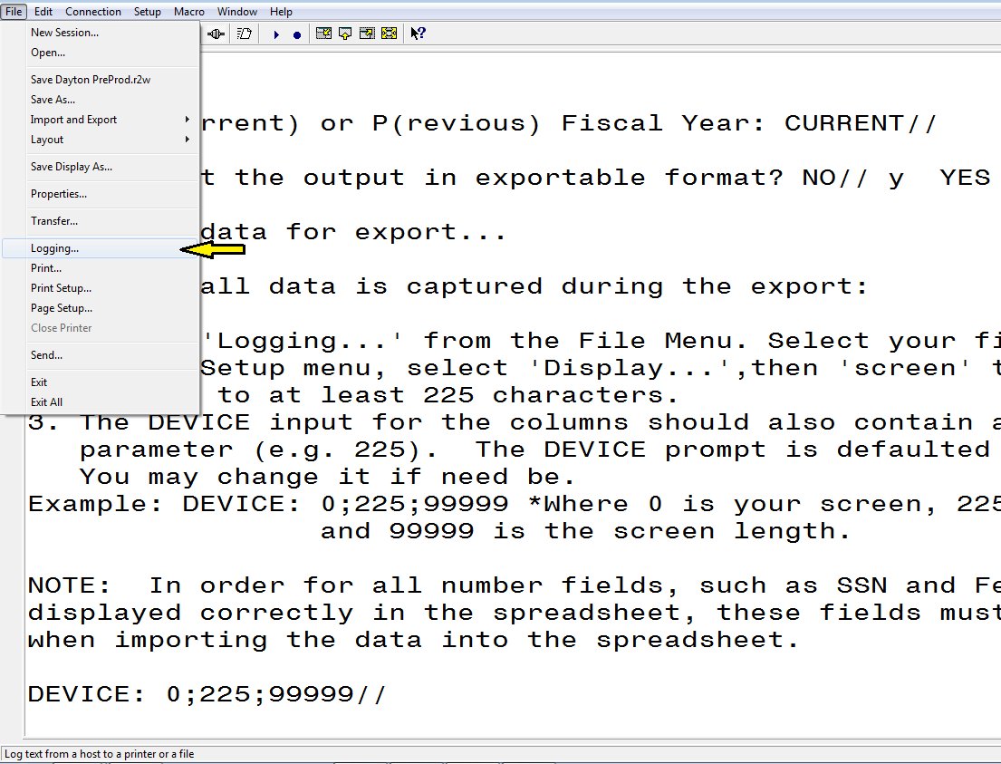

1. On the Logging popup screen:
   1. Click the box to select **Logging on.**
   2. Click the box to select the **Disk** option and name the file.
   3. Then, Click the **Browse** button.
2. Logging Screen

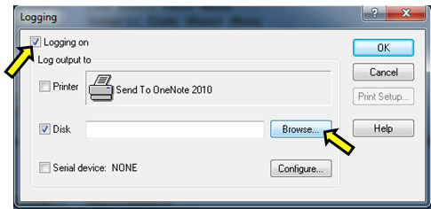

1. Select the folder where the text file will be saved and click the **Save** button.
2. Log Output To Disk File screen

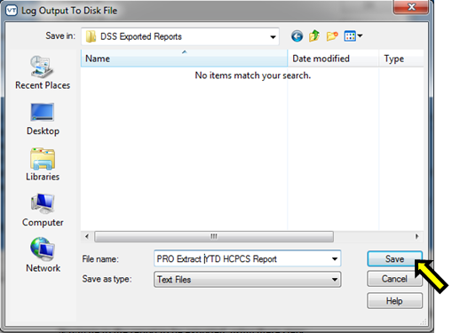

1. The file will be created in the folder selected.
2. DSS Export Report screen

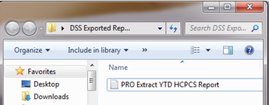

1. Respond to the application prompt for “DEVICE: 0;225;99999// “ by pressing the <**Enter>** key to keep the default parameters.

Gathering data for export...

To ensure all data is captured during the export:

1. Select 'Logging...' from the File Menu. Select your file, and where to save.

2. On the Setup menu, select 'Display...',then 'screen' tab and modify 'columns' setting to at least 225 characters.

3. The DEVICE input for the columns should also contain a large enough parameter (e.g. 225). The DEVICE prompt is defaulted to 0;225;99999 for you.

You may change it if need be.

Example: DEVICE: 0;225;99999 *Where 0 is your screen, 225 is the margin width and 99999 is the screen length.

NOTE: In order for all number fields, such as SSN and Feeder Key, to be

displayed correctly in the spreadsheet, these fields must be formatted as Text when importing the data into the spreadsheet.

DEVICE: 0;225;99999//

1. Once the running of the report has completed, turn off logging by:
   1. Select **Logging…** on the File menu.
   2. On the Logging popup screen, click the box to deselect **Logging on.**
2. Logging screen

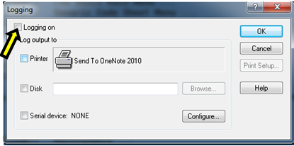

1. Open a new Excel workbook. Then click the **Data** tab and select the **From Text** option.
2. From Text option from Data Menu

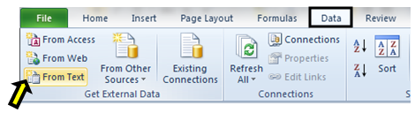

1. Navigate to the folder where the file was created.
   1. Select the text file that was created.
   2. Click the **Import** button, at the lower right-hand portion of the screen.
2. Import Text File screen

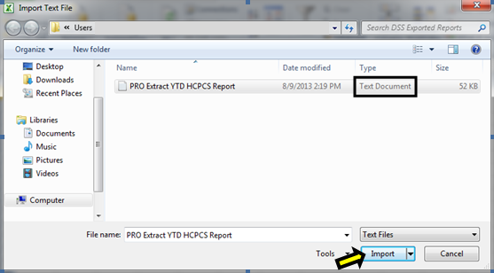

1. When the “Text Import Wizard – Step 1 of 3” screen appears:
   1. Chose **Delimited** as the data type (radio button).
   2. Then, click the **Next** button, at the lower right-hand portion of the screen.
2. Text Import Wizard – Step 1 of 3

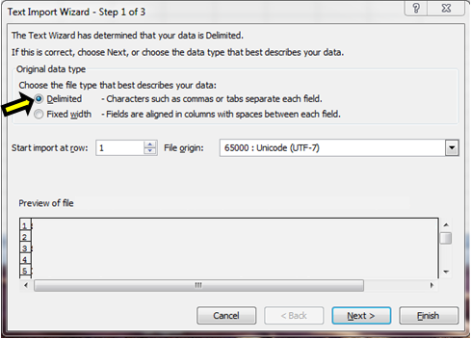

1. Text Import Wizard – Step 2 of 3 screen:
   1. Under Delimiters section, uncheck **Tab**, then check **Other** and type a caret (^) as for the delimiter value.
   2. Then, click the **Next** button, in the lower right-hand portion of the screen.
2. Text Import Wizard – Step 2 of 3

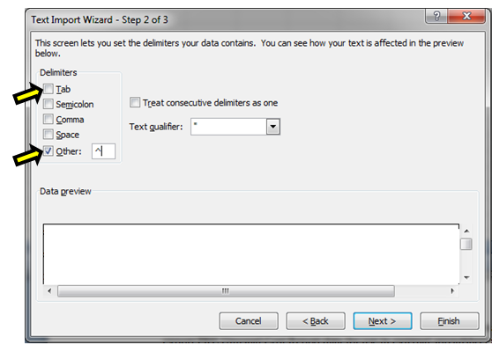

1. Text will be chosen as the format for each column on the Text Import Wizard – Step 3 of 3 screens. In the Data Preview section of the screen, click to highlight the column and select **Text** as the data format. Click **Finish** after each column has been formatted.
2. All columns can be selected at once if the first column is selected and then hold the shift key and move the scroll bar to the far right and select the last column.
3. Text Import Wizard – Step 3 of 3

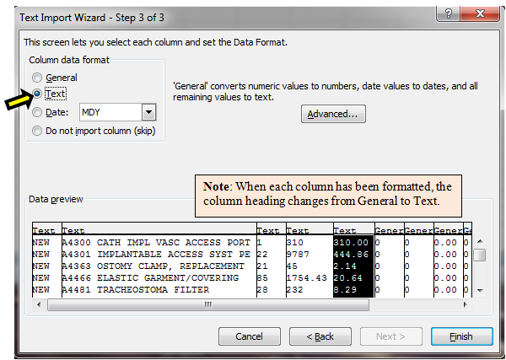

1. Click **OK** when the Import Data screen appears.
2. Import Data screen

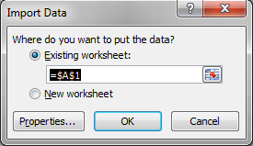

1. The report will be created and displayed in an Excel spreadsheet.
2. Excel Report

